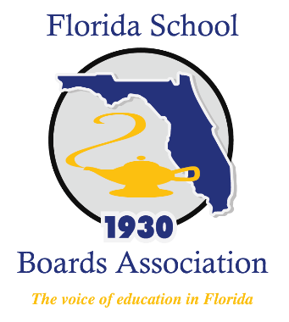

Honoring Florida Public
School Heroes

HURRICANE IRMA
Press Kit

Purpose & Contents
The contents of this press kit are to assist Florida Public School Districts in honoring their local Public School Heroes who selflessly served during Hurricane Irma. You can share your stories via social media by tagging FSBA (www.twitter.com/flschoolboards or www.facebook.com/flschoolboardsassociation) or by using the hashtag #FLPublicSchoolHeroes.

Enclosed you will find:
- Press Release Template
  - This optional template is available as a communications resource for creating your district’s press release about honoring your Public School Heroes.
    - Highlighted in yellow are fields that your district can customize, or add additional data points, quotes, or anecdotal evidence directly related to your community’s experience.
    - Be sure to circulate information about your public school heroes and your recognition ceremony to your local news outlets, legislators and community, and through your social media outlets.
  - Please submit your complete list of Public School Heroes & associated photos to the FSBA Communications Office by email (contact information listed below), as FSBA will be maintaining a statewide honoree page (www.fsba.org/florida-public-school-heroes/).
- Talking Points
  - Talking points have been provided for your reference in developing recognitions for your heroes.
- Florida Public School Heroes Honoree Certificate
  - This certificate is editable to enable you to enter your heroes’ names, date of ceremony, and/or names and signatures of your Superintendent and Board Chair. You can also insert your district logo.
  - Should your district need assistance in customizing your certificates, please do not hesitate to contact the FSBA staff (contact information listed below).

For questions, assistance, or additional resources please contact:
BillieAnne Gay, Member Communications Manager
The Florida School Boards Association
(Office) 850.414.2578
(Cell) 850.528.9104
Gay@fsba.org

INSERT YOUR LOGO/LETTERHEAD
FOR IMMEDIATE RELEASE CONTACT
[insert date] [insert media contact info]

SCHOOL BOARD TO HONOR PUBLIC SCHOOL HEROES IN IRMA’S AFTERMATH
[City, State]—The School Board of [county] County honored [#] school district employees and [#] volunteers for their service and courage directly following Hurricane Irma. These public school heroes were recognized in front of community members and staff at [enter day]’s School Board Meeting.
Across nation, when natural disasters occur, public school district employees are faced with the decision to put other children and families’ safety above their own. This has been witnessed during Hurricane Sandy, Hurricane Harvey, and most recently in Florida, with Hurricane Irma. Florida communities suffered a wide range of effects before, during, and after Hurricane Irma. As the storm passed and districts began to assess power outages, flooding, and other damages, they continued to serve families suffering from damages of their own.
“[insert quote from Board Chair]”
“I am extremely proud of the courage and service of Florida’s public school personnel in response to Hurricane Irma—many of whom were without power and shelter for their families and themselves,” stated FSBA Executive Director Andrea Messina.
All of Florida’s school districts were closed for a minimum of two days while many districts remained closed for a week or more as they assessed power outages and facility damages, impacting 2.8 million students and families. In the midst of inclement conditions and operating without power, public school employees continued to shelter and feed evacuees and displaced families suffering from damages of their own. [You may choose to insert specific data from yoru district here to illustrate your community’s experience]
For a complete list of public school heroes honored by Florida’s public school districts, and to find out how you can continue to support Florida’s public schools in their Hurricane recovery, click HERE (www.fsba.org/florida-public-school-heroes/).

- [attach list of names, occupation, blurb]
- [attach photos]

###

Talking Points/Speech Template
Once again our public school principals, teachers, administrators, and staff proved to be a force of hope and help during a time of great need for many Floridians. Time and time again nation when natural disasters occur, our public school family places helping others in front of helping themselves and their families.
We have seen this with Hurricane Sandy and Hurricane Harvey, to mention a few, and have witnessed it again most recently in Florida, with Hurricane Irma.
As Florida families know, many of these same teachers, principals, administrators and staff are heroes in our schools and classrooms on a regular basis. Many of our school district employee’s served above and beyond during one of the most difficult times in Florida history for many families. Thank you for what you do to help ensure every child learns and for once again stepping up to help the community during Hurricane Irma.
All of Florida’s school districts were closed for a minimum of two days while many districts remained closed for a week or more as they assessed power outages and facility damages, impacting 2.8 million students and families. In the midst of inclement conditions and operating without power, public school employees continued to shelter and feed evacuees and displaced families suffering from damages of their own.
Right here in [insert county], we experienced [insert data points, etc.]. Through the anticipation of the storm, damage, and recovery, our public school heroes served our community with bravery and honor. We would like to recognize some of our local public school heroes now:
[Read names, present with certificate]

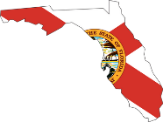
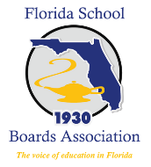

This recognition from the County School Board & Florida School Boards Association,
given on this ____________________, is awarded to:
Day Month, Year

for your courage, service, and selflessness in preparation and recovery due to
Hurricane Irma.

• FLORIDA PUBLIC SCHOOL HERO AWARD •

