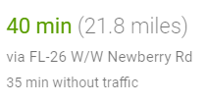
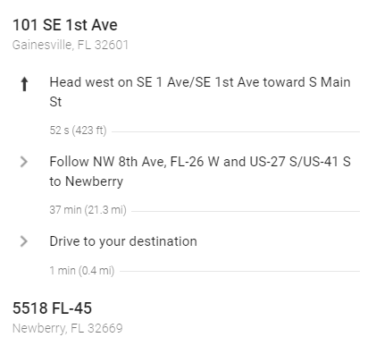
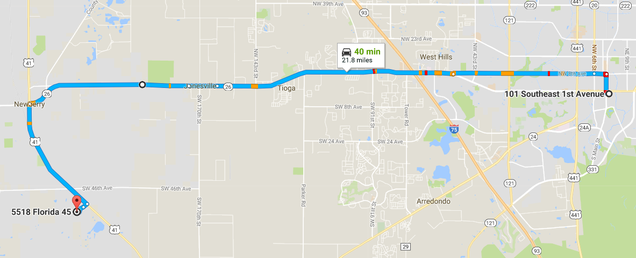

Directions to PINKOSON FARM from HAMPTON INN
October 24 Dinner – 6pm
If you need assistance, please contact:
Tina Pinkoson (352) 870-8484
April M. Griffin (352) 262-3113

