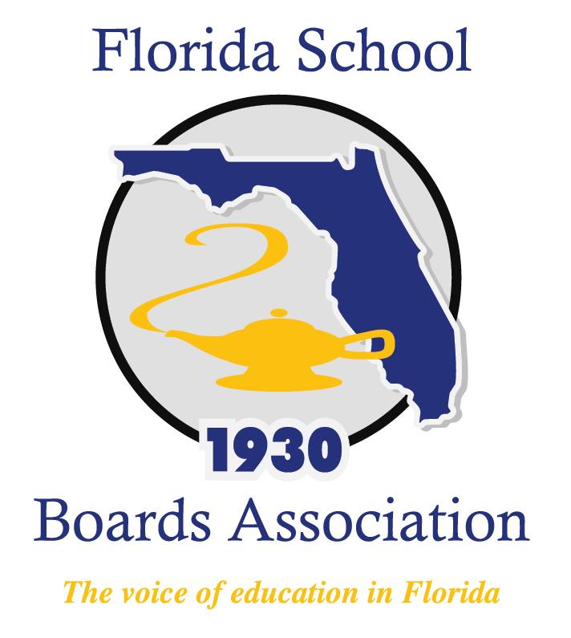
2018 Policy Governance Forum Agenda

Mission Inn at Howey-in-the-Hills, FL
Thursday, January 25, 2018
6:30 – 8:30 a.m. Help yourself to the Breakfast Buffet in La Hacienda
8:30 a.m. Welcome and Startups
Policy Scavenger Hunt
Policy and Governance
Break
Policy Development
Lunch
Policy Development (Continued)
Policy Maintenance and Revision
4:30 p.m. Closing and Adjournment

For those of you joining us for the Boardsmanship Forum,
we will meet back in this room tomorrow morning at 8:00.

