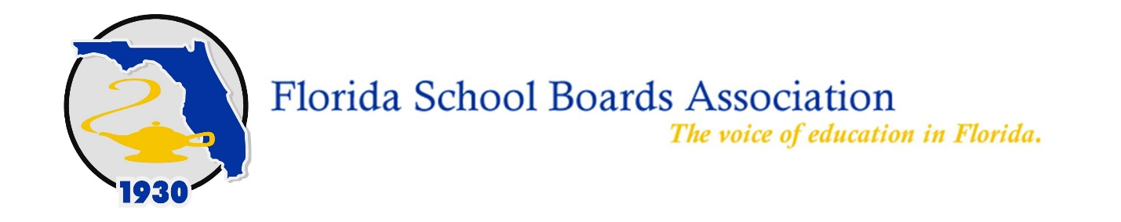

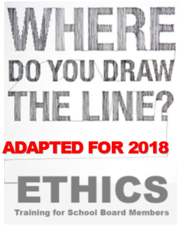
Thank you for registering for the Where Do You Draw the Line? Ethics Training for School Officials online course. FSBA is proud to partner with NEFEC to provide this on-demand virtual training to you.

- Visit https://www.nefec.org/mynefec/sign-up/ and create a MyNEFEC account to access the training and to keep track of your professional learning.
  - Already have a MyNEFEC account? Sign in at www.nefec.org and skip to step #3.
- Check your email to verify your account and complete the sign up process.
- Sign in using your account information at www.nefec.org.
  - Be sure to click “REMEMBER ME” before you sign in so that signing in will be easier next time.
- Once you have signed in, click: “MyNEFEC” in the top right corner, and when the menu drops down, click “FSBA Ethics Training.”
- Enter your enrollment key when prompted: ETHICS2018

For technical assistance, please contact:
NEFEC
elearning@nefec.org
386-329-3580

For content questions and assistance, please contact:
Tina Pinkoson
Pinkoson@fsba.org
352.870.8484

