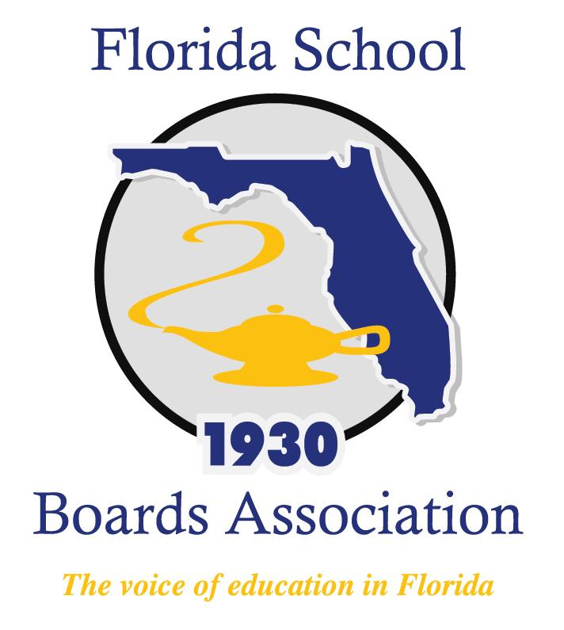
2019 Bargaining and Personnel Forum Agenda

Mission Inn at Howey-in-the-Hills, FL
Friday, September 27, 2019
7:15 a.m. Breakfast Buffet

8:00 a.m. Welcome, Introductions, and Startups

8:15 a.m. Your role in Personnel Issues with David Delaney
- Contracting and Employment Responsibilities
- Termination and Discipline Responsibilities
- Other Personnel Issues

11:15-12:00 Lunch

12:00 p.m. Bargaining Issues with Leonard Dietzen
- Roles of the School Board and the Superintendent
- Executive Sessions
- Scope of Bargaining
- Models of Bargaining
- Impasse / Legislative Hearings
- Ratification / Post Ratification

2:00 p.m. Adjourn

