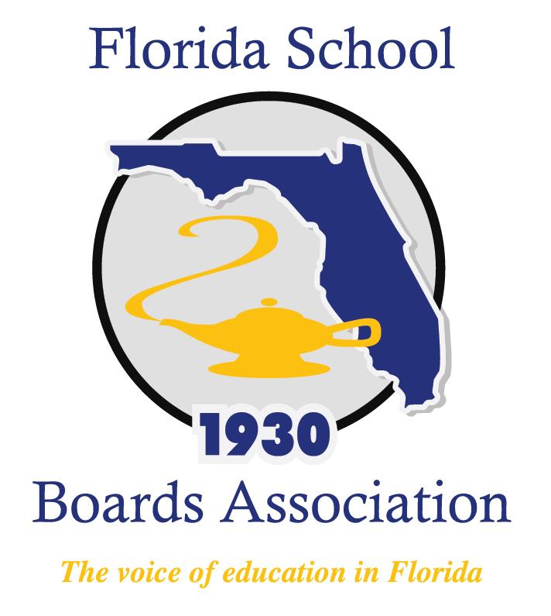
2019 Policy Governance Forum Agenda

Mission Inn at Howey-in-the-Hills, FL
Thursday, September 26, 2019
6:30 – 8:30 a.m. Breakfast Buffet – La Hacienda
8:30 a.m. Welcome and Startups
Policy Scavenger Hunt
Policy and Governance
Break
Policy Development
Lunch
Policy Development (Continued)
Policy Maintenance and Revision
4:30 p.m. Closing and Adjournment

