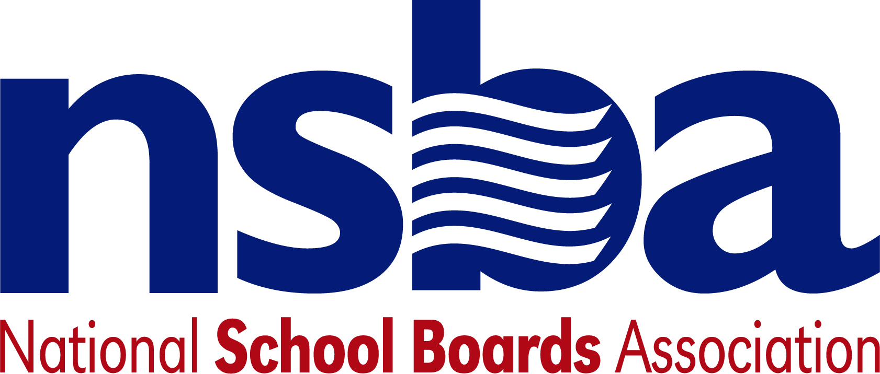

Federal Advocacy & Public Policy Team
May 22, 2020
NSBA Weekly Update

Congressional Update

Senate Adjourned Until June, House on Limited Memorial Day Schedule
Following House passage of the Democratic Leadership’s latest COVID-19 response bill (the “HEROES Act”) congressional work to respond to the emergency has slowed. Senate Republican Leaders said the body would not consider the HEROES Act. They also said they would not develop other emergency response legislation until the CARES Act has had more time to work. With the Senate on recess – and the House planning a light schedule - during Memorial Day week, NSBA does not expect significant work to begin again until June. At that time, the Senate and House appropriations committees are expected to focus on the regular fiscal year 2021 appropriations process, including continuing work on the U.S. Department of Education’s budget. Additional COVID-19 emergency response discussions between the Senate, House, and White House are likely to grow more serious later in the month. NSBA plans to continue urging
Congress to provide significant additional emergency funding for school districts, while also seeking key increases in regular fiscal year 2021 funding for the Department of Education.

Administration Update

Department of Education Publishes English Learner Fact Sheet
The Department of Education published a fact sheet that “outlines States’ responsibilities to English learners and their parents during the COVID-19 emergency.” The fact sheet covers questions associated with annual EL assessment, entrance requirements, providing services to EL students, use of ESSA Title III funds, exit procedures, and more.
USDA Extends Nutrition Program Waivers
The Department of Agriculture extended three nationwide waivers for schools and local programs to make it easier to feed eligible children through August 31, 2020. The initial waivers were set to expire on June 30. The Food and Nutrition Service waivers provide the following flexibility:

- Non-Congregate Feeding: FNS is allowing meals to be served to children outside of the normally required group setting to support social distancing;

- Parent Pickup: FNS is allowing parents and/or guardians to pick up meals and bring them home to their children; and

- Meal Times: FNS is waiving requirements that meals be served at certain standard times to allow for grab-n-go options. This also allows for multiple days-worth of meals to be provided at once. The USDA also said it is working quickly to approve states for Pandemic-EBT, which “provides food-purchasing benefits, equal to the value of school meals, to households with children who would otherwise be receiving free or reduced-price meals at school.”

Centers for Disease Control Publishes Re-Opening Guidelines
This week, the CDC published guidelines for reopening the economy, including schools, titled “CDC Activities and Initiatives Supporting the COVID-19 Response and the President’s Plan for Opening America Up Again”. CDC said, “[a]ll decisions about following these recommendations should be made in collaboration with local health officials and other State and local authorities who can help assess the current level of mitigation needed based on levels of COVID-19 community transmission and the capacities of the local public health and healthcare systems, among other relevant factors.”

Notable New K-12 Bills

- H.R.6902 To authorize the Secretary of Education to award grants to eligible entities to carry out educational programs that include the history of peoples of African descent in the settling and founding of America, the economic and political environments that led to the development, institutionalization, and abolition of slavery and its impact on all Americans, the exploration and expansion of America, impact on and contributions to the development and enhancement of American life, United States history, literature, the economy, politics, body of laws, and culture, and for other purposes. Sponsor: Rep. Fudge, Marcia L. [D-OH-11]

NSBA Updates
.
Non-binding Equitable Guidance to Non-Public Schools: NSBA continues to be very concerned over the non-binding equitable guidance that the U.S. Department of Education (ED) recently released concerning distribution of CARES Act funding to non-public schools including private schools under the CARES Act. NSBA is extremely concerned over this recent guidance that appears to be radically shifting resources away from public schools and to private schools. Under the provisions of The CARES Act, local educational agencies (LEAs) that receive education stabilization funds are to provide equitable services to non-public schools in the same manner as provided under Title I of the Elementary and Secondary Education Act (ESEA). Under that Act, LEAs base how much Title I funding is distributed for services to private schools on number of low income students served, not total enrollment numbers. ED’s announced guidance is contrary to that law. This issue is creating havoc and uncertainty for states as they seek to provide funds under the CARES Act. NSBA believes the guidance directing LEAs to base funding distribution to non-public schools based on total enrollment instead of poverty levels is contrary to the Law set out in the CARES Act and will cause the students most in need to receive less resources. Expect to hear more about this issue in the coming days as the level of concern rises.

CSALS Conference Call: There will be a CSALS call this Tuesday, May 26, 2020 at 4:30 pm eastern. The call information is:

(833) 444-6583; Conference ID: 926 195 919#

Have a nice Memorial Day weekend.

