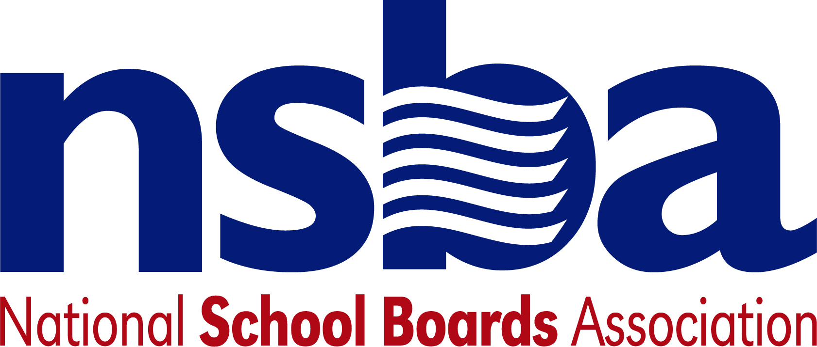

Federal Advocacy & Public Policy Team
May 29, 2020
NSBA Weekly Update

Congressional Update

Congress Plans Full June Calendar
The Senate and House will return to Washington next week with a busy schedule before the annual July 4th recess. The Senate Majority Leader plans to use the first two weeks of June to consider presidential nominations and indicated the final week of the month will be set-aside for debate about the Defense Authorization Act. The remaining schedule will be reserved for other Senate business, which could include discussions about additional pandemic aid. Following several weeks of “pumping the brakes” on additional aid, Majority Leader McConnell acknowledged, this week, that more emergency funding may be needed. He cautioned, however, that the Senate would not consider spending at the $3 trillion level recently approved by the House (the HEROES Act). Despite the acknowledgement that more funding may be needed, NSBA does not expect the Senate and House to agree to a new emergency bill until July. That assessment could change, however, if the stock market falters again or pressure increases from state leaders about troubling midyear state revenue estimates. As this work unfolds, NSBA intends to continue fighting for a direct investment in local education budgets, along with dedicated funding for providing disconnected students and teachers home broadband to connect to the Internet.

Senate HELP Committee Plans Hearings Focused on Return to School, College
Senate HELP Committee Chairman Alexander (R-TN) announced this week that the committee will hold two hearings in June focused on postsecondary and K-12 plans to return to school this fall. The first hearing, scheduled for June 4, will focus on college campuses. Senators will hear testimony from:

o Mr. Mitchell Daniels, President, Purdue University
o Dr. Christina Paxson, President, Brown University
o Dr. Logan Hampton, President, Lane College (TN)
o Dr. Georges Benjamin, MD, MACP, FACEP(E), FNAPA, Hon FRSPH, Hon FFPH, American Public Health Association

The second hearing, scheduled for June 10, will focus on plans for safely reopening K-12 schools. The committee has not yet announced the witness list for the K-12 hearing.

Department of Education News

U.S. Ed Reports Every State Has Now Filed a K-12 Emergency Relief Fund Application
The Department of Education said this week that every state has requested funding through the CARES Act’s $13.4 billion Elementary and Secondary Education Relief Fund. Program funding is allocated by formula – based on a state’s proportional share of Title I funding - but states were required to submit applications before the funding would be released. NSBA encourages district leaders to contact their State Education Agencies about the process and timeline for states to release the funds to the local level. States must provide 90% of the funding to school districts based on their proportional share of Title I funding. The funds may be utilized for a wide variety of uses, including any use authorized by the ESEA, IDEA, Perkins CTE Act, McKinney-Vento Act, and more.

Secretary DeVos Doubles Down on Controversial Equitable Services Decision
Earlier this month, the Department of Education published CARES Act guidance that took an expansive view of the law’s equitable services language. Under the Department’s interpretation, school districts were required to use a portion of their K-12 Emergency Relief Funds to provide all private school students with equitable services, not just those students who are disadvantaged or at risk. After learning that some states planned to ignore the non-binding guidance, Secretary DeVos announced plans to adopt regulations forcing states and school districts to follow her interpretation of the law. Congressional leaders, including Chairman Alexander, publicly disagree with the secretary’s interpretations, but NSBA expects the agency to publish proposed regulations for public comment later this month. NSBA advocacy efforts to combat this misinterpretation of the law by the Secretary will aggressively continue as Congress considers new supplemental legislation.

Department Announces Mental Health Grants Competition
The Department of Education invited applications for the “School-Based Mental Health Services Grant Program.” The program provides funding to increase the number of qualified mental health service providers available to students in districts with demonstrated need. Congress provided $10 million for the program which aims to increase the number of counselors, social workers, psychologists, and other service providers. The Department estimates that 5 awards will be given, at $2 million each. Applications are due by July 13, 2020 Further information is available here.

NSBA Updates
.
Next week, NSBA is going through a historic change as Tom Gentzel retires as our CEO and Anna Maria Chávez takes over as our next leader. On behalf of the federal advocacy and public policy team, we would like to thank Tom for his strong leadership and vision to improve public education for millions of children. We wish Tom nothing but the best. Moving forward, we are excited to work with Anna and welcome her as our new CEO. We are confident under her leadership, NSBA will build on its mission to be the leading advocate for public education.

