FSBA FAQ - November Organization Meeting
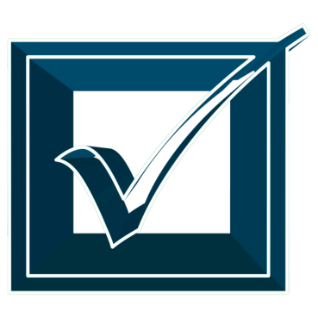
Since 2020 is an election year, your district must hold its organization meeting on November 17, according to the very specific confines found in 100.041(3)(a) F.S.

In addition to meeting the statutory requirements of 1001.371 F.S., by electing a chair and adopting a schedule for regular meetings, the November Organization Meeting is a great time for the school board to discuss protocols for the upcoming year.

Below are some topics to consider adding to your reorganization meeting agenda are:
- re-commitment of vision, mission, beliefs
- meeting and workshop agenda creation policies
- meeting and workshop agenda formats
- annual budget calendar/cycle
- school visitations by board members
- communications with staff
- expectations of reports to the board
- roles and responsibilities of the chair and vice chair
- roles and responsibilities of board members as liaison to community groups/committees/boards

Having important conversations during the organization meeting helps ensure that roles, expectations, and responsibilities are clarified before problems arise.

Staff is available to assist you should you have any questions info@fsba.org.

Updated: August 19, 2020

