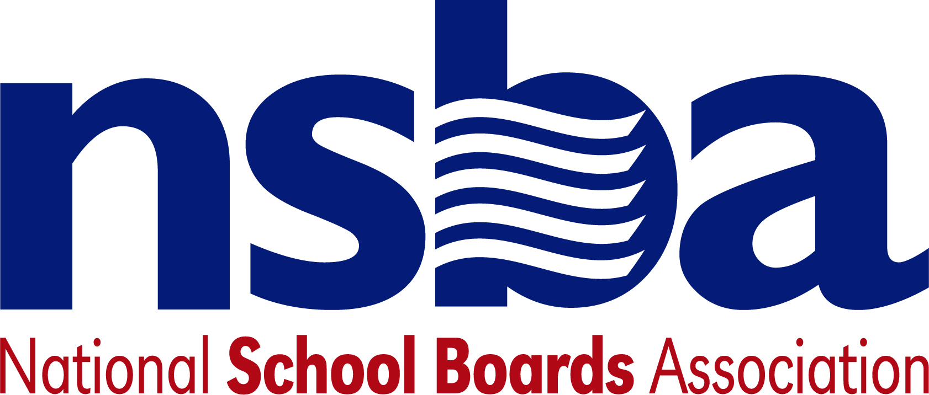

Federal Advocacy & Public Policy Team
August 14, 2020
NSBA Weekly Update

Congressional Update

COVID-19 Relief Legislation Stalled
For the past few weeks, Congressional leaders and White House officials have worked to reach agreement on additional legislation related to the COVID-19 pandemic. These discussions have largely been unsuccessful to date, with House Democrats, Senate Republicans, and the Trump Administration at odds over the size and content of the anticipated aid package. As these talks stalled last week, President Trump signed several Executive Orders in the hopes of pressuring Congressional Democrats on several key issues at the center of the negotiations (issues mostly unrelated to K-12 education). These actions did not have the desired effect and most lawmakers in both chambers have now, , returned back to their states and districts as part of a previously planned August recess. Lawmakers are on notice, however, and could return to the Capitol within 24 hours should a deal be reached by Congressional leaders and the White House in the coming weeks. In the meantime, the 2020 federal fiscal year deadline is fast approaching. This deadline could potentially force lawmakers to combine both issues into an even larger agreement later this fall ahead of the November elections. As these efforts continue, NSBA’s advocacy team will be working with lawmakers to ensure they appreciate the significant funding needs of the K-12 education community.

Kamala Harris Selected as Democratic VP Nominee
On Wednesday, August 12, current Democratic Presidential Candidate, and former Vice President Joe Biden formally announced that he was selecting Senator Kamala Harris (D-CA) as his running mate for the 2020 Presidential election. During Senator Harris’s time as Attorney General for the state of California, she won a multimillion-dollar settlement with a for-profit charter school operator related to alleged deceptive practices. This Congress, she sponsored several pieces of education legislation including bills that seek to provide funding for federally impacted school districts and additional federal funding for childcare. As a former Democratic Primary candidate, Senator Harris strongly advocated for a significant expansion of ESEA Title I funding—a priority shared with Vice President Biden—and a large increase in pay for K-12 teachers among other education priorities. The debate between Senator Harris and Vice President Mike Pence is scheduled to take place on October 7.

Administration Update

New Title IX Regulations for Schools Take Effect Today
The U.S. Department of Education’s new Title IX regulations take effect today after a last-ditch effort seeking intervention by the courts failed. The new rule directs how schools respond to sexual harassment and sexual violence. Every school district must have new policies and procedures in place, paired with required staff training, to ensure compliance with the changed regulations.

White House Releases School Reopening Guidance
Earlier this week, the White House released a high-level set of recommendations and guidance for K-12 schools to physically reopen for learning this year. Titled “Schools Should Reopen Safely,” the guidance is part of a broader push by the Trump administration to encourage schools to mitigate, rather than avoid, risk associated with physically reopening for schooling during the pandemic. The guidance comes after the American Pediatrics Association released data this week showing that at least 97,000 children in the U.S. have tested positive for COVID-19 in the last two weeks of July.

Recent Legislation
H.R.8004 To amend the Head Start Act to extend the duration of grants under such Act, and for other purposes. Sponsor: Rep. Fudge, Marcia L. [D-OH-11]

NSBA Update

CSALS Call on Monday, August 17, 2020 at 4:00 pm eastern: There will be a short CSALS call this Monday to give an update on the current state of play in Washington. The logistics are below:

Topic: CSALS Conference Call
Time: Aug 17, 2020 04:00 PM Eastern Time (US and Canada)
Join Zoom Meeting
https://nam03.safelinks.protection.outlook.com/?url=https%3A%2F%2Fzoom.us%2Fj%2F99883786114&amp;data=02%7C01%7Ccslaven%40nsba.org%7Cdbebe5b5866b48a2be9708d840962029%7C00932d080ddd44afb700c3c0549e4e68%7C0%7C0%7C637330360826659454&amp;sdata=%2BGwKa2H2iXkEveHePufbz%2BJDuR3MA%2B%2BfCCXg59lu3k4%3D&amp;reserved=0
Meeting ID: 998 8378 6114
One tap mobile
+13017158592,,99883786114# US (Germantown)
+13126266799,,99883786114# US (Chicago)
Dial by your location
+1 301 715 8592 US (Germantown)
+1 312 626 6799 US (Chicago)
+1 646 876 9923 US (New York)
+1 408 638 0968 US (San Jose)
+1 669 900 6833 US (San Jose)
+1 253 215 8782 US (Tacoma)
+1 346 248 7799 US (Houston)
Meeting ID: 998 8378 6114
Find your local number: https://nam03.safelinks.protection.outlook.com/?url=https%3A%2F%2Fzoom.us%2Fu%2FabvGokKbkO&amp;data=02%7C01%7Ccslaven%40nsba.org%7Cdbebe5b5866b48a2be9708d840962029%7C00932d080ddd44afb700c3c0549e4e68%7C0%7C0%7C637330360826659454&amp;sdata=Y%2F9LiIYIsYUI%2FtU07kitr4BwR2Uwe0p2igD5pFfpTRY%3D&amp;reserved=0

