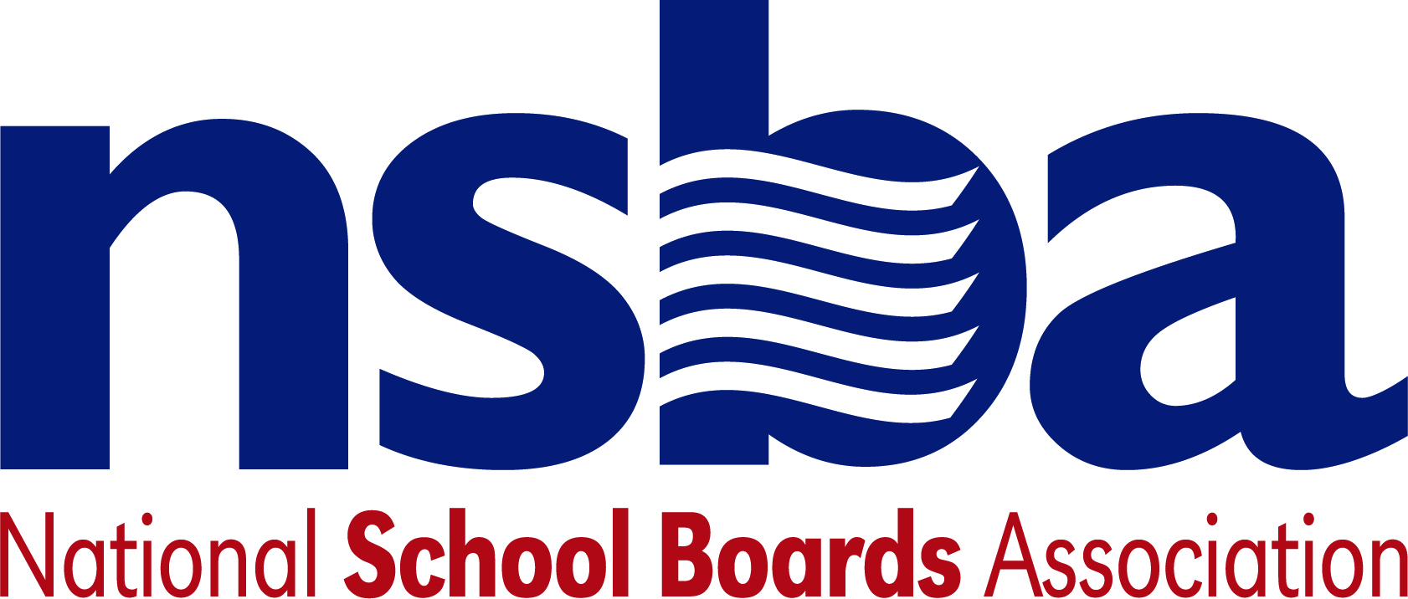

Federal Advocacy & Public Policy Team
August 21, 2020
NSBA Weekly Update

Congressional Update

Impasse on COVID-19 Relief Continues
Congressional leaders from both parties and the Trump Administration continue to be at odds over an expected next round of pandemic relief legislation. Both the House and the Senate are, for all intents and purposes, on their annual August recess, with most lawmakers in their home states and districts. More recently, concerns regarding the administration of the U.S. Postal Service (USPS) have refocused the attention of leaders in both Congressional chambers. On Tuesday, August 18, Senate Republicans re-introduced a narrower version (the education section begins on page 141) of their earlier pandemic relief proposal which included a modest amount of new funding for USPS and $105 billion for education, two-thirds of which would be designated for the K-12 community. The Senate, however, remains out of session and will not formally consider this legislation until they reconvene next month. In the House, leaders plan to temporarily reconvene over the weekend to vote on an emergency USPS funding package. Rank-and-file lawmakers are also pushing for new votes on additional pandemic relief measures as part of this effort. Despite this recent spate of activity, all sides remain far apart on key issues related to a forthcoming relief package.

Administration Update

Trump Administration Moves to Categorize Teachers as Essential Workers
Earlier this week, the U.S. Department of Homeland Security (DHS) issued an advisory memo that updates the federal government’s list of “essential workers” who are encouraged to work, in-person, to contribute to the maintenance of critical national infrastructure. This updated list now includes “workers who support the education of pre-school, K-12, college, university, career and technical education, and adult education students, including professors, teachers, teacher aides, special education and special needs teachers, ESOL teachers, para-educators, apprenticeship supervisors, and specialists” among other occupational fields. While the memo is not legally binding, the change comes amid the Trump Administration’s wider efforts to encourage states and school districts to resume in-person instruction for the upcoming school year.

USDA Extends School Nutrition Waivers
On Thursday, August 20, the U.S. Department of Agriculture (USDA) issued a series of short-term school nutrition waivers for summer food service programs. These existing waivers were set to expire on August 31 and have been temporarily extended through September 30. In a recent response letter to the Senate, USDA has said they lack the legal authority to extend these waivers past this date without additional legislation from Congress. The authority to provide these waivers stems from the second COVID-19 relief bill—the Families First Coronavirus Response Act—enacted earlier this year.

USED Announces New CTE Space Initiative
This week, the U.S. Department of Education unveiled a “Space Mission Challenge for High School Students”. Dubbed “CTE Mission: CubeSat”, the national challenge is aimed at encouraging high school students to build satellite prototypes that support research efforts in space. An informational webinar will be held on September 1 for interested applicants and full proposals are due October 16.

NSBA Update

NSBA Urges Census Focus During August Recess and Political Conventions: There continues to be great concerns over the current low count of the U.S. Census. The COVID-19 pandemic has impacted achieving a complete 2020 Census count. The current self-response rate is less than 70 percent as of August 19, 2020, according to the U.S. Census Bureau. A Census undercount impacts our most vulnerable students and communities. Studies have shown that for each person missed in the 2010 census, their communities lost an average of $3,000 per person, per year for 10 years. Our school districts and communities cannot afford to repeat this loss for the next decade. Therefore, NSBA is focusing on getting assistance from Congress to extend the Census beyond the current scheduled date of completion on September 30, 2020, and in calling for additional dedicated funding to help complete the Census count. This undercount for the Census will impact federal, state, and local resources for our school districts and communities for the next 10 years, unless we act now to ensure a complete count. For additional information about the 2020 Census, please visit the NSBA special Census webpage. You can find the 2020 Census questionnaire here.

