📅 TUESDAY, JUNE 24, 2025
3:30 – 5:00 pm | 📝 Registration | Lobby
5:30 – 7:00 pm | 🎉Welcome Reception | Hospitality Villa
📅 WEDNESDAY, JUNE 25, 2025
8:00 – 8:45 am | 📝Registration | Lobby
9:00 – 4:00 pm | 📝Registration | Jacaranda Hall Foyer
8:00 – 8:45 am | 🍳 Breakfast | Banyan Breezeway
8:45 – 10:15 am | 🎤 Opening Session Keynote | Banyan/Citrus
10:15 – 10:30 am | Break
10:30 – 11:30 am | BREAKOUT SESSIONS I
11:30 – 12:30 pm | Lunch | Banyan Breezeway
12:30 – 1:30 pm | BREAKOUT SESSIONS II
1:30 – 1:45 pm | Break
1:1:45 - 2:45 pm | BREAKOUT SESSIONS III
3:00 – 3:45 pm | 🪑 Annual Convention Managers Business Meeting | Glades
3:00 – 3:45 pm | 🪑 Annual Member Engagement Business Meeting | Spotted Curlew
4:00 – 4:45 pm | 🤝 Speed Networking Activity | South Lawn
8:00 – 9:30 pm | 🎉 Hospitality time | Hospitality Villa
📅 THURSDAY, JUNE 26, 2025
7:30 – 3:00 pm | 📝 Registration | Jacaranda Hall Foyer
8:00 – 8:45 am | 🍳 Breakfast | Banyan Breezeway
8:45 – 10:00 am | 🎤 General Session Keynote | Banyan/Citrus
10:00 – 10:15 am | Break
10:15 – 11:15 am | BREAKOUT SESSIONS IV
11:30 – 12:30 pm | Lunch | Banyan Breezeway
12:30 – 1:30 pm30 pm | BREAKOUT SESSIONS V
1:30 – 1:45 pm | Break
1:45 – 2:45 pm | BREAKOUT SESSIONS VI
3:00 – 4:15 pm | 🪑 Annual Fed-Trainers Business Meeting | Banyan/Citrus
3:00 – 4:00 pm | 🪑 Annual Fed-Tech Business Meeting | Spotted Curlew
3:00 – 4:00 pm | 🪑 Annual Communications Business Meeting | Glades
8:00 – 9:30 pm | 🎉Hospitality time | Hospitality Villa
📅 Friday, June 27, 2025
8:15 – 9:00 am | 🧳 Check out of your room and bring your luggage with you!
8:15 – 9:00 am | 🍳Breakfast | Banyan Breezeway
9:15 – 10:15 am | 📢 Update from Idaho – Host of the 2026 Conference  🎤 General Session Keynote | Banyan/Citrus
10:30 – 11:30 am | 🎬 Activity, Takeaways, Final Words, and Adjournment | Banyan/Citrus

DAILY AGENDA

📅 Tuesday, June 24, 2025
3:30 – 5:00 pm | 📝 Registration | Lobby
5:30 – 7:00 pm | 🎉Welcome Reception | Hospitality Villa
📅 Wednesday, June 25, 2025
8:00 – 8:45 am | 📝Registration | Lobby
9:00 – 4:00 pm | 📝Registration | Jacaranda Hall Foyer
8:00 – 8:45 am | 🍳 Breakfast | Banyan Breezeway
8:45 – 10:15 am | 🌴 Welcome to Florida!  🎤 Opening Session Keynote:  A Humorous Look at Personal, Professional and Family Success!  In this interactive, high-energy, and humorous presentation, Patrick T. Grady highlights the critical role that school board association staff play in empowering school board members to lead through impactful policymaking. By emphasizing leadership by example, enthusiasm, and motivation, Grady underscores the importance of equipping policymakers with practical skills to positively influence districts, schools, and ultimately, students. Recognizing that school board members create the framework supporting educators and students, this session reinforces association staff’s essential role in preparing board members to build strong educational policies that pave the way for students' success in college, careers, and life.  Patrick Grady, President & CEO of Today ‘n Tomorrow’s Enterprises, Inc.  Sponsored by:  | Banyan/Citrus
10:15 – 10:30 am | Break
10:30 – 11:30 am | Breakout Sessions I
10:30 – 11:30 am | 🏛️ Trainers  No More Point Chasing! Making Board Member Certifications and Awards More Purposeful  **Wednesday, June 25 - Continued**  In 2024, we revamped our Board Member Certifications and Governance Team Award to make them more meaningful and purposeful. Join me as I share how we restructured these programs around the themes of Learning, Growing, and Leading and incorporated more choice. I'll discuss  the changes from the old to the new, how we gathered feedback from board members throughout the process, and how we are implementing and communicating the new requirements to our members.  Lisa Nieder, Director of Board Development, Missouri  John Downs, Director of Board Development, Missouri | Banyan/Citrus
10:30 – 11:30 am | 🖥️ Technology  Security in the Cloud  This presentation explores the security ecosystem within Microsoft Azure and some best-of-breed tools focusing on services that help safeguard cloud environments. We will explore:  • Threat Detection and Response  • Web Application Firewalls  • Distributed Denial of Service  • Penetration Testing including SAST and DAST  • Security Information and Event Management (SIEM) systems  • Azure Monitoring  Do you participate in any compliance programs? Security tools and services form layers of defense in the security of your environment. But are you following best practices consistently? We will explore some of the standard’s organization and discuss our experiences in compliance.  Tim Covert, Systems Architect, Georgia | Spotted Curlew
10:30 – 11:30 am | 📢 Communications  Beyond the Logo: ASBA’s Rebrand Journey and the Power of RPIE  The Arizona School Boards Association (ASBA) embarked on a transformative rebranding journey not just to update its visual identity, but to ensure its members and stakeholders felt seen, heard and represented in the organization they support. This session will take attendees behind the scenes of ASBA’s rebrand, demonstrating how the RPIE (Research, Planning, Implementation, and Evaluation) process guided every step of the campaign.  For the first time in ASBA’s history, members played an active role in shaping the brand’s identity, with their voices, values, and needs driving the process. Through extensive member engagement,  strategic storytelling, and a commitment to inclusivity, ASBA crafted a brand that truly reflects the diverse communities it serves. The rebranding effort unfolded amidst significant organizational challenges, requiring thoughtful communication strategies to ensure buy-in, foster trust and reinforce ASBA’s role as a champion for Arizona’s public schools.  Heidi Vega, Communications Director, Arizona  Sarah James, Board Support and Field Services Specialist, Arizona | Glades
10:30 – 11:30 am | 📅 Convention Managers  What Students Need Next: Designing Programs that Prepare, Empower, and Inspire  Get an inside look at how the Colorado Association of School Boards (CASB) developed the Student Leadership Academy, a student program held during our annual convention. Participants will explore the intentional process used to design the academy, the structural framework that supports its success, and how student voice and leadership have been embedded at every stage. The session highlights how students are engaged as co-creators and empowered to take on leadership roles in shaping and delivering the experience. Attendees will leave with practical insights and replicable strategies for developing similar student-centered programs within their own associations.  Leslie Bogar, Deputy Executive Director, Colorado  Tracy DeMeo, Event Specialist, Colorado  Emily Thompson-Anderson, Member Engagement Specialist, Georgia | Chart Room
11:30 – 12:30 pm | Lunch | Banyan Breezeway
12:30 – 1:30 pm | Breakout Sessions II
12:30 – 1:30 pm | 🏛️ Trainers  Communicating as a Leader  Engage with time-tested practices that improve communication, build trust, and strengthen relationships. The past two years, ISBA has used grant funds to support improved communication and relationships among Idaho school boards, superintendents, staff, and community. This includes large and small workshops, trust-building content with boards and staff, and larger community listening sessions. These efforts often support ongoing and additional board  **Wednesday, June 25 - Continued**  development work and strategic planning. Gain insight from our strategies and materials to identify tools you can use to complement work in your state.  Phil Gore, Chief Learning Officer and Jayson Lloyd, Board Development Specialist, Idaho | Banyan/Citrus
12:30 – 1:30 pm | 🖥️ Technology  Security, Licensing, and Integrations: Reduce Costs and Enhance Security School Board Associations face the unique challenge of balancing limited budgets with increasing security demands. During this session, we will discuss the impact of ransomware and how to enhance your association's security while reducing overall IT costs through smarter Microsoft Office365 licensing and cloud based integrations.  Dan Clarke, Systems Engineer, Nebraska  Craig Caples, Director of Technology, Nebraska | Spotted Curlew
12:30 – 1:30 pm | 🤝 Member Engagement  Building Bridges: Engaging Newly Elected Board Members Through Early Connection  The New Jersey School Boards Association has developed a clear plan to engage newly elected school board members in our events. We start with a pre-election regional Candidate's Briefing, where we provide potential candidates with essential information and answer their questions. After their election, we invite them to a '3Rs Training,' which covers their Roles, Responsibilities, and Resources. We conveniently schedule this training alongside one of our 21 county meetings. By implementing this approach across all counties, we help new members connect with others and foster a desire to participate in future meetings. Discover how the NJSBA engages with our newly elected board members!  Robert Acerra, County Activities Coordinator, New Jersey | Glades
12:30 – 1:30 pm | 📅 Convention Managers  Crisis Plans: Building a Blueprint for the Unexpected  The Georgia School Boards Association will present its comprehensive crisis management plan, developed to ensure organizational readiness in the face of unexpected events. This session will offer an inside look at how GSBA has structured its internal crisis response protocols and will outline critical components every association should consider when developing a crisis plan for conferences and large-scale events. Attendees will leave with practical guidance and key takeaways to strengthen their own organization's preparedness.  Leigh Crow, Board Development Program Manager: Conferences & Events, Georgia | Chart Room
1:30 – 1:45 pm | Break
1:1:45 - 2:45 pm | Breakout Sessions III
1:1:45 - 2:45 pm | 🏛️ Trainers  One Key to Success for Goal Setting and Strategic Planning  Up-to-date Goals and a Strategic Plan are a first step in focusing on student success. One key to this success is involving the right people. Who should you involve? When should they be involved? Why should they be involved? How do you involve them? Where do you find those who should be involved? Why does this matter? Ensure your School Board speaks for the entire school community by involving the right people in setting goals focused on student success.  Gail Gilman, M.Ed., CFCS, Director of Strategic Planning and Board Leadership, Minnesota  Kristy Cook, Associate Director of Board Development, Minnesota | Banyan/Citrus
1:1:45 - 2:45 pm | 🖥️ Technology  Artificial Intelligence as a Core Competency  What is AI, and how big is this moment?  · AI is more than just ChatGPT and Copilot  · What does this AI moment compare to in history  What is on the horizon for AI?  · New AI developments  · Emerging AI technologies  · How do we bridge the gap to the mass public?  AI-Enhanced Adaptive Learning Systems  · Discuss how AI can personalize education by adapting to each student's learning pace,  preferences, and knowledge gaps in real-time. This technology can help educators provide  more individualized attention, even in large classroom settings.  AI Literacy as a Core Competency  · Discuss the importance of teaching students AI tools and how to understand their  capabilities, limitations, and societal impacts as a fundamental skill for future careers  across all disciplines.  How to prepare for future careers in AI  · Identify and explain emerging careers in AI.  Edward Kirk, Founder - IT Engineer, KeenPlex Technologies LLC | Glades
1:1:45 - 2:45 pm | **Wednesday, June 25 - Continued**  📢 Communications  Dim Bulbs and Bright Ideas: Sharing Successes and Missteps  Every professional has experienced that exhilarating moment when a creative idea takes off, or that challenging situation when a project unexpectedly fizzles out. The "Dim Bulbs and Bright  Ideas" session provides a dynamic platform for participants to openly share and discuss their most memorable projects, campaigns, and events from the past year.  Participants will have the opportunity to:  - Present a Bright Idea, celebrating successful projects and highlighting key factors that led to their positive outcomes.  - Share a Dim Bulb moment, openly reflecting on projects that didn't go as planned, exploring reasons behind the challenges, and identifying lessons learned.  - Dive into the "Good, Bad, and Ugly" of a single project, offering a comprehensive review of its highlights and pitfalls.  Join us to illuminate your experiences, spark valuable conversations, and leave inspired by fresh insights and new approaches.  Bridgett Johnson, Communications Manager, Georgia | Spotted Curlew
1:1:45 - 2:45 pm | 📅 Convention Managers  Streamlining Operations: Software Solutions That Work  Explore practical tools that can simplify your workflow and improve team coordination. This session will highlight how Wrike supports project management, how Expo Pass can streamline badge creation and event check-ins, and how different associations handle staff assignments. Please be prepared to share your own tools, tips, and best practices for managing logistics and staff roles efficiently.  Ceri Goulter, Director of Marketing and Member Events, Kansas | Chart Room
3:00 – 3:45 pm | 🏛️ Trainers  Superintendent Evaluation That Works  Based on feedback from superintendents and board members, the Missouri School Boards' Association joined forces with the state superintendent association and Department of Elementary and Secondary Education to create a refined evaluation process that works for superintendents and their school boards. Using a four-step model, the cycle is designed to foster continuous learning and growth by focusing on high-quality collaboration. This session will provide an overview of the evaluation model and allow time for participants to share their own best practices in assisting boards with superintendent evaluation and development.  John Downs, Director of Board Development, Missouri | Banyan/Citrus
3:00 – 3:45 pm | 🪑 Annual Convention Managers Business Meeting | Glades
3:00 – 3:45 pm | 🪑 Annual Member Engagement Business Meeting | Spotted Curlew
4:00 – 4:45 pm | 🤝 Speed Networking Activity | South Lawn
8:00 – 9:30 pm | 🎉Hospitality time | Hospitality Villa
📅 Thursday, June 26, 2025
7:30 – 3:00 pm | 📝 Registration | Jacaranda Hall Foyer
8:00 – 8:45 am | 🍳 Breakfast | Banyan Breezeway
8:45 – 10:00 am | 🌴 Test your Florida knowledge!  🎤 General Session Keynote:  Currents of Change: The Unseen Force Behind Board Leadership  Behind every effective school board stands a powerful current, YOU! While board members navigate the visible waters of governance, your expertise creates the depth and momentum that propels public education forward.You may not stand at the podium, but you shape the message. You don’t cast the votes, but you equip those who do. You’re not in the spotlight, but your work powers the beam. Your efforts ripple from boardrooms to classrooms to communities, making a difference that extends far beyond what’s visible. When students succeed and communities thrive, your influence is there, often beneath the surface, but creating the undercurrent of every  **Thursday, June 26 - Continued**  achievement. You don't just facilitate governance, you amplify impact. You are the essential force behind every wave of positive change.  Andrea Messina, Chief Executive Officer, Florida School Boards Association  Sponsored by:  | Banyan/Citrus
10:00 – 10:15 am | Break
10:15 – 11:15 am | Breakout Sessions IV
10:15 – 11:15 am | 🏛️ Trainers  Mistakes Superintendents Make  This presentation will discuss common mistakes superintendents make and how they can affect the work of the board of education and the performance of the district. This presentation has been given to numerous supereintendent certification preparation classes.  Nick Caruso, Associate Executive Director for Field Services and Technology, Connecticut | Banyan/Citrus
10:15 – 11:15 am | 🖥️ Technology  Impactful Insights: Fueling Engagement through Your Association CRM  Discover how integrating a CRM into your association management tech stack can provide actionable insights, improve relationships, and optimize processes. This presentation will highlight the benefits of automated marketing, including streamlined communication, personalized member experiences, and enhanced engagement. Learn to create targeted campaigns, automate tasks, and make informed business decisions using data-driven strategies.  Jason Marentette, Director of Information Services and Technology, Michigan  Jessie Stickler, Director of Communication, Public Relations and Marketing, Michigan | Spotted Curlew
10:15 – 11:15 am | 📢 Communications  Hot Topics & Real Talk: Solution Share and Idea Exchange  Join your Comms peers for a collaborative session designed just for you. This forum is your space to surface hot topics, share best practices, and swap strategies that are working in your state. Be prepared to share ideas on the following topics:  • AI policy/AI summit  • ICE/Federal Changes, including changing language  • Dealing with pop-up associations offering School Board Member training  • Using your partners at NSPRA, state school PR associations, and other associations  Come ready to contribute, connect, and leave with fresh ideas you can take back to your district.  Greg Abbott, Director of Communications, Minnesota | Chart Room
10:15 – 11:15 am | 📅 Convention Managers  Let’s Talk Trade Shows-Strategies for Engaging Board Members with Vendors  Looking for new ways to make your trade show a can't miss staple at your annual conference? In this session, we'll highlight some of the ways Iowa has shaped our trade show into a high-quality, engaging component of our annual convention that leaves a lasting impression on school board members and keeps vendors coming back year after year. We'll share strategies we use to stay connected with vendors throughout the year, highlight the trade show's value, and craft high-value sponsorship opportunities. This session will include dedicated discussion time for convention managers to share successes, challenges, and creative ideas. Join us to swap strategies for delivering a trade show that stands out!  Emily Miller, Convention and Events Director, Iowa  Jeff Rohrick, Membership Specialist, Iowa | Glades
11:30 – 12:30 pm | Lunch | Banyan Breezeway
12:30 – 1:30 pm30 pm | Breakout Sessions V
12:30 – 1:30 pm30 pm | 🏛️ Trainers  Eight lessons on Team Building, Leadership, and Life Learned Running 196 Miles  In April of 2022 I ran the length of New Jersey 196 miles over 65 hours. It was an epic journey with hard to believe occurrences. Yet the journey held many lessons on school governance such as hints on team building, the importance of goal setting, what to do when things go wrong, and finally the power of kindness. The presentation mixes storytelling, humor, and experiences in school governance training.  Ray Pinney, Chief Membership Engagement Officer, New Jersey | Banyan/Citrus
12:30 – 1:30 pm30 pm | 🖥️ Technology  Empowering Associations: Crafting Connected Digital Ecosystems for School Board Associations  **Thursday, June 26 - Continued**  Join us to revolutionize your state school board association’s digital strategy in this dynamic session. We’ll dive into designing intuitive websites, leveraging powerful association management software, and creating seamless membership portals to boost engagement and streamline  operations. Additionally, explore the power of third-party software integrations to enhance functionality, connect critical tools, and create a cohesive digital ecosystem. Gain practical  insights and tailored solutions to modernize your infrastructure, improve member connectivity, and drive efficiency, all while meeting the unique demands of school board associations.  Craig Caples, Director of Technology, Nebraska | Spotted Curlew
12:30 – 1:30 pm30 pm | 📢 Communications  Public Education Campaigns: Best Practices & Collaborative Insights  Explore effective strategies for promoting public education through successful campaigns. Hear firsthand insights and experiences from state-level initiatives in North Carolina, Minnesota, and Georgia. Discover how partnering with influencers can amplify positive messaging, and participate in an interactive discussion on practical methods to handle negativity and criticism in online spaces. Bring your questions and experiences to this collaborative session designed to empower attendees with actionable tools and shared best practices.  Ben Christoph, Assistant Director of Communications, North Carolina | Chart Room
12:30 – 1:30 pm30 pm | 🤝 Member Engagement  Using Data to Drive Your Member Engagement Strategy  This session will explore how school board associations can use data to better understand member behavior, preferences, and needs—so you're not just guessing what works. We'll look at practical, approachable ways the Georgia School Board Association collects and analyzes data from events, services used, and member interactions to inform GSBA’s engagement strategy. Whether you're new to data or looking to refine your approach, you'll leave with ideas for utilizing research to tailor outreach, boosting participation, and showing real impact through measurable results. We'll also discuss how to effectively involve your association's Board of Directors in implementing your engagement strategy, turning them into active ambassadors and strategic partners.  Julie Rhame, Director of Member Engagement, Georgia | Glades
1:30 – 1:45 pm | Break
1:45 – 2:45 pm | Breakout Sessions VI
1:45 – 2:45 pm | 🏛️ Trainers (Open to All Tracks)  Ensuring AI Fidelity in an Ever-changing World  In this workshop, we’ll explore how to ensure that AI technologies benefit all segments of society. We will focus on the need to create and utilize AI systems that are ethical and transparent. Join us as we delve into strategies for creating AI systems that benefit all in our ever-changing world.  Terrance Peterson, Senior Director of Growth and Stakeholder Engagement, Missouri | Banyan/Citrus
3:00 – 4:15 pm | 🪑 Annual Fed-Trainers Business Meeting | Banyan/Citrus
3:00 – 4:00 pm | 🪑 Annual Fed-Tech Business Meeting | Spotted Curlew
3:00 – 4:00 pm | 🪑 Annual Communications Business Meeting | Glades
8:00 – 9:30 pm | 🎉Hospitality time | Hospitality Villa
📅 Friday, June 27, 2025
8:15 – 9:00 am | 🧳 Check out of your room and bring your luggage with you!
8:15 – 9:00 am | 🍳Breakfast | Banyan Breezeway
9:15 – 10:15 am | 📢 Update from Idaho – Host of the 2026 Conference  🎤 General Session Discussion  Carol Cook, FSBA Consultant, Former School Board Member, Pinellas County Schools  Dr. Michael Grego, Ed.D., Former Superintendent, Pinellas County Schools  What You Do Matters!  This session brings together a superintendent and school board member to share their firsthand experiences on how effective training, thoughtful conference planning, and strategic  **Friday, June 27 - Continued**  communications directly strengthen school governance and student outcomes.  Attendees will gain a deeper understanding of the direct impact their work has on district leadership and ultimately on student success. This session offers a unique opportunity to hear from the very stakeholders you serve about how you make a difference in the students they serve.  Join us for this candid conversation about the critical relationship between your work and effective school governance, with time for Q&A and collaborative discussion as well. | Banyan/Citrus
10:30 – 11:30 am | 🎬 Activity, Takeaways, Final Words, and Adjournment | Banyan/Citrus
🎤 Keynote Speakers
📅 WEDNESDAY, JUNE 25, 8:45 AM

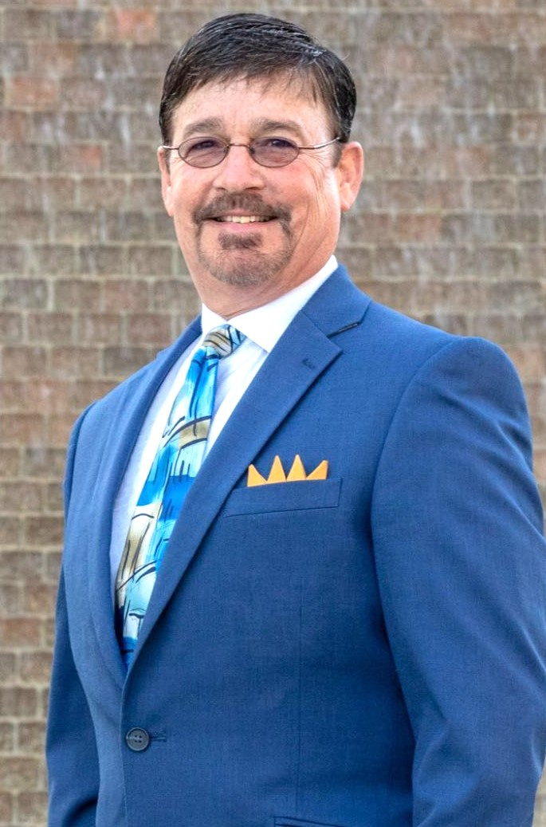
Patrick Grady, President & Chief Executive Officer, Today ‘n Tomorrow’s Enterprises, Inc.
Professional speaker, trainer and entertainer, Patrick Grady brings a uniquely diverse background to every stage he
steps on. His career spans roles in agriculture, education, government, and entertainment. From surveying land for the
Florida Department of Agriculture and serving with the Sergeant-at-Arms Office in the Florida Legislature, to teaching
in middle and high schools and leading as Vice President of Tomorrow’s America Foundation, Patrick’s professional
journey is anything but ordinary.

He is also a certified stage hypnotist, the founder of a national full-service audio-visual company, and has spent more
than 25 years as a full-time professional speaker, having inspired over three million people across the globe. With a
résumé this varied, some might say he just doesn’t like to sit still – or can’t keep a job.

📅 THURSDAY, JUNE 26, 8:45 AM

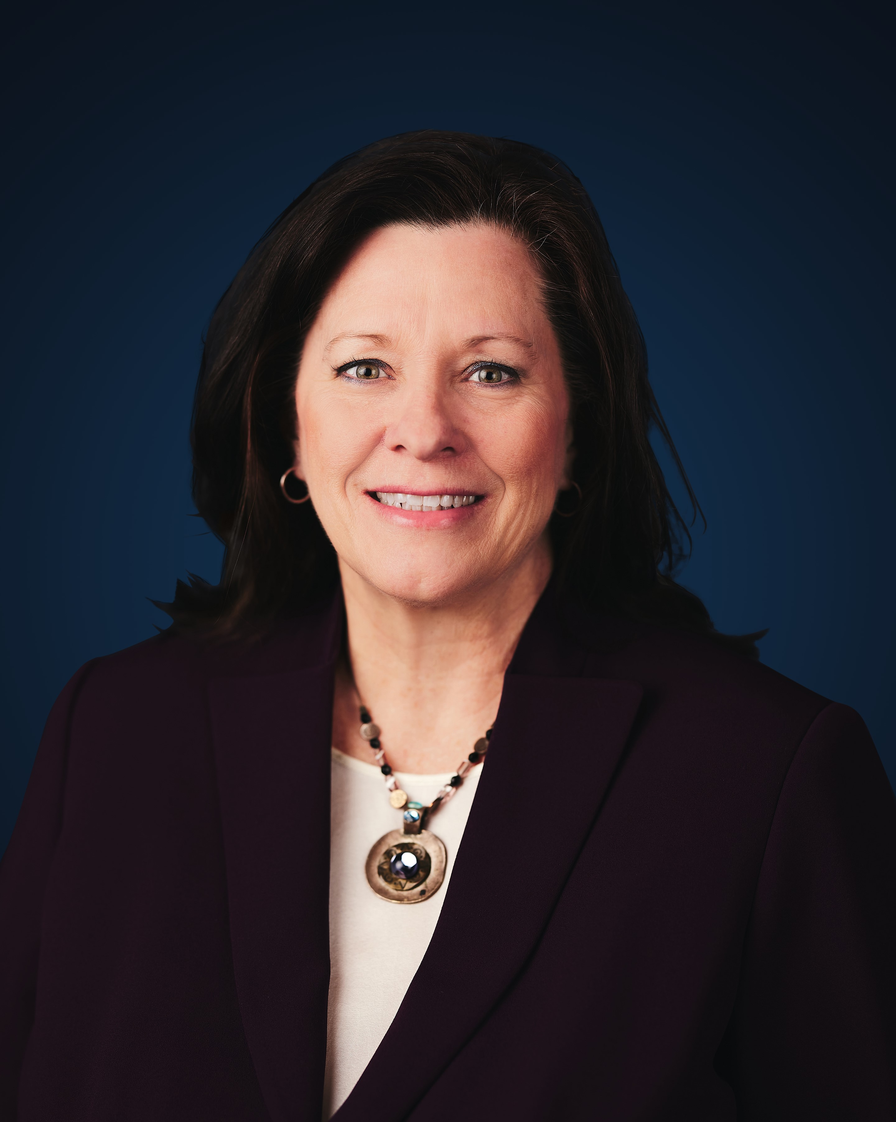
Andrea Messina, Chief Executive Officer, Florida School Boards Association
Andrea Messina has served as Chief Executive Officer of the Florida School Boards Association (FSBA) since July 1,
2015. With a background as an English teacher, Charlotte County School Board member, and FSBA Professional
Development Coordinator, she offers a broad and insightful perspective on educational leadership. As CEO, Andrea
leads all facets of the organization’s operations, working in close partnership with the Board of Directors and staff to
advance FSBA’s mission through strategic initiatives, impactful programming, and statewide engagement. She is also
responsible for securing and managing the resources that sustain the Association’s financial health.
📅 FRIDAY, JUNE 27, 9:15 AM J

ne
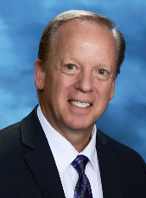
Mike Grego, Ed.D. Former Superintendent, Pinellas County Schools
Dr. Michael Grego, Ed.D., is an innovative leader who served in public education in the state of Florida for 42
years, with the last ten of his career as superintendent of Pinellas County Schools. A nationally recognized
administrator, Dr. Grego served as the 2020-2021 president of the Florida Association of District School
Superintendents and was the 2018 Florida Superintendent of the Year. Under Dr. Grego’s leadership, Pinellas
County Schools earned districtwide accreditation, achieved record-high graduation rates, and successfully
narrowed achievement gaps between minority students and their peers. During his tenure, Pinellas realized
tremendous growth in magnet, STEM and career education programs.

Twice during his leadership, the district earned the top score in Florida for offering the best choices for parents.
Pinellas has also received national recognition for its digital curriculum and exemplary use of technology, and for
preparing high school students for success in college, career and life.

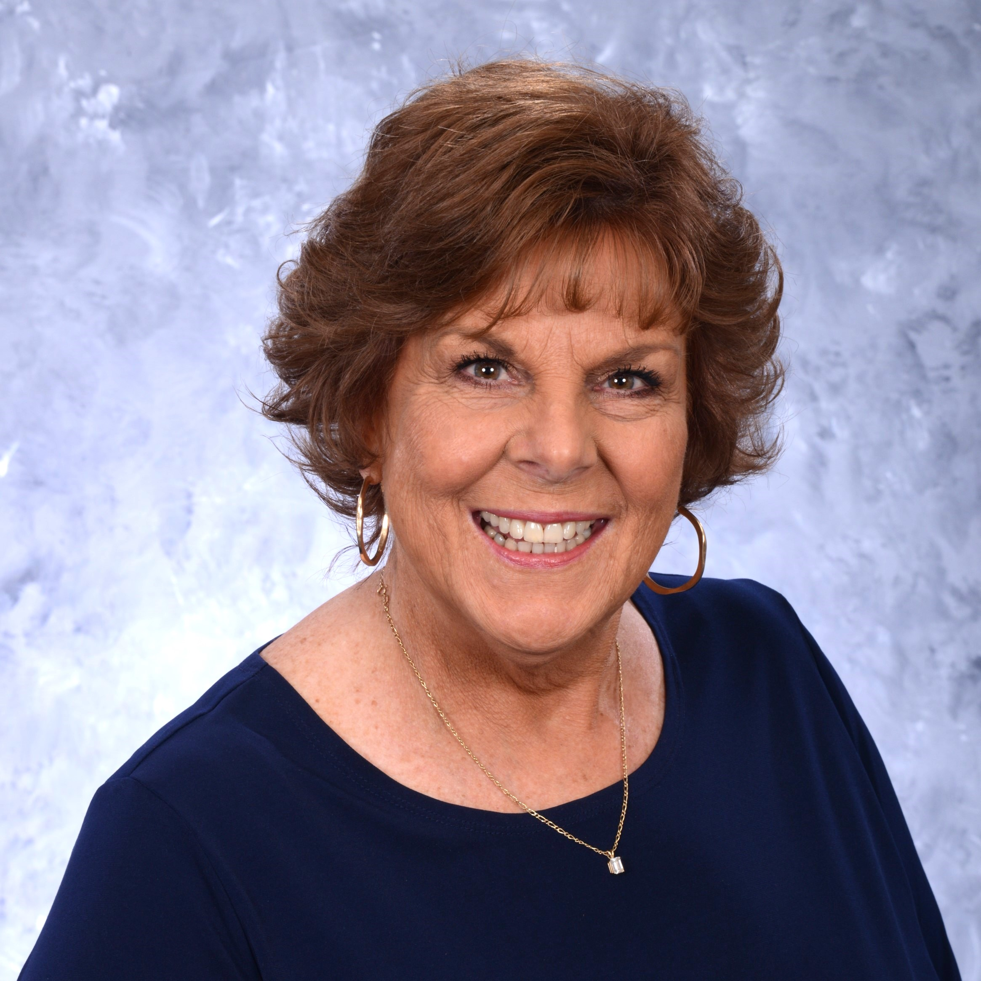
Carol Cook served on the Pinellas County School Board from November of 2000 to 2024. During that time, she earned the the Certified Board Member designation and served on or was chairman of several FSBA committees. She is a former
teacher in Pinellas County. Before her election, Carol served on the Florida PTA Board of Directors for nine years. Her
service included Pinellas County Council President, Vice President for Regions and Councils, and Vice President for
Leadership.

Carol has been awarded the Maureen M. Flynn Children’s Angel Award for her Advocacy work on behalf of
children and youth. She is a recipient of the Florida School Music Association's School Board Member of the Year. The
Council of Great City Schools elected Carol as a finalist for School Board Member of the Year and in 2024, she was
awarded the Dillenger-McCabe Putting Children First Leadership Award. Carol is currently a member of the FSBA
Leadership Services Team where she mentors and trains Florida’s school board members.

