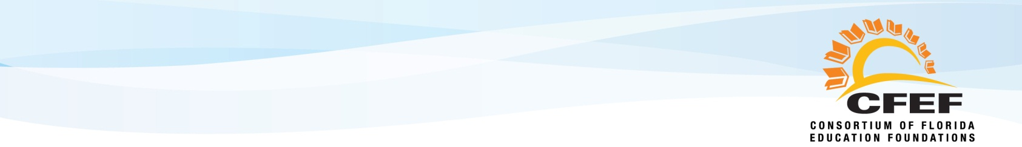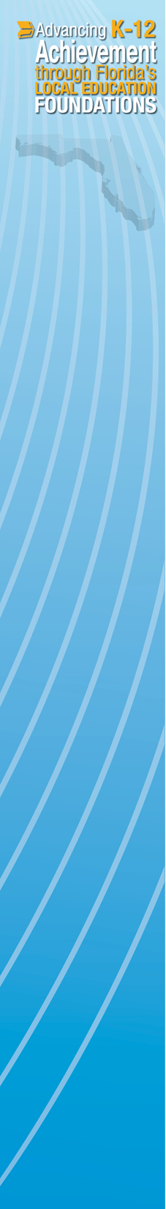

Two Florida school system leaders were recognized for their exemplary leadership by the Consortium of Florida Education Foundations (CFEF) December 3rd at the 70th Annual Joint Conference of Florida School Boards Association and Florida Association of District School Superintendents in Tampa. They were chosen from among several local nominees for championing community and business involvement in education through their local education foundations.

“We think it’s important to celebrate the school district leaders who make it a priority to foster private-sector support of public education through their local education foundations,” said Carman Cullen-Batt, CFEF Membership Chair. “This year’s recipients are outstanding examples of the many individuals who advocate for our local education foundations and help us raise more than $45 Million annually to support our students, teachers and schools.”

This year’s STAR awards were sponsored by Bank of America, a strong and longtime supporter of local education foundations as well as a supporter of statewide efforts to strengthen education foundations through the CFEF.

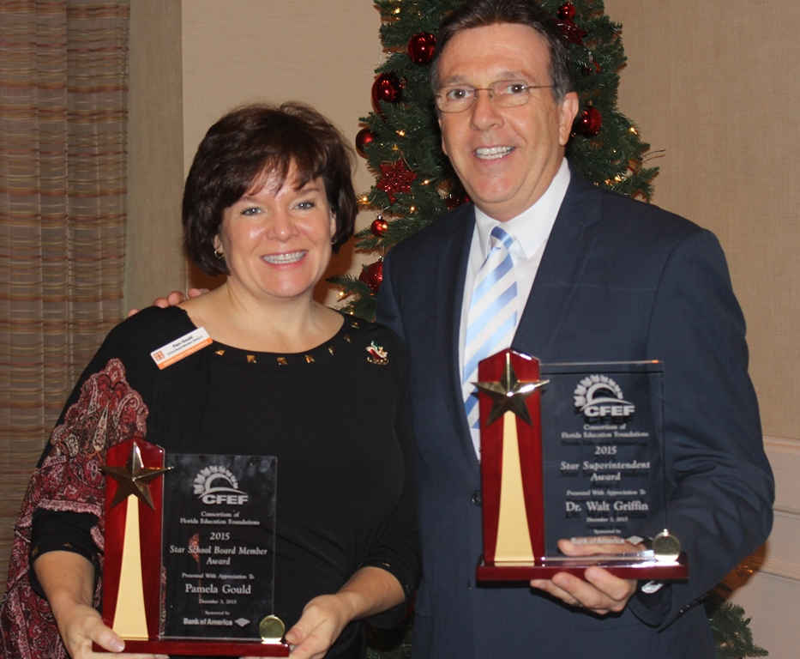

**CFEF 2015 STAR Award Recipients:**

Dr. Walt Griffin – Superintendent, Seminole County

Pam Gould – School Board Member, Orange County

Established in 1987, the CFEF is the membership organization for Florida’s county wide school district local education foundations with a mission to advance student achievement in Florida by increasing private sector investment and involvement in public education. The CFEF now represents 61 member foundations with 1,100 business and community leaders serving as volunteer board members and has offered the annual STAR awards since 2007.

To learn more about the CFEF or connect directly to a member local education foundation, visit [www.educationfoundationfl.org](http://www.educationfoundationfl.org) or contact Mary Chance, president, at (352) 338-0250 or [marychance@cfef.net](mailto:marychance@cfef.net).

**Outstanding Superintendent and School Board Member Receive Statewide “STAR” Recognition from Consortium of Florida Education Foundations**