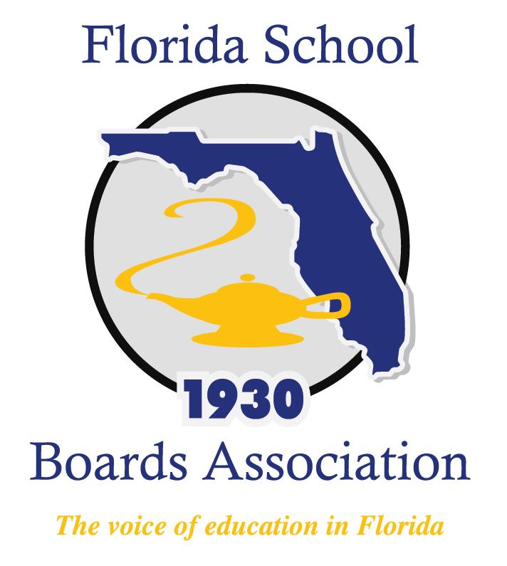
2018 Boardsmanship Forum Agenda

Mission Inn at Howey-in-the-Hills, FL
Friday, January 26, 2018
6:30 – 8:00 a.m. Help yourself to the Breakfast Buffet in La Hacienda
8:00 a.m. Welcome and Startups
Public Education: Then and Now
How Do You Learn?
Break
Exploring Governance Roles
Lunch
How Do You Receive Information
Boardsmanship with Andy
2:00 p.m. Closing

