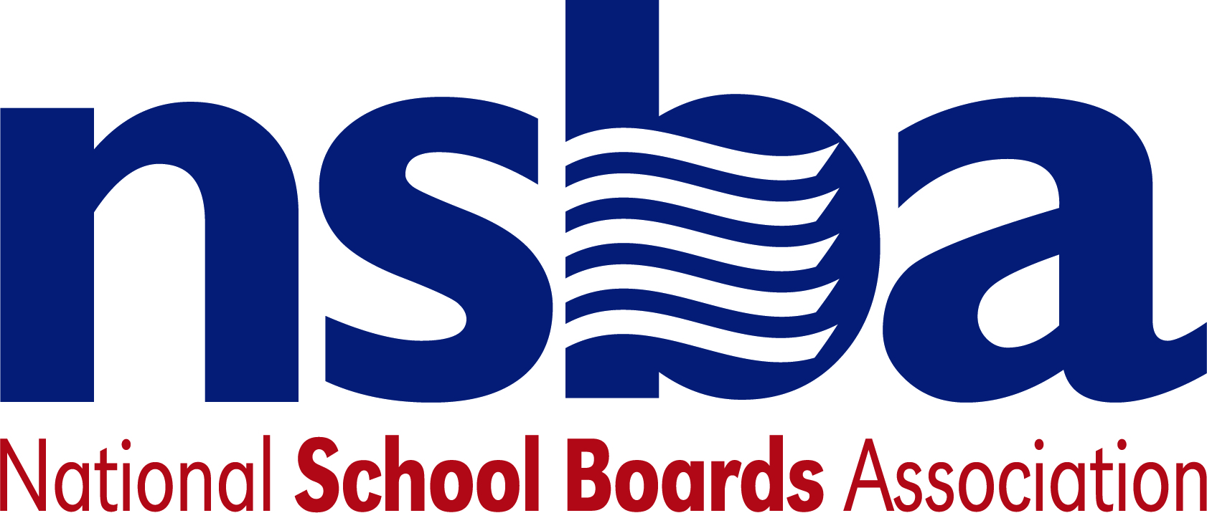

Federal Advocacy & Public Policy Update
January 31, 2020
NSBA Weekly Policy Update

Congressional Update

House Subcommittee on Communications and Technology Hearing on Digital Equity
On Wednesday, the House Subcommittee on Communications and Technology held a hearing titled "Empowering and Connecting Communities through Digital Equity and Internet Adoption”. Full committee Chairman Pallone (D-NJ) said “it is increasingly difficult to participate in today’s economy without internet service, and yet millions of Americans who are wired for internet access aren’t actually connected” due to cost. Subcommittee Chairman Doyle (D-PA) emphasized but that we have to "dig deeper" because many Americans have broadband access, but elect not to sign-up. Many Americans also lack the basic skills to use digital technologies. Ranking Member Walden (R-OR) agreed, saying "[w]hile the internet has been largely adopted in a relatively short span of time, there are still millions of Americans who do not have access to the internet in their homes. In some cases, it is because high-speed broadband has not been deployed, an issue that this Committee has focused on for many years." The committee heard testimony from witnesses from NC Department of Information Technology, the American Enterprise institute, National Digital Inclusion Alliance, the Director of Digital inclusion for Detroit, MI, and Georgetown Law Institute for Technology Law and Policy.

Administration Update
President to Deliver State of the Union and FY21 Budget
President Trump is slated to deliver his State of the Union speech on Tuesday, February 4. The following week, on February 10, the White House is expected to release the President’s FY21 budget proposal. The release of the proposal will kick off the FY21 appropriations season which will have appropriators working quickly to negotiate budgets for FY21. NSBA will be monitoring both the State of the Union for any mentions of education policy, as well as the proposals the President’s Budget will make on funding for the Department of Education and other programs of importance to school board members.

Department of Education Announces new National Assessment Governing Board Members
The Department of Education announced new members of the National Assessment Governing Board which include Haley Barbour (former Mississippi Governor), Christine Cunningham (professor of education and engineering at the College of Education at Pennsylvania State University), and Patrick Kelly (AP U.S. Government and Politics and coordinator of professional learning for Richland School District 2 near Columbia, S.C). Their terms began on October 1, 2019 and will end on September 30, 2023. The national Assessment Governing Board is the independent body that sets policies for the National Assessment of Educational Progress (NAEP).

NSBA update

Due to the Advocacy Institute, there will be no CSALS conference call next week. We will let you know when the next call is scheduled.

For those attending AI, we remind you logistics and scheduling will be more challenging this year due the State of the Union address and its related activities. We encourage everyone to download the AI App for event logistical information.

Have a nice weekend.

