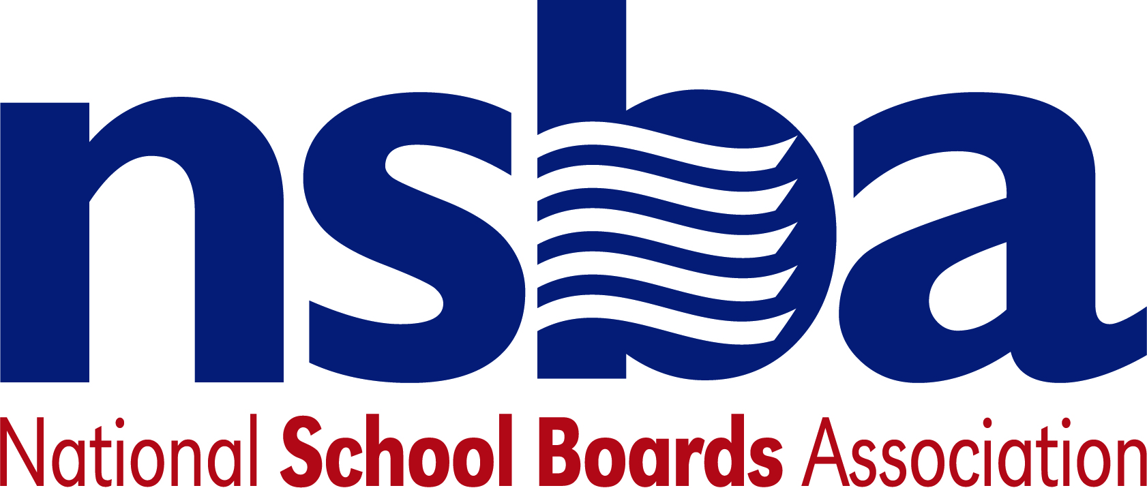

Federal Advocacy & Public Policy Update
February 14, 2020
NSBA Weekly Policy Update

Congressional Update

President Trump Submits Fiscal Year 2021 Education Budget Request to Congress
The White House released President Trump’s fiscal year 2021 budget request this week, including his proposed budget for the Department of Education. The president asked Congress to cut the Department of Education’s total budget by 8.4% and urged legislators to combine 29 Elementary and Secondary Education Act programs – including Title I – into a single funding stream called the “Elementary and Secondary Education for the Disadvantaged Block Grant”. Under the president’s proposal, the new block grant would receive $19.4 billion, which represents a $4.8 billion cut to the covered programs. NSBA does not expect Congress to adopt the president’s request – he has sought similar cuts every year of his tenure - but the size of the proposed reductions is notable. Delivery of the president’s budget to Capitol Hill marks the beginning of the annual congressional budget process. During the coming weeks, the Senate and House appropriations committees will hold several hearings before beginning to draft the twelve separate bills that annually set funding levels for federal operations and programs.

Senate and House Focus on Cybersecurity, including Cyber Attacks on School Districts
The Department of Homeland Security’s cybersecurity director testimony this week before the Senate Homeland Security Committee that at least "89 universities, colleges, or school districts were impacted by ransomware" in 2019. This figure does not include dozens of other types of cyberattacks on school districts, including phishing and other hacks that did not feature demands for ransom, but which nonetheless were costly and compromised student, teacher, and other employee data. At the same hearing, the Executive Director of the Texas Department of Information Resources echoed DHS's concern about schools’ network security, noting that at least 15 Texas school districts were subject to recent ransomware attacks. Separately this week, the House Homeland Security Committee approved a bipartisan bill called the State and Local Cybersecurity Improvement Act to “make grants to States to address cybersecurity risks and cybersecurity threats to information systems of State, local, Tribal, or territorial governments, and for other purposes.”

Administration Updates

Administration Establishes School Safety Clearinghouse
The Trump Administration launched a new School Safety Clearinghouse website: SchoolSafety.gov. The clearinghouse is designed to serve as a “one-stop-shop of resources for K-12 administrators, educators, parents, and law enforcement to use to prepare for and address various threats related to safety, security, and support in schools.” In conjunction with the announcement, Secretary Devos said, “[a]ll students deserve a safe learning environment, and the Federal School Safety Clearinghouse is an essential resource for information and best practices…because every school community has its own unique needs, SchoolSafety.gov equips decision makers with resources for developing, customizing, and implementing actionable school safety plans.” The site includes a “School Safety Readiness Tool, an assessment that assists users in evaluating their respective school’s safety posture across 10 foundational elements of school safety.”

Department of Ed Invites Comment about Proposed Sexual Misconduct Study
Section 8546 of the Every Student Succeeds Act requires states to have laws, regulations, or policies in place that prohibit all state education agencies, districts, schools, or any school employee, contractor, or agent from “assisting an individual in obtaining new employment if they know, or have probable cause to believe, that the individual has engaged in sexual misconduct with a student or minor in violation of the law.” The U.S. Department of Education has proposed to examine the development and implementation of such laws and policies, including evaluating the challenges states are having in implementing the requirements of Section 8546. The Federal Register notice announcing the study indicates that it is not intended to determine compliance with this particular section of ESSA, rather it will be used to inform the Department in technical assistance efforts to states. The Department is accepting comments about the study until March 11, 2020.

Department of Ed Invites Applications for Special Education Personnel Grants
This week, the Department of Education invited applications for the following IDEA competitive grant: “Personnel Development to Improve Services and Results for Children with Disabilities – Leadership Development Programs: Increasing the Capacity of Leaders to Improve Systems Serving Children with Disabilities”. This discretionary grant focuses on personnel preparation in special education, early intervention, related services, and regular education to work with children and youth with disabilities, and to ensure those personnel have the skills and knowledge to be successful serving those children. The estimated available funds for the competition are $1,600,000. Applications are due by April 13, 2020. Further information is available here.

New K-12 Bills

- H.R.5854 To authorize the Secretary of Education to make grants to eligible schools to assist such schools to discontinue use of a derogatory or discriminatory name or depiction as a team name, mascot, or nickname, and for other purposes. Sponsor: Rep. Pallone, Frank, Jr. [D-NJ-6]

NSBA Update

Special Census Webinar: “Why the 2020 Census Matters for Public Schools” Thursday, February 20, 2020
1:30 pm – 2:30 pm Eastern. Please join NSBA’s teleconference and webinar to discuss the upcoming decennial Census and why a complete count matters for our children, school districts, and communities. Presenters include Deborah Stein, Esq., Network Director, Partnership for America's Children and Co-Founder, Count All Kids Campaign; and Victoria R. Glasier, Chief, Statistics in Schools Branch, U.S. Census Bureau. We encourage you to share this webinar with your staff and school board members. Register HERE to join the teleconference/webinar online or by telephone: https://attendee.gotowebinar.com/register/551163593667331329.

Public Opinion Poll: The poll commissioned by NSBAC can be found by going to the NSBAC website at https://nsbac.org/. States are free to distribute or use information from the poll in newsletters or other means. We are in the process of finalizing the release of additional information and will get that to you as soon as we can.

Public Schools Week and Digital Learning Day: We want to remind everyone that Public Schools Week is from February 24 to 28, 2020 and Digital Learning Day is also during that week on Thursday, February 27, 2020. NSBA will doing advocacy and social media around both campaign events. We encourage states and local school board members to visit schools, issues proclamations, and participate in other ways around these two events to focus on local schools. NSBA will be focusing on specific topics each day and will provide additional information next week. You can learn more about Public Schools Week at https://learningfirst.org/publicschoolsweek and Digital Learning Day by visiting https://digitallearningday.org/.

CSALS Conference Call: The next CSALS call will be Tuesday, February 18, 2020 at 4:00 pm eastern due to the federal holiday on Monday of next week. The conference call information is:

(833) 444-6583, 874306030# (Dial-in Number)

Have a wonderful weekend!

