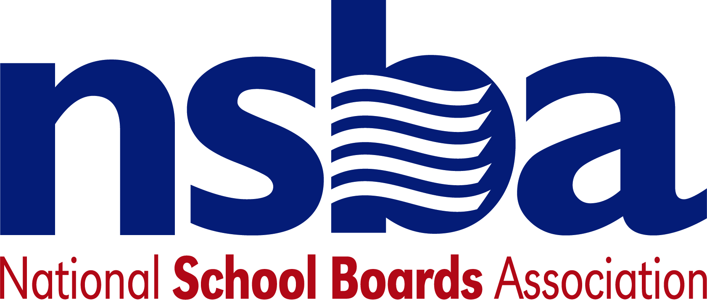

Federal Advocacy & Public Policy Update
February 21, 2020
NSBA Weekly Policy Update

Congressional Update

Secretary DeVos to Testify about FY21 Education Budget Request

Secretary DeVos is scheduled to testify next week, before the House Appropriations Subcommittee on Labor, Health and Human Services, Education, and Related Agencies. The Secretary will be the only witness and her testimony will focus on the president’s fiscal year 2021 budget request, which asked Congress to cut the Department of Education’s budget by 8.5% and to consolidate Title I and many other Elementary and Secondary Education Act programs into a single block grant. NSBA strongly opposes the president’s proposed budget cuts and consolidation plan and we will work with members of the House and Senate to oppose it. The hearing is scheduled for Thursday, February 27 (10:00 AM EST) and will be livestreamed here.

House Education Committee to Host Apprenticeship Hearing
The House Higher Education and Workforce Investment Subcommittee has scheduled a hearing titled “Reauthorizing the National Apprenticeship Act: Strengthening and Growing Apprenticeships for the 21st Century.” The hearing is a precursor to expected bipartisan committee work to update the NAA, including emphasizing high need areas, such as early childhood educators. We expect Chairman Scott (D-VA) and Ranking Member Foxx (R-NC) to release draft apprenticeship legislation for public comment later this year. The hearing will be held on Thursday, February 27 (10:15 AM EST). Witnesses have not yet been announced. The hearing will be livestreamed here.

Administration Update

Department of Education Announces Special Education Event
The Department of Education’s Office of Special Education and Rehabilitative Services is hosting a discussion about student transition experiences and success stories titled “VR100 – Vocational Rehabilitation” on Tuesday, February 25 (1-2:30pm ET). Acting Assistant Secretary, Office of Special Education and Rehabilitative Services, and Commissioner of RSA, Mark Schultz will moderate a panel about the topic, including an individual with disabilities, a teacher, a vocational rehabilitation counselor, and an employer. Watch the live broadcast here.

White House Hosts Governors for “Business Sessions”
President Trump hosted the nation’s governors on February 11 for a White House business session. Following remarks by the president, Secretary DeVos co-led, with other Cabinet officials, two breakouts focused on strengthening America’s workforce by expanding STEM education, apprenticeships, and CTE and re-skilling America’s workers for the growing industries of the future. The event was held in conjunction with the final day of the National Governors Association winter meeting.

FCC Seeks Public Comment about Net Neutrality
This week, the FCC invited public comment on aspects of the agency’s Net Neutrality decision, which were overturned by a recent court decision. The D.C. Circuit Court of Appeals remanded key elements of the FCC’s rollback of net neutrality. In particular, the court decision said the agency must consider how the FCC’s decision affects public safety, Lifeline service, and broadband infrastructure. The rulemaking provides an opportunity for school districts to urge the FCC to provide protections to ensure that schools and students are not harmed by carrier decisions to block websites, “throttle” services, and preference their own or their partners’ online content. Public comments must be submitted on or before March 30, 2020.

NSBA Update

Reminder: Next Week is Public Schools Week and Digital Learning Day: We want to remind everyone that Public Schools Week begins on Monday and runs from February 24 to 28, 2020 and Digital Learning Day is also during that week on Thursday, February 27, 2020. NSBA is doing advocacy and social media around both campaign events. We encourage states and local school board members to visit schools, issues proclamations, and participate in other ways around these two events to focus on local schools. You can learn more about Public Schools Week at https://learningfirst.org/publicschoolsweek and Digital Learning Day by visiting https://digitallearningday.org/.

Have a nice weekend.

