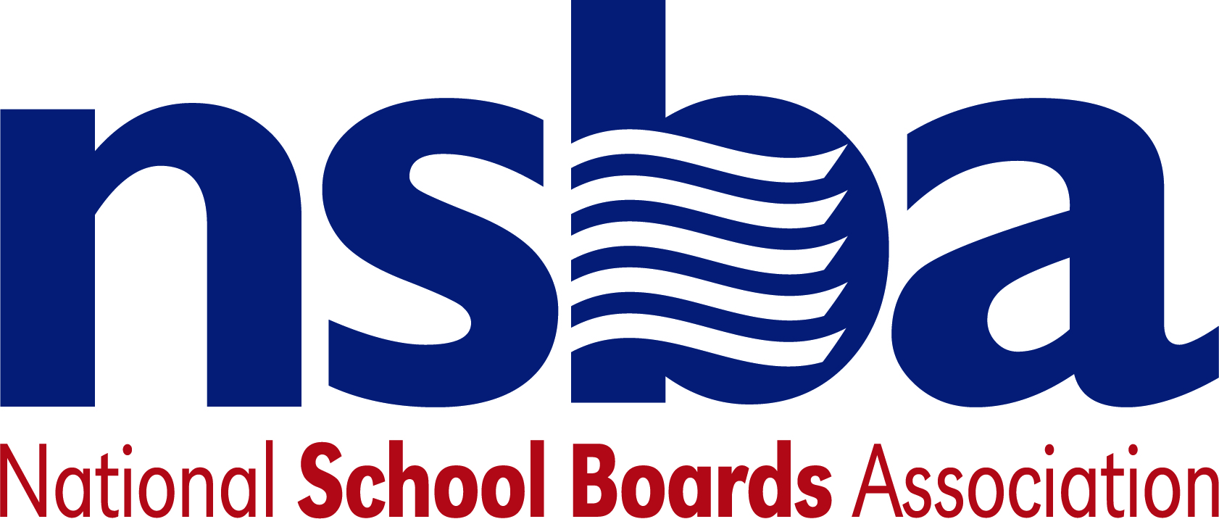

Federal Advocacy & Public Policy Update
February 7, 2020
NSBA Weekly Policy Update

Congressional Update

House Subcommittees Focus on Child Care and Workforce Challenges
This week, the House Subcommittee on Early Childhood, Elementary and Secondary Education held a hearing titled "Solving America’s Child Care Crisis: Supporting Parents, Children, and the Economy." Subcommittee Chairman Sablan opened the hearing by noting that the cost of childcare in America has increased 2000% in the last 40 years. Ranking Member Allen noted that the federal government funds several early childcare programs and said we need to ensure the programs provide options for parents.

Next week, the House Small Business Innovation and Workforce Development Subcommittee will hold a hearing titled “The Innovation Pipeline: From Universities to Small Businesses”. Witnesses include: Dr. John Younger (University City Science Center), Dr. Sheila Martin (Association of Public and Land-grant Universities), Dr. Ethan Mann (Sharklet Technologies, Inc), and Dr. Gregory P. Crawford (Miami University of Ohio). The hearing will be livestreamed here.

Senators Seek Insights from Department of Education about Early College Opportunities
A bipartisan group of 19 Senators sent a letter to Secretary DeVos asking the Department of Education to examine how school districts are using federal funding opportunities under the Every Student Succeeds Act (ESSA) to support increasing student access to high quality dual and concurrent enrollment and other early college high school programs.

Administration Update

Administration to Publish Fiscal Year 2021 Education Budget Request
The Administration is scheduled to publish President Trump’s fiscal year 2021 budget request, including proposed funding levels for the Department of Education, on Monday, February 10. As part of the announcement, the Department of Education is scheduled to hold a briefing starting at 2:00 p.m. (EST). The briefing will be livestreamed here and the budget materials will be posted here. Delivery of the president’s budget to Capitol Hill marks the beginning of the annual congressional budget process, including committee hearings where executive branch leaders, including Secretary DeVos, will testify about the budget request. As this process unfolds, NSBA will begin conversations with the Senate and House about the importance of federal education programs.

President Gives State of the Union Address with Considerable Focus on Education
The President’s State of the Union had considerable focus on “choice” issues and “privatization” of public education through his call for the Education Freedom Scholarships and Opportunity Act. The proposed legislation is a $5 billion federal tax credit program to fund scholarships for 1 million students to attend private school—many of which would be religiously affiliated and can restrict admittance to certain students. The scholarships are an attempt to avoid the term “vouchers” though they operate in much the same way. By giving an individual a tax credit so they can give it to a scholarship program, the scheme simply eliminates the money flowing directly from the government but the impact to public education is the same and since the money directly flows from other sources there are less safeguards to protect students. The result is that government has $5 billion less at the end of the day to fund public education and other important programs. The National School Boards Action Center released a poll the day prior to the State of the Union that found that 73% of likely voters agree with the statement we should NOT take away public funds from our public schools to fund private, religious, and home school education. Moreover, 64% of voters are much less likely to vote for an elected official who supports taking away funds from public schools to give to private schools, including 47% who would be much less likely to do so. The poll received considerable media attention. Data and messaging learned through the poll will play a valuable part of the advocacy agenda throughout the year. The SOU also included language highlighting the President’s recent activity on prayer in school.

Department of Education Announces Ed-Flex States
Earlier this week, Secretary DeVos announced that four new states – Massachusetts, North Carolina, Texas, and Vermont – will participate in the Education Flexibility Program (Ed-Flex), under the Every Student Succeeds Act (ESSA). The program allows state educational agencies to waive certain ESSA requirements for school districts, educational service agencies, or schools. Ed-Flex states may waive the following requirements for not more than five years: Title I, Part A (Basic Programs Operated by LEAs, other than section 1111); Title I, Part C (Education of Migratory Children); Title I, Part D (Prevention and Intervention Programs for Children and Youth Who are Neglected, Delinquent, or At-Risk); Title II, Part A (Supporting Effective Instruction); Title IV, Part A (Student Support and Academic Enrichment Grants); and the Carl D. Perkins Career and Technical Education Act.

According to the Department, the four approved states plan to use the flexibility to do the following.
- Massachusetts – enhance educator recruitment and licensure;
- North Carolina – address class size, school year schedule, and funding to schools in areas of need;
- Texas – address staff development requirements, teacher certification, and attendance requirements;
- Vermont – enhance school districts’ ability to implement long-term improvement initiatives while keeping their focus on improving student outcomes.

New K-12 Legislation

- H.R.5764 To establish high-quality dual language immersion programs in low-income communities, and for other purposes. Sponsor: Rep. Grijalva, Raul M. [D-AZ-3]
- H.R.5759 To establish a career pathway grant program. Sponsor: Rep. Adams, Alma S. [D-NC-12]
- H.R.5748 Jobs, On-the-Job "Earn-While-You-Learn" Training, and Apprenticeships for Young African-Americans Act Sponsor: Rep. Scott, David [D-GA-13]
- H.J.Res.84 Expressing support for designation of the week of February 3, 2020, through February 7, 2020, as "National School Counseling Week". Sponsor: Rep. Sanchez, Linda T. [D-CA-38]

NSBA Update

NSBAC Publishes Results of National Poll
In conjunction with NSBA’s 2020 Advocacy Institute, the National School Boards Action Center released the results of its national poll of voter opinions and attitudes about public education, federal policymaking and key issues impacting public schools and student achievement. The poll, "America Speaks on Public Schools: Results from the 2020 NSBAC Public Education Poll" shows that voters strongly support public schools and are opposed to taking away funds from public schools to fund for-profit charters or private schools.

NSBA would like to thank all the CSALS members for their assistance with this year’s Advocacy Institute, particularly Dan Rossmiller who provided advice and assistance throughout the planning. We are already planning for next year.

The next CSALS call will be Tuesday, February 18, 2020 at 4:00 pm eastern due to the federal holiday on Monday of that week. The conference call information is:

(833) 444-6583, 874306030# (Dial-in Number)

Have a great weekend!

