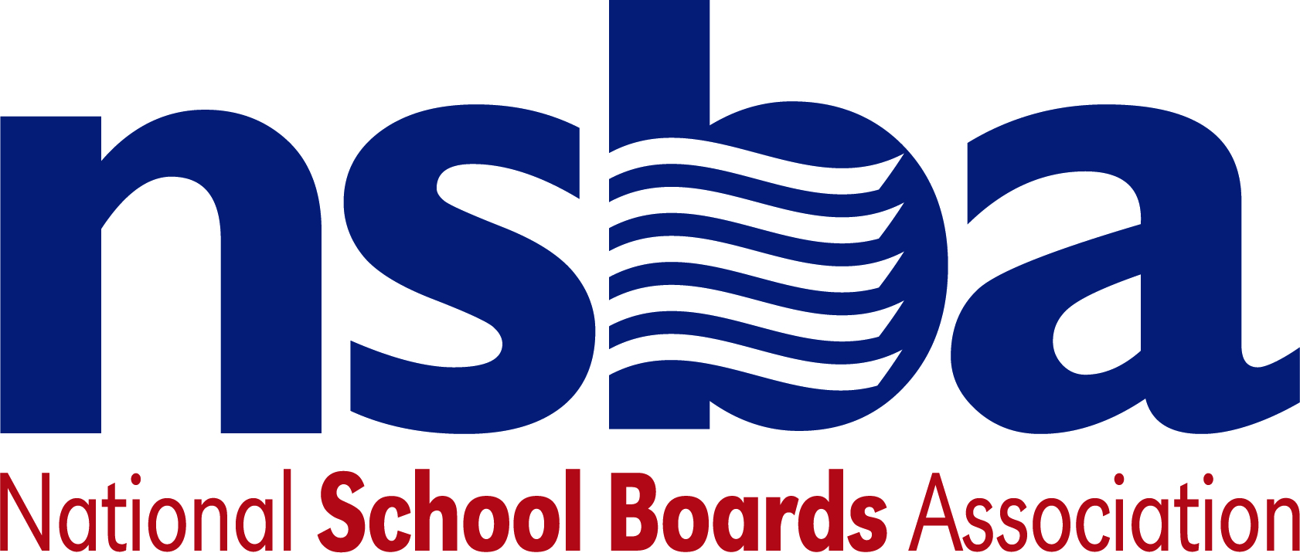

Federal Advocacy & Public Policy Update
March 13, 2020
NSBA Weekly Policy Update
Congressional Update

Congress and White House Negotiating Second Coronavirus Bill
There are some reports Friday evening that a compromise bill has been agreed to for an additional supplemental appropriation. However, the situation still appears fluid at this time. House Speaker Pelosi and U.S. Treasury Secretary Mnuchin have been having ongoing negotiations on a second emergency bill designed to help the country respond to the COVID-19 pandemic. Speaker Pelosi reportedly hopes to hold a floor vote later today on a bill that has bipartisan support, but she intends to move forward with a Democrats only proposal if she is unable to reach a deal with the White House and Congressional Republicans. The initial House Democrats’ proposal (H.R. 6201, Families First Coronavirus Response Act), which was released publicly on Thursday, covers the following areas:

- Nutrition policy flexibility and additional funding to help states and localities administer federal food assistance programs, including programs focused on low income students;
- Healthcare worker protections;
- Emergency paid leave provisions; and
- Emergency unemployment insurance provisions;

The outcome of these House negotiations will not be known until later today. If the House approves a bill today, the Senate is not likely to take it up until at least Monday, when the body reconvenes. NSBA will continue to closely monitor the process and will share information about any provisions that Congress approves that are important to school district leaders and their staff and students.

U.S Capitol, Senate, and House Buildings Close to the Public
Yesterday, Congress announced that the public will not have access to the U.S. Capitol, or House and Senate buildings, until at least April 1. Congress took this step as part of broader efforts to minimize the spread of the coronavirus and to protect members and staff. Many congressional offices are making plans to work remotely as a precautionary measure. NSBA’s advocacy staff intends to remain in contact with staff virtually.

Administration Update

FCC Extends E-rate Application Deadline and NSBA Urges Other E-rate Flexibility
Today, the FCC extended the 2020 E-rate application filing window due to COVID-19 disruptions. Applicants now have until 11:59 on April 29 to submit their Form 471 applications. The order also directs the Universal Service Administrative Company to provide all applicants with an automatic 14-day extension for Program Integrity Assurance (PIA) requests. The FCC’s public notice is available here. Separately, NSBA joined other Education and Libraries Network Coalition members in sending a letter to the FCC urging the agency to use its emergency powers to enable school districts to use E-rate as a tool for connecting students to broadband during prolonged school closures.

U.S. Department of Agriculture Provides Nutrition Program Flexibility
The USDA announced plans to offer waivers to states so that they feed children meals following the Summer Food Service Program and National School Lunch Program’s Seamless Summer Option. when schools close due to COVID-19. Testifying before the House Agriculture Committee this week, Secretary Perdue said, “Our legal counsel tells us that we have to be asked, [so] we’ve sent the message to all the states that they can preemptively assume a positive response . . . once a waiver request comes in.” The Secretary also acknowledged, however, that USDA needs additional authority from Congress to ensure all eligible students are served, given that he cannot waive eligible service site rules that may make it difficult to serve low income students in their neighborhoods. COVID-19 response language pending on Capitol Hill includes provisions designed to address this issue and other nutrition policy changes that need to be addressed to help programs continue service during this emergency period.

U.S. Department of Education Publishes COVID-19 Guidance Materials
This week, the Department of Education released several guidance documents for school districts to help local leaders guide their systems and serve their students during extended COVID-19 school closures. The guidance materials include the following:

  - Fact sheet regarding flexibility the department could grant with regard to accountability “Impact of COVID-19 on Assessments and Accountability under the Elementary and Secondary Education Act”
  - Q & A document titled “Questions and Answers on Providing Services to Children with Disabilities During the Coronavirus Disease 2019 Outbreak”
  - Student Privacy FAQ titled “FERPA & Coronavirus Disease 2019 (COVID-19) Frequently Asked Questions (FAQs)”

Given the dynamic nature of the emergency, including the government’s evolving response, we expect the Department of Education to publish additional guidance. NSBA will share additional guidance materials and other information as it becomes available.

NSBA Update

Notable New K-12 Bills
- S.3445 A bill to direct the Secretary of Labor to award grants to develop, administer, and evaluate early childhood education apprenticeships, and for other purposes. Sponsor: Sen. Young, Todd [R-IN]
- S.3405 A bill to strengthen student achievement and graduation rates and prepare children and youth for college, careers, and citizenship through innovative partnerships that meet the comprehensive needs of children and youth. Sponsor: Sen. Booker, Cory A. [D-NJ]
- H.R.6203 To provide for certain waivers of program requirements under the Richard B. Russell National School Lunch Act to appropriately address safety measures with respect to COVID-19, and for other purposes. Sponsor: Rep. Bonamici, Suzanne [D-OR-1]
- H.R.6200 To authorize the Secretary of Agriculture to provide certain food assistance for eligible children during periods when their schools are closed due to a public health emergency; and for other purposes. Sponsor: Rep. Fudge, Marcia L. [D-OH-11]
- H.R.6195 To amend the Elementary and Secondary Education Act of 1965 to provide grants to eligible local educational agencies to encourage female students to pursue studies and careers in science, mathematics, engineering, and technology. Sponsor: Rep. McNerney, Jerry [D-CA-9]
- H.R.6187 To allow the Secretary of Agriculture to grant certain waivers under the Richard B. Russell National School Lunch Act to address school closures due to COVID-19, and for other purposes. Sponsor: Rep. Omar, Ilhan [D-MN-5]
- H.R.2486 FUTURE Act Sponsor: Rep. Adams, Alma S. [D-NC-12]
- H.R.6109 INSPIRES Act Sponsor: Rep. Cox, TJ [D-CA-21]
- H.R.6107 To amend the Elementary and Secondary Education Act of 1965 to improve diversity in accelerated student learning programs. Sponsor: Rep. Cohen, Steve [D-TN-9]
- H.R.6106 DIPLOMA Act Sponsor: Rep. Chu, Judy [D-CA-27]

NSBA Update

CSALS MEETING: Monday, March 16, 2020
There will be a CSALS meeting this Monday, March 15, 2020 at 4:00 pm eastern time. The call information is below:

(833) 444-6583, 6214424#

REMINDER: NSBA Coronavirus Information is Available:
Again, we want to remind everyone that NSBA has put together information and resources on the coronavirus. It can be found on the NSBA home page or you can go directly to it at nsba.org/resources/coronavirus.

