**FSBA 2020 Partner & Annual Sponsor Resources**

We truly value our partners and annual sponsors that help support FSBA’s mission: To increase student achievement through the development of effective board leadership and advocacy for public education. *Please see below for special offers and resources from FSBA Annual Sponsors during COVID-19 and school closures.*

**BoardDocs**

 Digital school board management solution will be made available to K-12 public school boards through the end of the school year.

**MARCH 20, 2020 – NEW YORK** – Diligent Corporation announced today it will offer Community by Diligent, a modern governance solution that enables online school board meetings, free of charge to K-12 public school districts through at least the end of the school year.

Faced with widespread closures due to COVID-19, school districts across the country are shifting classroom structures, changing policies, and adapting to the realities of “social distancing.” The changes impact not only students and faculty, but also school boards and administration, who are unable to hold business meetings in person while their districts are forced to shut down due to the risk of the novel coronavirus.

**“**In times of crisis, modern governance matters more than ever.” said Brian Stafford, CEO of Diligent. “School boards are facing an array of unprecedented challenges, but access to technology does not have to be one of them. At Diligent, we’re committed to putting communities first and want to support school boards who are in need of communication tools that allow remote access to critical information, enable decision-making, and allow community participation in meetings – even in this new entirely virtual world.”

To learn more about Community by Diligent or request free access, please visit: <https://learn.diligent.com/crisis-communication-support>.

**Vocabulary.com**

|  |  |  |  |
| --- | --- | --- | --- |
| |  |  |  | | --- | --- | --- | | |  |  | | --- | --- | | |  | | --- | | https://imgssl.constantcontact.com/letters/images/1101116784221/S.gif | | | |

|  |  |  |  |  |  |
| --- | --- | --- | --- | --- | --- |
| |  |  |  |  |  | | --- | --- | --- | --- | --- | | |  |  | | --- | --- | | [https://files.constantcontact.com/04448ca7401/17acd21e-946d-4afe-b4fe-8ff8d0abe28d.png](vocabulary.com) | https://imgssl.constantcontact.com/letters/images/sys/S.gif | | https://imgssl.constantcontact.com/letters/images/sys/S.gif | https://imgssl.constantcontact.com/letters/images/sys/S.gif |   **Vocabulary.com Offers FREE Resources for Districts**  Vocabulary.com is an ideal resource for remote learning that’s used by tens of thousands of Florida students and teachers. The platform requires minimal supervision by teachers and provides each student with a personal learning program. [Learn more](https://www.vocabulary.com/educator-edition/) about starting a free pilot in your school or district. | |

**No Kid Hungry**

In Florida alone, in response to the effects of COVID-19, No Kid Hungry has granted approximately $750,000 to Florida schools and community based organizations.   
[Learn more here](http://www.fsba.org/wp-content/uploads/2020/04/No-Kid-Hungry-Florida-Responds_-COVID-19.pdf)

[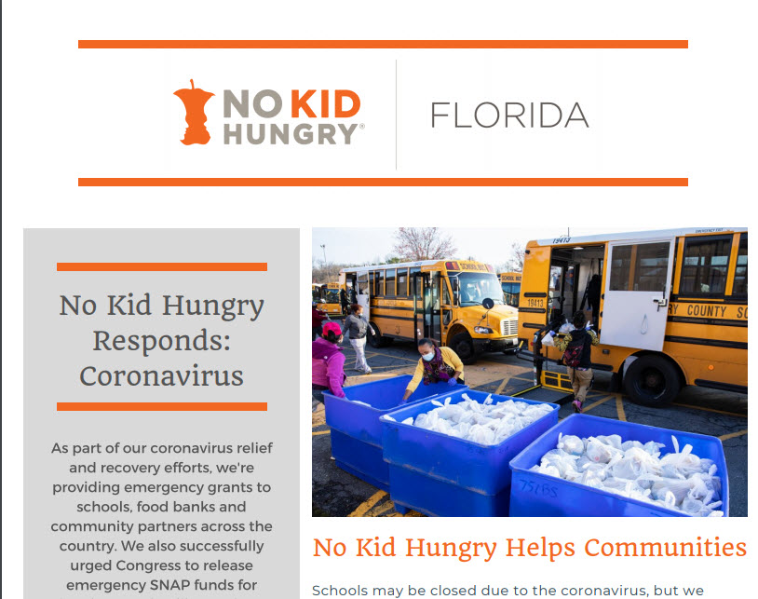](http://www.fsba.org/wp-content/uploads/2020/04/No-Kid-Hungry-Florida-Responds_-COVID-19.pdf)

**Parchment**

[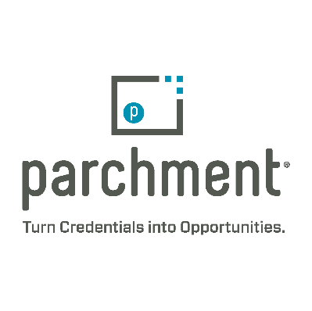](https://www.parchment.com/)

**Parchment** is providing online transcript ordering processing, and delivery for students and administrators through June 2020**. School districts can learn more by visiting this link:**  <http://info.parchment.com/K12_COVID.html>

**RENAISSANCE**

cid:image001.jpg@01D6116B.B10424E0To support educators during this time of school closures, the Renaissance at Home webpage provides information on free programs for remote learning to help educators, students, and families learning from home. Additionally, the site supports Renaissance customers using Accelerated Reader, myON, myON News, and Freckle for remote learning with resources and best practices. <https://www.renaissance.com/renaissance-at-home/>

Renaissance provides digital solutions to assist students and families with at-home learning. This includes complimentary access options for digital reading with myON, and online practice with Freckle for math, ELA, science and social studies. <https://p.widencdn.net/yjia0u/379249-Unexpected-school-closures-e-Learning-Handout1>. Students only need a device and an internet connection to access engaging literacy and math activities and complete assignments outside of school.

**FREE WEBINAR FOR FLORIDA EDUCATORS HOSTED BY RENAISSANCE**

**Date:** Thursday, May 7 from 11:00am-12:00pm ET

**Speakers:**

* Presenter: Gene Kerns
* Host: Jonathan Pounds

**At Home or in the Classroom: High-Impact Strategies for Student Learning**

As a Florida educator, you’re challenged with building an Instructional Continuity Plan that is impactful on student learning, as well as easy to implement and scale.

Join this webinar to **explore proven best practices for remote learning, including Renaissance solutions that guide growth whether students are learning from home or in the classroom**.

Dr. Gene Kerns will share:

* Research on the impact of long-term school closures
* Assistance available through the Elementary and Secondary Education CARES funds
* Tips for supporting learning across all subject areas with nonfiction books and articles
* Why improved access to digital books and expanded choice engages readers
* How to provide standards-based math and ELA practice at the right level for each student
* Methods for engaging students with project-based science and social studies assignments

**Registration Page:**

* Full link: <https://www.renaissance.com/fmm_webinars/at-home-or-in-the-classroom-high-impact-strategies-for-student-learning/>