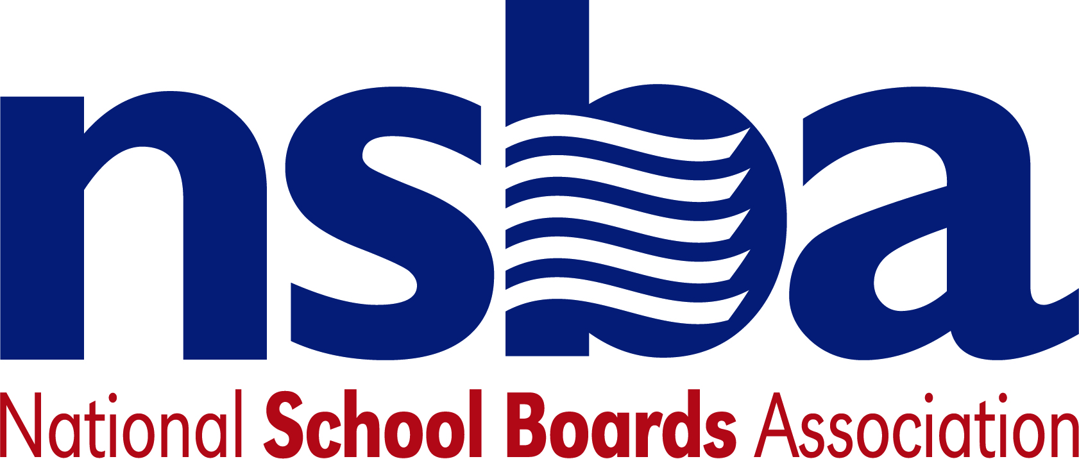

Federal Advocacy & Public Policy
May 8, 2020
NSBA Weekly Update

Congressional Update

Senator Markey Plans to Introduce Emergency E-rate Legislation
Senator Ed Markey (D-MA) is poised to introduce legislation next week that would provide $4 billion in emergency funding, through the E-Rate program, to help connect elementary and secondary students who lack broadband access for learning. The bill, which is expected to have at least 41 Democratic cosponsors, is a companion to a House measure introduced last month by Representative Grace Meng (D-NY). The sponsors’ goal is to secure inclusion of the E-rate funding in the next COVID-19 emergency response bill considered by Congress. NSBA strongly supports the Markey/Meng proposal and is working with other national groups to build support for it and a minimum of at least $4 billion in funding to help close the homework gap.

Senate HELP Committee Plans Hearing About Safely Returning to School
On Tuesday, May 12, the Senate Health, Education, Labor, and Pensions (HELP) Committee will hold a hearing titled, “COVID-19: Safely Getting Back to Work and Back to School”. Witnesses at the hearing will include: Anthony Fauci, MD (Director, National Institute of Allergy and Infectious Diseases, National Institutes of Health, Bethesda, MD); Robert Redfield, MD (Director, United States Centers for Disease Control and Prevention, Atlanta, GA); ADM Brett Giroir, MD (Assistant Secretary for Health, United States Department of Health and Human Services, Washington, D.C.); and Stephen Hahn, MD (Commissioner of Food and Drugs, United States Food and Drug Administration, Silver Spring, MD). A live video of the hearing may be accessed here.

Additional Emergency Spending Discussions to Start on House Side
Speaker Nancy Pelosi (D-CA) has initiated discussions in the House about the next federal response to the COVID-19 emergency. The speaker has been urging committee leaders to develop plans for the next bill with the goal of introducing another far-reaching spending bill within the next two weeks. NSBA is urging House members to include a minimum of $200 billion in the bill to help school districts in addition to the $4 billion call homework gap funds through the E-Rate program. Senate Majority Leader McConnell has called for a slower process, arguing that the CARES Act should be allowed to work before Congress takes additional action. As a result, NSBA does not expect Senate leaders to introduce new emergency legislation anytime soon, but we intend to continue talking with senators about the importance of providing additional funding for public education, including dedicated funding for student and teacher broadband connectivity, IDEA, and Title I.

Administration Update

Department of Education’s Inspector General Announces COVID Relief Oversight Plan
The Education Department’s Office of the Inspector General (OIG) announced a Coronavirus Relief Oversight Plan, for evaluating use of the CARES Act’s emergency education funding. According to the announcement, “OIG auditors anticipate performing a series of audits and reviews of programs, grants, requirements, and flexibilities established under the CARES Act.” The oversight plan includes use of the Elementary and Secondary School Emergency Relief Fund and “States’ continued compliance with certain requirements under the Individuals with Disabilities Education Act and the Rehabilitation Act.”

Department of Education Releases Final Title IX Regulations
The Department of Education published the final Title IX regulations, which will take effect on August 14, 2020. Among the many changes adopted by the agency, the rule defines sexual harassment to include sexual assault, dating violence, domestic violence, and stalking, as unlawful discrimination on the basis of sex; and it requires elementary and secondary schools to respond promptly when any school employee has notice of sexual harassment. That would represent a change from a rescinded Obama-era guidance that made K-12 schools responsible for incidents they “reasonably should” have known about. Under the new rule, elementary and secondary schools are not required to hold hearings in response to complaints that they receive from students.

Department of Education Announces New Grant Opportunities

The Department of Education published the following new competitive grant opportunities.

- “Education Research and Special Education Research Grant Programs” – The Institute of Education Sciences (IES) will award grants to support “national leadership in expanding knowledge and understanding of: (1) developmental and school readiness outcomes for infants and toddlers with or at risk for a disability; (2) education outcomes for all learners from early childhood education through postsecondary and adult education; and (3) employment and wage outcomes when relevant (such as for those engaged in career and technical, postsecondary, or adult education).” The announcement covers eight research competitions through two of the IES centers:
    - IES National Center for Education Research: Four competitions focus on education research, education research training, education research and development centers, and systematic replication in education.
    - IES National Center for Special Education Research: Four competitions focus on special education research, special education research training, National Assessment of Educational Progress (NAEP) process data, and systematic replication in special education.
The estimated range of awards varies according to the specific competition. Applications for all competitions are due August 20, 2020, and further information is available here.

- “Competitive Grants for State Assessments Program” – The Competitive Grants for State Assessments program focuses on enhancing the quality of assessment instruments and systems used to measure the academic achievement of elementary and secondary school students. Two of the priorities for this competitive grant program build on the flexibility in ESSA establishing the Innovative Assessment Demonstration Authority (IADA). A third priority is for states who are neither planning to apply for nor implementing the IADA. The estimated available funds for this program total $12,327,000. Applications are due by June 30, 2020, and further information is available here.

Notable New K-12 Bills

- H.R.6722 To strengthen Federal nutrition assistance programs as automatic stabilizers, and for other purposes. Sponsor: Rep. Neguse, Joe [D-CO-2]
- H.R.6703 To amend the Richard B. Russell National School Lunch Act to include eating disorder prevention within local school wellness policy, and for other purposes. Sponsor: Rep. Adams, Alma S. [D-NC-12]
- H.R.6646 To provide State and local workforce and career and technical education systems with support to respond to the COVID-19 national emergency. Sponsor: Rep. Scott, Robert C. "Bobby" [D-VA-3]

NSBA Updates
.
New CPE Blog: The NSBA Center for Public Education (CPE) recently released a blog on the NAEP data concerning civics. The blog is entitled “Achievement Gap & Technology-enhanced Learning at Home” and can be accessed at the following link. The blog notes that the NAEP results provide additional evidence concerning the importance of technology-enhanced student learning at home and why closing the homework gap is vital for future education success.

CSALS Call: There will be a CSALS conference call this Monday, May 11, 2020 at 4:00 pm eastern. The call information follows: (833) 444-6583, Conference ID: 156 395 940#

