**FSBA 2020 Partner & Annual Sponsor Resources**

We truly value our partners and annual sponsors that help support FSBA’s mission: To increase student achievement through the development of effective board leadership and advocacy for public education. *Please see below for special offers and resources from FSBA Annual Sponsors during COVID-19 and school closures.*

**BoardDocs**

|  |  |
| --- | --- |
| Moving From Crisis to Calm: A Board’s Role in Healing the Community  Wednesday, July 15th  12pm EDT \ 9am PDT | |
| [Register](https://learn.diligent.com/CrisistoCalm.html?utm_source=partners) | |
| As school districts begin the process of coming back together, reopening district offices and resuming some form of in-person services, questions are starting to arise about what that will look like. Join James Bryant Conant Award winning governance expert, AJ Crabill and Diana Freeman, Governance Specialist at Diligent, for a conversation about the future of education in the wake of the many crisis events of this spring. They will address many of the different scenarios that are developing as districts navigate the uncharted waters of resuming school after months of closure. Register for “[Moving From Crisis to Calm: A Board’s Role in Healing the Community](https://learn.diligent.com/CrisistoCalm.html?utm_source=partners),” which will cover Board response to current events and their impact on:   * Student social-emotional wellbeing * Projected budget shortfalls * Goals, parameters, and expectations moving forward * Student outcomes and achievement   We look forward to helping you move forward incorporating the lessons learned in order to be stronger on the other side. | |
| |  |  |  | | --- | --- | --- | | |  |  | | --- | --- | | |  | | --- | | **Vocabulary.com**https://imgssl.constantcontact.com/letters/images/1101116784221/S.gif | | | |

|  |  |  |  |  |  |
| --- | --- | --- | --- | --- | --- |
| |  |  |  |  |  | | --- | --- | --- | --- | --- | | |  |  | | --- | --- | | [https://files.constantcontact.com/04448ca7401/17acd21e-946d-4afe-b4fe-8ff8d0abe28d.png](vocabulary.com) | https://imgssl.constantcontact.com/letters/images/sys/S.gif | | https://imgssl.constantcontact.com/letters/images/sys/S.gif | https://imgssl.constantcontact.com/letters/images/sys/S.gif |   **Vocabulary.com Offers FREE Resources for Districts**  Vocabulary.com is an ideal resource for remote learning that’s used by tens of thousands of Florida students and teachers. The platform requires minimal supervision by teachers and provides each student with a personal learning program. [Learn more](https://www.vocabulary.com/educator-edition/) about starting a free pilot in your school or district. | |

**No Kid Hungry**

In Florida alone, in response to the effects of COVID-19, No Kid Hungry has granted approximately $750,000 to Florida schools and community based organizations.   
[Learn more here](http://www.fsba.org/wp-content/uploads/2020/04/No-Kid-Hungry-Florida-Responds_-COVID-19.pdf)

[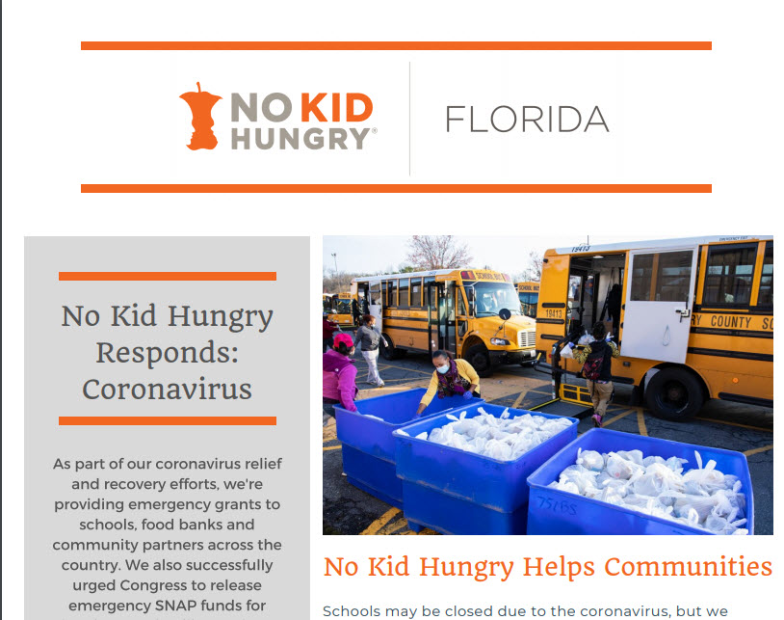](http://www.fsba.org/wp-content/uploads/2020/04/No-Kid-Hungry-Florida-Responds_-COVID-19.pdf)

**Parchment**

[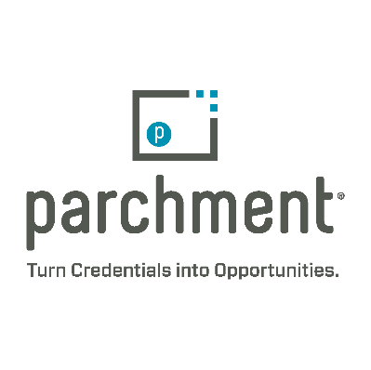](https://www.parchment.com/)

**Parchment** is providing online transcript ordering processing, and delivery for students and administrators through June 2020**. School districts can learn more by visiting this link:**  <http://info.parchment.com/K12_COVID.html>

**RENAISSANCE**

cid:image001.jpg@01D6116B.B10424E0 Focus Skills are—simply put—the **building blocks of student learning.** Based on extensive research into how learning progresses in reading and mathematics, Focus Skills provide a roadmap for closing learning gaps as you move every student toward greater mastery. Visit the Renaissance Focus Skills Resource Center to learn more: <https://www.renaissance.com/focus-skills/>

Available resources include:

* View focus skills for literacy and math by state
* Download the Focus Skills Research Brief
* Register for the Focus Skills Webinar on July 15 at 2:00pm ET

---------------------------

We have received an overwhelmingly positive response from educators that the free focus skills will be part of their back-to-school plans.

* “This is amazing and so helpful. I am going to share with the admin team!”
* “Very great information and resources that I hope most teachers will use!”
* “I am excited to use these resources to target gaps that may be there after so much missed school.”

**Martha Harmon** | **Field Marketing Manager**

**P:** 715-424-3636 x.4589 | **C**: 910-308-7567 | [www.renaissance.com](http://www.renaissance.com/)

cid:image001.jpg@01D6448F.5AF05400

**Disclaimer:** The information contained in this communication may be confidential, is intended only for the use of the recipient(s) named above, and may be legally privileged. If the reader of this message is not the intended recipient, you are hereby notified that any dissemination, distribution, or copying of this communication, or any of its contents or attachments, is strictly prohibited. If you have received this communication in error, please return it to the sender immediately and delete the original message and any copy of it from your computer system. If you have any questions concerning this message, please contact the sender. Emails sent to and from **Renaissance Learning, Inc.** and its affiliates are monitored and subject to disclosure, including in connection with regulatory or other legal proceedings.