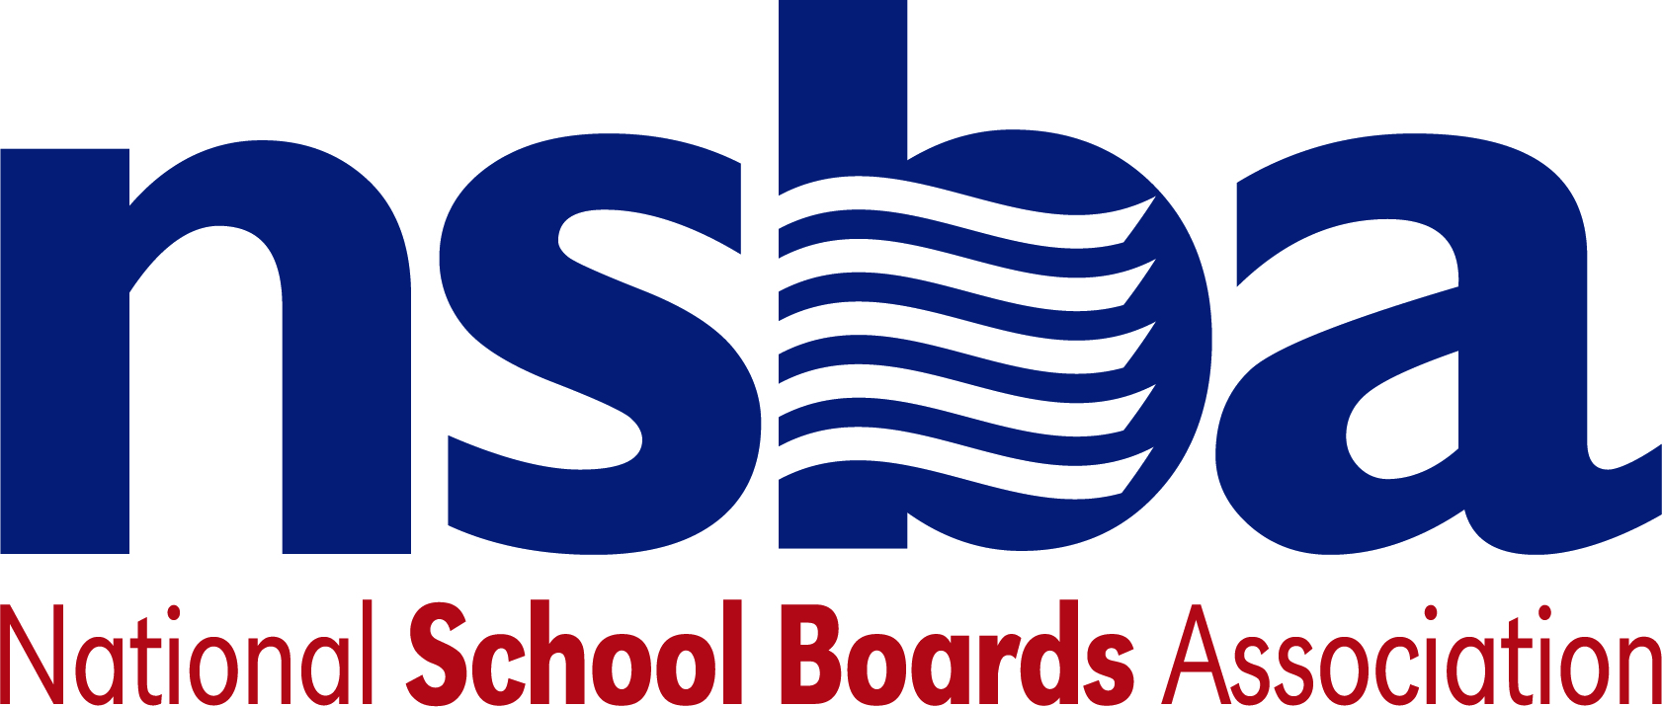

Federal Advocacy & Public Policy Team
July 24, 2020
NSBA Weekly Update

House Appropriations Committee Advances Education Spending Package
On July 20, the House Appropriations Committee released a “minibus” spending package for federal Fiscal Year (FY) 2021. This measure combines seven different appropriations bills that the committee previously marked-up and approved over the past few weeks and includes $73.5 billion for the U.S. Department of Education (USED) and related programs. Totaling $1.4 trillion, the full House will consider the legislation next week. It is expected to pass the chamber. A smaller FY 2021 minibus, containing four other spending bills, is slated to be passed by the House this week as Democratic leaders in the chamber seek to approve all 12 federal funding bills for the upcoming fiscal year prior to Congress’ annual August recess. The Senate Appropriations Committee has not yet made similar progress. It remains unclear if lawmakers in that chamber will pass their own appropriations legislation prior to the beginning of the next federal fiscal year (beginning October 1) or if lawmakers will pursue alternative stop-gap legislation to extend current funding for a shorter period of time.

Congressional Republican’s COVID-19 Marker Bill Delayed
Congressional Republicans, led by Senate Majority Leader McConnell (R-KY), hoped to introduce a legislative proposal this week that would have outlined their priorities for the next iteration of a COVID-19 aid package as they prepare for formal negotiations with Democrats. However, continued disagreements between the Trump Administration and Congressional Republican leadership on how to structure additional unemployment benefits have delayed the unveiling of this proposal and it is now expected to be released sometime during the week of July 27. The forthcoming Republican proposal will likely include $70 billion exclusively for K-12 education with $10 billion of this money set-aside for private schools. $30 billion of this funding would go directly to states and school districts, much like with the CARES Act, on a formula basis. Another $30 billion would be made available to schools as a condition for physically reopening facilities and providing a district-level reopening plan. An additional $5 billion will likely be set-aside specifically for Governors to supplement both K-12 and postsecondary needs in their state.

The legislation reportedly contains liability protection for schools that follow local health department guidelines and protocols. This includes an exclusive federal cause of action that applies to litigation against any business, non-profit, school, medical provider, or medical professions arising from COVID-19; allows cases to brought in state or federal court, but this cause of action is the only standard of liability that applies either way; and allows defendants to have the right to remove any case filed in state court to the federal district court in that area. To prevail in litigation, plaintiffs must show that the defendant was grossly negligence or engaged in willful misconduct and violated relevant state and/or local public health guidelines in place at the time the incident occurred. Simple negligence is not enough to prevail. Additionally, there is a cap on damage awards. The legislation reportedly provides no money for broadband expansion or for funds directly addressing the homework gap through the E-Rate program.

Additionally, earlier this week, Senate HELP Committee Chair Alexander (R-TN) and Senator Scott (R-SC) announced the "School Choice Now Act" which we anticipate will end up in the COVID relief bill. The School Choice Now Act would provide scholarships to students to return to the private school they attended before the pandemic. It would also allow other students to attend private school by:
• Providing one-time, emergency funding for “scholarship-granting organizations” (these are non-profits that help students attend private schools in each state).
• Providing permanent dollar-for-dollar federal tax credits for contributions to scholarship granting organizations.

As Congressional discussions on the next phase of this pandemic aid package take shape, NSBA’s advocacy team will continue to work to ensure that lawmakers appreciate the urgent funding needs of the K-12 community.

House Subcommittee Holds Hearing on Safely Reopening Schools
On Thursday, July 23, the House Education and Labor Subcommittee on Early Childhood, Elementary, & Secondary Education held a hearing exploring issues related to the reopening of K-12 schools. The hearing emphasized the need for additional federal funding to support locally designed and driven strategies for school re-openings later this fall. In his opening remarks, Subcommittee Chairman Sablan (D-N.M.I.) shared his frustration with the Trump administration’s recent threat to withhold funding from schools that do not physically reopen for the upcoming school year. Subcommittee Ranking Member Allen (R-GA) focused his remarks on the costs associated with additional federal funding that will be needed to safely reopen schools, arguing that such support is unsustainable in the long-term. Witnesses, however, voiced strong support for additional funding for K-12 schools to support safe re-openings this fall and also called on Congress to provide additional support for broadband connectivity for students who may still be attending school virtually later this year.

Administration Update

Executive Order Concerning the U.S. Census
NSBA’s federal advocacy, legal, and communications teams began work to analyze the Administration’s executive order announced this week regarding the Census count, and its potential impact on public school districts and educational equity. The executive order calls for excluding unauthorized immigrants from Census numbers from the apportionment base used for Congressional redistricting. This issue complicates an already difficult process to conduct an accurate Census during the COVID-19 pandemic. Based on consultation with the Count All Kids Campaign, efforts are in progress to secure at least a four-month extension from Congress to allow the Census Bureau to continue efforts for a complete count. The national self-response rate was less than 63 percent as of July 23, 2020.

While the executive order does not directly address federal funding for K-12 education and related services, its effort to exclude individuals with non-citizenship status from the official Census count could reduce federal appropriations for education in underserved communities, and also impact state and local resources for education, should Congress and state and local governments decide to use an amended Census count from the Administration. Public schools must educate students who are enrolled regardless of citizenship, according to the U.S. Supreme Court decision in Plyer v. Doe, holding that states cannot constitutionally deny students a free public education because of their immigration status. Additionally, any amended Count could impact congressional redistricting, thereby disenfranchising federal representation for underserved communities and their public schools and students.

CCSSO Releases Statement on Assessments for Next School Year
The Council of Chief State School Officers (CCSSO) released a statement on July 20 regarding the use of assessments in the upcoming school year. The statement emphasized the importance of high-quality assessments and acknowledged that the “. . . context across states today is vastly different than it was before the pandemic.” The organization remained agnostic on whether the U.S. Department of Education (USED) should grant further assessment and accountability waivers for the coming school year and instead emphasized that high-quality assessments, in many shapes and forms, are an important tool for states, districts, and educators as they support students in their learning. USED has granted all 50 states and territories waivers from accountability and assessment requirements under the Every Student Succeeds Act for the 2019-20 school year, but has not committed to additional waivers for the year ahead.

CDC Releases New Guidelines Emphasizing School Reopening
The Centers for Disease Control and Prevention (CDC) released updated guidelines on July 23 strongly encouraging students to physically return to school this fall. The guidance argues that K-12 students are “less likely” to contract COVID-19 than adults and stresses that attending school, in-person, is important for students’ social and emotional learning. The document noted that schools offer other important resources for students and families such as nutritional programs, counseling, special education services, and after-school programs that often benefit low-income and other disadvantaged student populations the most. Ultimately the document contends that the risks from the pandemic are lower than the associated health and academic risks facing students if they were to continue to stay home from school. The updates to this guidance come amid calls from the Trump Administration and some Congressional Republicans to condition further pandemic aid for the K-12 community on the physical reopening of schools later this fall.

Discretionary Grant Updates
USED published a notice on a discretionary grant program for the Office of Elementary and Secondary Education: “Indian Education Discretionary Grant Programs – Demonstration Grants for Indian Children and Youth Program” – This grant program seeks to improve education opportunities and achievement of Indian children and youth. The one priority under this grant competition requires applicants to propose a project to expand educational choice by allowing a Tribe to select a project focus that best meets the needs of their students. The education options that parents and students may choose include advanced, remedial, or elective courses; apprenticeships or training programs; concurrent or dual enrollment options; native language, history, or culture courses; supplemental counseling services; tuition; summer or afterschool education programs, and student transportation that may be needed; among others. The estimated available funds for this program total $15,000,000, contingent upon the availability of funds and the quality of applications. Applications are due by August 31, 2020, and further information is available here.

Recent Legislation
- H.R.7726 permit child care providers that receive payment for services provided under the of the Child Care and Development Block Grant Act of 1990 to use a portion of such payment to purchase personal protective equipment, and other equipment, necessary to protect the health of participating children and child care workers. Sponsor: Rep. Mucarsel-Powell, Debbie [D-FL-26]
- H.R.7720 To permit child care providers that receive payment for services provided under the of the Child Care and Development Block Grant Act of 1990 to use a portion of such payment to pay the cost of sanitization and other costs associated with the COVID-19 public health emergency, necessary to protect the health of participating children and child care workers. Sponsor: Rep. Cisneros, Gilbert Ray, Jr. [D-CA-39]
- H.R.7704 To amend the Richard B. Russell National School Lunch Act to establish the Food and Nutrition Education in Schools Pilot Program, and for other purposes. Sponsor: Rep. Horn, Kendra S. [D-OK-5]
- H.R.7693 To establish a grant program to fund the installation of green roof systems on public school buildings, and for other purposes. Sponsor: Rep. Velazquez, Nydia M. [D-NY-7]
- H.R.7692 To provide a grant program for elementary schools, secondary schools, and institutions of higher education to help offset costs associated with complying with guidelines, recommendations, and other public health communications issued by the Centers for Disease Control and Prevention, or a State, Indian Tribe, Tribal organization, or locality related to mitigating the hazards presented by COVID-19. Sponsor: Rep. Titus, Dina [D-NV-1]
- H.R.7635 To direct the Secretary of Labor to award grants to develop, administer, and evaluate early childhood education apprenticeships, and for other purposes. Sponsor: Rep. Guthrie, Brett [R-KY-2]
- H.Res.1052 Expressing the sense of the House of Representatives that all young children and families should have access to high-quality child care that is affordable for families. Sponsor: Rep. Bonamici, Suzanne [D-OR-1]
- S.4285 A bill to establish a pilot program through which the Institute of Museum and Library Services shall allocate funds to States for the provision of Internet-connected devices to libraries. Sponsor: Sen. Manchin, Joe, III [D-WV]
- S.4261 A bill to establish a grant program to assist elementary and secondary schools with reopening after closures related to COVID-19, and for other purposes. Sponsor: Sen. Perdue, David [R-GA]
- S.4221 A bill to provide for grants to support the provision of child care by reopening and maintaining the operation of child care programs. Sponsor: Sen. Ernst, Joni [R-IA]

NSBA Update

National Homework Gap Day of Action on July 21, 2020: NSBA would like to thank the strong participation in this important grassroots effort to close the homework gap. Numerous state associations did media interviews with local press, sent tweets, shared Facebook pages, and contacted Capitol Hill. This level of engagement will be helpful going forward as Congress moves ahead on the fourth supplemental appropriation.

