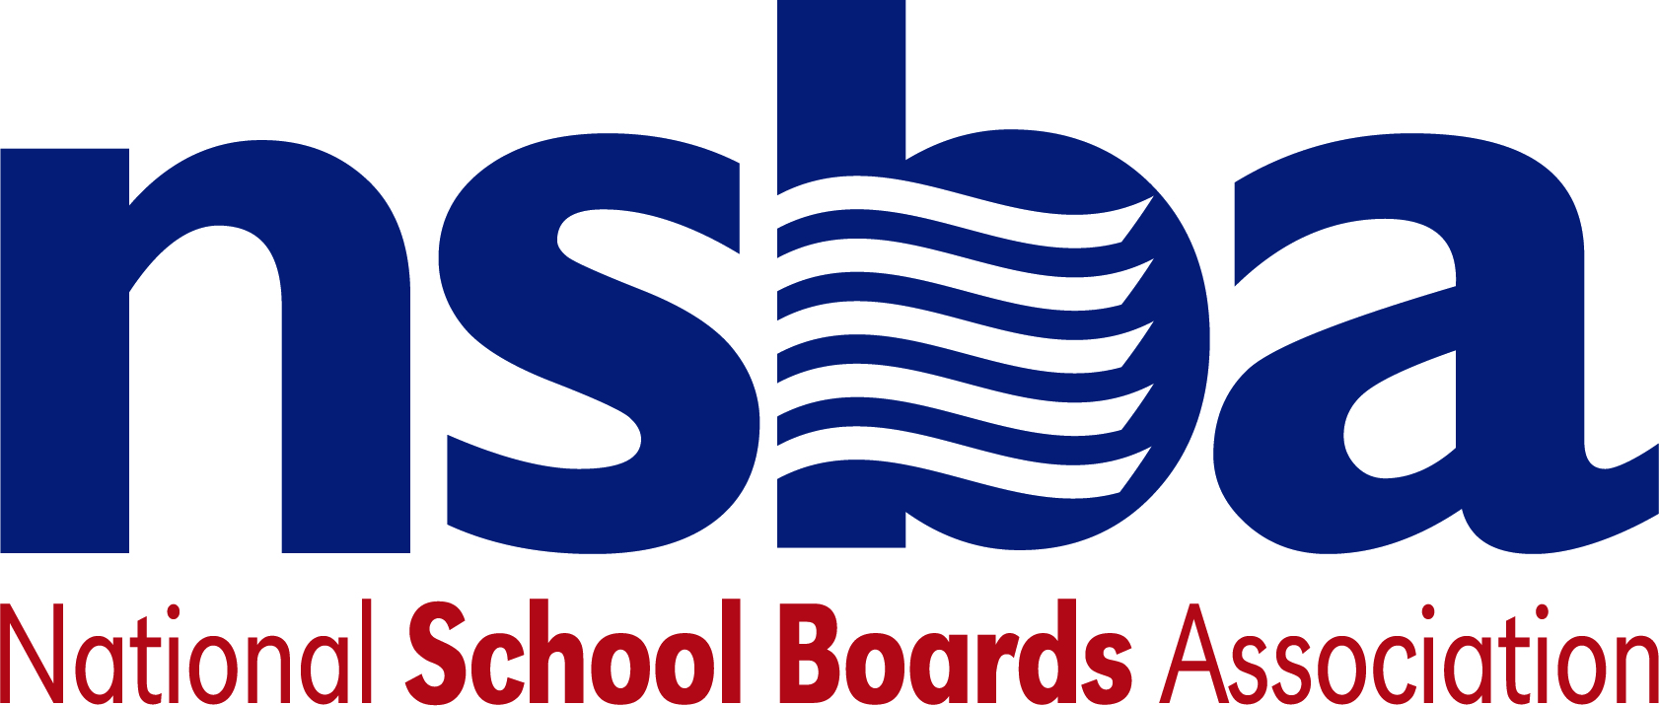

Federal Advocacy & Public Policy Team
October 16, 2020
NSBA Weekly Update

Congressional Update

Pandemic Relief Remains Out of Reach
Discussions regarding a much-needed next round of pandemic relief have been ongoing the past week, but despite a few promising developments lawmakers and the White House do not appear much closer to agreement. There are several outstanding areas of disagreement, including the total cost of pandemic relief. Congressional Democrats favor a package totaling around $2.2 trillion while Congressional Republicans support a proposal closer to $500 billion. Complicating matters further, the White House has shifted their position a few times in recent weeks and has most recently offered $1.8 trillion. Importantly, each of these proposals would include significant emergency funding for the K-12 community—an important priority for NSBA’s advocacy team. NSBA will continue to advocate for funds and resources for public schools and will carefully monitor each proposal to make sure that funds that should go to public schools are not diverted elsewhere.

However, Senate Majority Leader Mitch McConnell (R-KY) has emphasized that he does not support the White House’s newest position and plans to hold an additional vote on Senate Republicans’ $500 billion offer sometime next week. This vote is intended to apply pressure on Democrats who have, so far, held firm to their existing negotiation position of at least $2 trillion. With the November elections a few short weeks away and the Senate consumed by a contentious Supreme Court confirmation, the likelihood of a pandemic relief package before the elections is unlikely.

Administration Update

USDA Formally Extends School Nutrition Waivers
Late last Friday, October 9, the U.S. Department of Agriculture (USDA) formally extended waiver flexibilities to allow schools and other local program operators to continue to provide no-cost meals to children through the Summer Food Service Program (SFSP) and the Seamless Summer Option (SSO) through June 20, 2021. This development was made possible by the most recent stopgap government funding bill, passed by Congress last month, which provided and encouraged USDA to extend these flexibilities past the end of 2020. More information regarding this announcement can be found here.

CDC Updates School Coronavirus Testing Guidance
On Tuesday, October 13, the Centers for Disease Control (CDC) published updated guidance regarding COVID-19 testing strategies for K-12 schools. This updated guidance comes as many states and school districts have sought to reopen schools for in-person instruction with some communities requiring that all students take a test for COVID-19 prior to coming back to the classroom. The CDC’s guidance is supportive of voluntary testing regimes in schools, but strenuously argues against mandatory testing saying, in part, “It is unethical and illegal to test someone who does not want to be tested, including students whose parents or guardians do not want them to be tested.” The CDC also recommends against retesting individuals who have already tested positive but are no longer showing symptoms after three months. Importantly, the guidance emphasizes that these recommendations are not legally binding and are not meant to legally supplant other federal, state, or local community policies regarding how to test for the COVID-19 virus.

USED Releases Civil Rights Data
The U.S. Department of Education (USED) released the biennial Civil Rights Data Collection (CRDC) on Thursday, October 15—a dataset that includes information from 17,604 public school districts and 97,632 public schools and educational programs. The universal collection of data covers a broad range of topics from student enrollment to offered educational programs among many other data elements and disaggregates this information by student subpopulation. The data collection and subsequent release had been delayed earlier this year due to the ongoing pandemic. The release announcement can be found here and the CRDC dataset can be accessed here.

NSBA Update

Special NSBA Webinar on Tuesday, October 27, 2020 at 1:00 pm EDT: The speakers for NSBA’s Public School Transformation Now! Access, Equity, & Innovation for Each Child have been announced. Join us on Oct. 27 at 1 p.m. EDT to hear from Linda Darling-Hammond, Roberto Rodriguez, and former governors Jim Geringer (Wyoming), Bev Perdue (North Carolina), and Bob Wise (West Virginia). The speakers will share their insights on innovative practices during the pandemic and how to continue public school transformation in a post-COVID world. After the event, NSBA will hold a Twitter Chat using the hashtag #EdTransformation. Learn more and register now.

