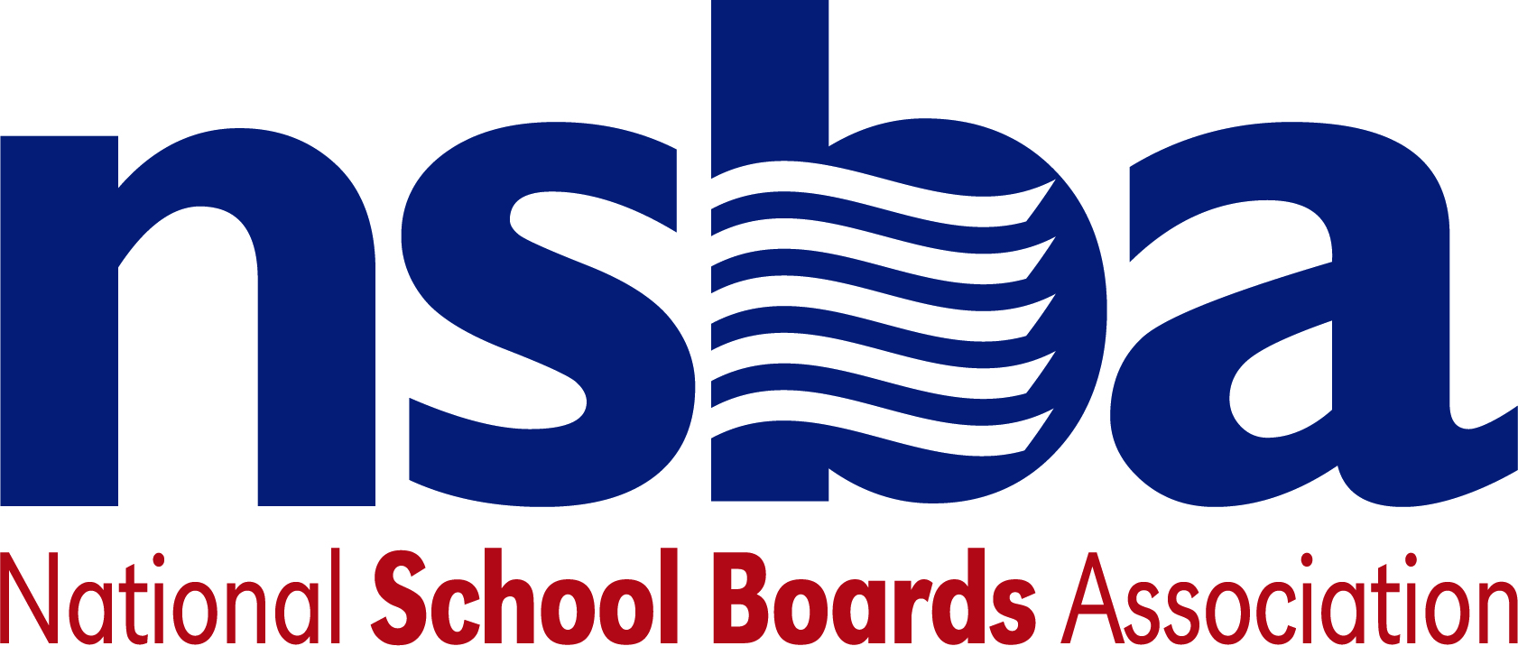

Federal Advocacy & Public Policy Team
October 9, 2020
NSBA Weekly Update

Congressional Update

Pandemic Relief Uncertain After President Trump Ends Talks
Congressional lawmakers and the White House have been negotiating sporadically, for the past several months, regarding a much-needed additional round of pandemic relief aid. More recently these talks had shown signs of progress, with House Speaker Pelosi (D-CA) and U.S. Treasury Secretary Mnuchin meeting regularly last week attempting to find agreement. House Democrats successfully passed a pared back version of their relief proposal totaling $2.2 trillion last week and the White House reportedly floated a $1.62 counteroffer to try and reach a deal. Both proposals included significant amounts of emergency relief aid for the K-12 education community to contend with the ongoing pandemic, yet both sides still remained in disagreement on other key issues related to the scope and content of the aid package. On Friday, the Administration offered a $1.8 trillion package that has already been rejected by Speaker Pelosi. Later in the day, the President made a statement he was now supportive of more funding than the $2.2 trillion proposal passed by House Democrats. Senate Majority Leader McConnell has indicated he does not think it likely a deal passes before the election.

The drama over the negotiation began earlier in the week. On Tuesday afternoon, September 6, President Trump unilaterally withdrew from the negotiations, arguing that he would seek to prioritize pandemic relief sometime after the upcoming November elections. Although the President formally discontinued these negotiations, members of his own administration have remained hopeful that Congress could pass standalone legislation to provide targeted relief for sectors of the economy where bipartisan agreement has already been reached. On Wednesday, September 7, Assistant U.S. Education Secretary Jim Blew indicated that the administration was still open to and seeking negotiations on smaller aid packages targeted at issues such as K-12 and higher education. Despite this openness, House Democrats have largely rejected this approach and have remained committed to passing a comprehensive pandemic relief package. Moreover, in ending the talks on an aid package, President Trump encouraged the Senate to prioritize the confirmation of an additional U.S. Supreme Court Justice—further reducing the likelihood that lawmakers will revisit this issue prior to the November elections.

Administration Update

Private School Proposal Struck Down in South Carolina
On Monday, September 5, House Education and Labor Chairman Bobby Scott (D-VA), along with Select Subcommittee on the Coronavirus Crisis Chairman Jim Clyburn (D-SC) wrote a letter to U.S. Secretary of Education Betsy DeVos to express concerns regarding South Carolina’s use of some of its CARES Act funding. At issue is South Carolina Governor Henry McMaster’s $32 million Safe Access to Flexible Education (SAFE) grant program which is funded through the state’s Governor’s Emergency Education Relief Funding—a flexible component of the CARES Act providing discretionary funding for Governors to address educational needs during the pandemic. Specifically, the SAFE grant program would provide these funds to families to offset the costs of private or parochial school tuition. On Wednesday, September 7, the South Carolina Supreme Court declared this program unconstitutional and has prevented the Governor from moving forward with the program’s implementation NSBA filed a brief in the case on Sept. 3 explaining that CARES Act funds were intended to support public schools and students in poverty, and noting the harm caused by voucher programs. During oral argument Justice Kaye Hearn identified NSBA as having drawn the Court’s attention to recent federal court rulings rejecting the U.S. Department of Education’s misinterpretation of the CARES Act’s intent in its filing on the case. NSBA’s statement on the decision reflected this significant victory.

Recent Legislation
- H.R.8535 — 116th Congress (2019-2020) To amend the Carl D. Perkins Career and Technical Education Act of 2006 to direct the Secretary of Education to award grants for new agricultural education programs in secondary schools. Sponsor: Rep. Finkenauer, Abby [D-IA-1]
- H.R.8534 — 116th Congress (2019-2020) To amend the Richard B. Russell National School Lunch Act to allow direct certification of children in households of active duty members of the Armed Forces for certain Federal school meal programs, and for other purposes. Sponsor: Rep. Davis, Susan A. [D-CA-53]
- H.R.8519 — 116th Congress (2019-2020) To authorize the Secretary of Education to award grants to eligible entities to carry out educational programs that include the history of peoples of Asian and Pacific Islander descent in the settling and founding of America, the social, economic, and political environments that led to the development of discriminatory laws targeting Asians and Pacific Islanders and their relation to current events, and the impact and contributions of Asian Americans to the development and enhancement of American life, United States history, literature, the economy, politics, body of laws, and culture, and for other purposes. Sponsor: Rep. Meng, Grace [D-NY-6]
- H.R.8486 — 116th Congress (2019-2020) To establish a competitive grant program to increase financial literacy instruction in elementary schools and secondary schools. Sponsor: Rep. Gallagher, Mike [R-WI-8]
- S.4782 — 116th Congress (2019-2020) A bill to authorize the Secretary of Education to award grants to improve indoor air quality in elementary schools and secondary schools in response to the COVID-19 public health emergency using proven technologies. Sponsor: Sen. Heinrich, Martin [D-NM]

NSBA Update

Special NSBA Webinar: On Tuesday, October 27, 2020 at 1:00 pm eastern, NSBA will host the kickoff event of its Public School Transformation Now! Access, Equity, & Innovation for Each Child campaign, which will bring together national education leaders to discuss innovative policies and practices to reshape and provide a more equitable public education for each child. A key issue for the COVID-19 crisis and beyond is creating student-centered, personalized learning experiences to ensure our students graduate with the 21st century skills needed to navigate a rapidly changing world. After the event, NSBA will hold a Twitter Chat using the hashtag #EdTransformation. National education experts will be sharing their insights on innovative practices during the pandemic and how to continue public school transformation in a post-COVID world. Register for the Oct. 27 event here. Additional details including the group of nationally known education leaders who will participating will be announced next week.

CSALS Call on Monday: There will be a CSALS call this Monday, October 12, 2020 at 4:00 pm eastern. The agenda will go out Monday. The details are below:

Topic: CSALS Meeting
Time: Oct 12, 2020 04:00 PM Eastern Time (US and Canada)

Join Zoom Meeting
https://zoom.us/j/98156634398

Meeting ID: 981 5663 4398
One tap mobile
+13126266799,,98156634398# US (Chicago)
+16468769923,,98156634398# US (New York)

Dial by your location
+1 312 626 6799 US (Chicago)
+1 646 876 9923 US (New York)
+1 301 715 8592 US (Germantown)
+1 408 638 0968 US (San Jose)
+1 669 900 6833 US (San Jose)
+1 253 215 8782 US (Tacoma)
+1 346 248 7799 US (Houston)
Meeting ID: 981 5663 4398
Find your local number: https://zoom.us/u/aAVn5d4WH

