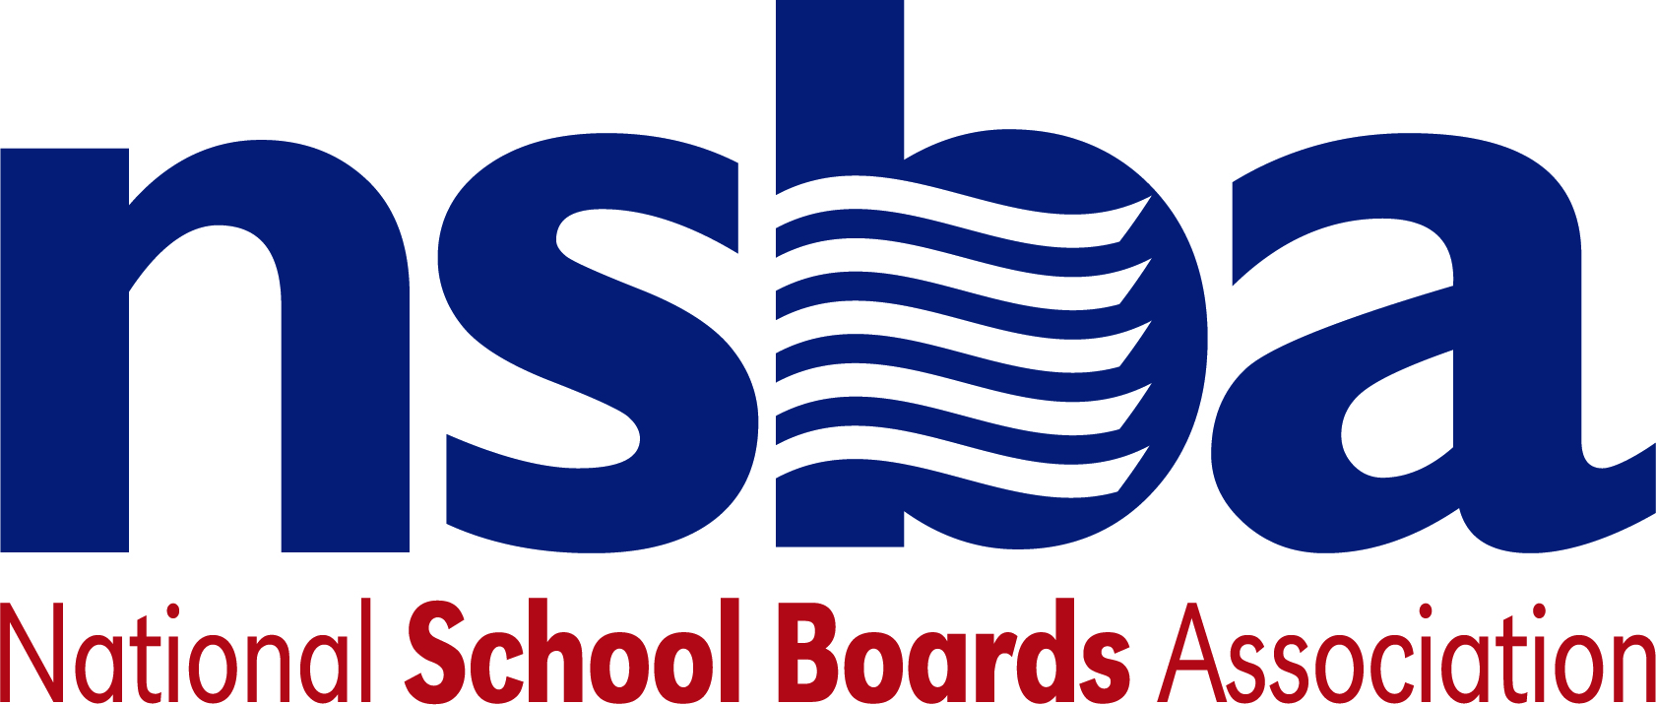

Federal Advocacy & Public Policy Team
December 21, 2020
COVID-19 Emergency Relief and Budget Update

Summary:

After technical issues delayed releasing the legislation text, the latest COVID-19 emergency relief legislation and legislation to fund the government is now available at this link. Though it is smaller in scope at $900 billion compared to the much larger CARES Act passed in March that had $2.2 trillion in funding, this is a massive piece of legislation totaling nearly 6,000 pages and includes both the emergency relief legislation and the full $1.4 trillion to fund the government next year, including education. NSBA will do its best to go through the legislation and find the most relevant issues that impact public schools and our state association members. This update is providing the best information we have at the present time. We will provide additional information as we learn more about the legislation. This update will begin with the COVID-19 emergency relief information followed by the appropriations for FY 2021.

Emergency Relief Legislation:

The COVID-19 emergency relief legislation will offer some much need relief for public schools, students, and the nation. But it still falls far short of what NSBA believes is ultimately necessary for public schools and the students we serve.

The funding level is considerably higher for K-12 public education at $54 billion than the $13.4 billion included in the CARES Act. But is still far short of the $200 billion minimum NSBA believes schools will ultimately need. The failure to provide any funding for states and local governments will also impact public school budgets as revenues tighten as the crisis continues. NSBA will be calling for another supplemental to address these financial needs and other issues not addressed in this legislation.

Notably, the bill does extend the Coronavirus Relief Fund (CRF) spending deadline to December 30, 2021 which had an original deadline of December 30, 2020. Additionally, the legislation would also extend the Families First Coronavirus Response Act (FFCRA) until March 21, 2021 which gives employer tax credits for providing both paid sick leave and paid family and medical leave. Schools and local governments were not eligible for the tax credits in the original legislation and we are still evaluating the legislation to ascertain if that exemption was placed in this legislation. We will include any information we can learn on that issue in future updates.

There remain connectivity issues that will need to be addressed in future legislation. It was disappointing that funds for the homework gap were stricken from the legislation late in the process. While there is some funding for broadband in this legislation that will offer some benefit to some students and families, it is far inadequate to deal with the full situation impacting so many students. States and districts may also use some of the funding in the $54 billion designated for K-12 public schools for connectivity as an allowable use of the funding. NSBA will continue to call on Congress to work on a bipartisan agreement for funding of at least $12 billion to go to the FCC’s E-Rate program to improve connectivity for millions of students in the next legislative package.

Key overall components of the $900 relief legislation for education include:

- $82 billion for education overall.
  - $54 billion for K-12 public schools. There is no condition related to funding based on schools physically reopening and operating with in-person education.
  - $22.7 billion for higher education.
  - $4.05 billion for the Governor Emergency Relief Fund. This includes a set-aside for private K-12 schools.
  - $250 million for Head Start.
- $10 billion for the Child Care and Development Block Grant (CCDBG).
- $7 billion to increase access to broadband.
  - $3.2 billion in emergency funds for low-income families to access broadband through "an FCC fund” which appears to be a new program. This will have some positive impact for some students but will force them to compete with other interests for the funding.
  - $1 billion for a tribal broadband fund.
  - $65 million to complete broadband maps pursuant to the Broadband DATA Act approved earlier this year.
  - There is no dedicated funding to connect the millions of students impacted by the homework gap. Originally, there was $3 billion proposed that would have been run through the E-Rate program.

2021 Appropriations and Budget:

The legislation provides a total of $73.5 billion in discretionary appropriations for the U.S. Department of Education which accounts for a slight increase of $785 million above the 2020 enacted level. It is $7 billion more than what was in the President’s budget. You can find the ED section in Title III of Division H which starts on page 1024, which is page 1032 out of 5593 pages in the PDF version. You can find the legislation at this link.

K-12 public education will receive $40.6 billion, which included funding for the Individuals with Disabilities Education Act (IDEA) This is an increase of $498 million above the 2020 enacted level. There is $16.5 billion designated for Title I grants to local educational agencies which accounts for an increase of $227 million for this program above the 2020 enacted level.

There is $14.1 billion designated for special education, an increase of $186 million above the 2020 enacted level. This includes $12.9 billion for Part B grants to states which is an increase of $173 million above the 2020 enacted funding level. There is also $23.7 million for Special Olympics education programs, representing an increase of $3.6 million above the 2020 enacted funding level.

Additional information can be found in the Report language (“statement of managers”) which includes descriptions of the program levels and the conferees’ intent behind the funding. The description of the Department of Education starts on page 111 and the funding table for Department of Education starts on page 179. You can also find additional information in the Senate Republican summary of funding highlights and House Democratic summary of funding highlights.

We will be sending additional details on this legislation as we continue to go through it. It is expected the House of Representatives will vote on the legislation later this evening and then it will go on to the U.S. Senate. We will continue to keep you informed as this process continues.

