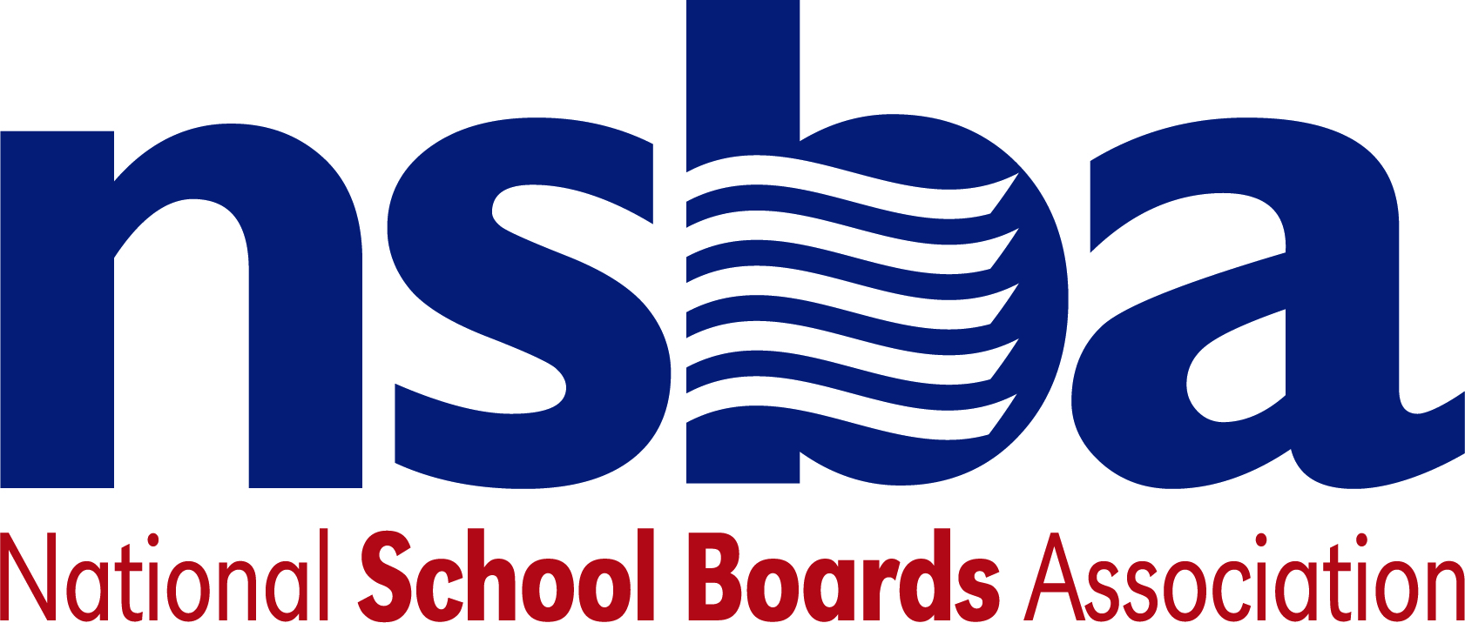

Federal Advocacy & Public Policy Team
December 11, 2020
NSBA Weekly Update

Congressional Update

Congress Pushes Funding Deadline by a Week
There was some significant progress today to keep the government temporarily open. The U.S. Senate passed the National Defense Authorization Act (NDAA) by a veto-proof majority today and the legislation passed the U.S. House of Representatives by a veto proof majority yesterday. There is also a one-week stopgap funding measure to extend government funding until next Friday, December 18. The Senate has adjourned for the weekend and is expected to be back in session Monday afternoon. The House will return on Tuesday. According to reports, lawmakers remain close to a deal on the wider omnibus spending package although funding for the southern border wall remains a sticking point in the last stage of these negotiations.

During these efforts, lawmakers are also seeking to find consensus on much needed emergency relief funding to help respond to the ongoing pandemic. If successful, lawmakers hope to attach a pandemic relief bill to the end-of-the year spending package noted above. These discussions remain fluid, but the $908 billion bipartisan proposal unveiled last week envisions at least $82 billion in targeted funding for the education sector. It is unclear yet how much of that funding would go just to K12 public education. But regardless of the breakdown, the funding level is far below NSBA’s priority request of at least $200 billion and there are concerns over diverting some funding away from public schools to go to private education through vouchers. There is continued disagreement over liability protections and state and local relief preventing consensus on the overall legislation. There is also a growing push by Senator Bernie Sanders (I-VT) with the support of Senator Josh Hawley (R-MO) to ensure a new round of $1,200 stimulus checks is included in any package which is an additional point of contention. It is unclear if the Families First Coronavirus Response Act (FFCRA) that requires covered employers with less than 500 employees to provide eligible employees with up to twelve weeks of paid leave will be extended. FFCRA is set to expire on December 31, 2020. As discussions continue, NSBA’s advocacy team will continue to impress upon Congress the critical importance of providing adequate emergency funding for the K-12 community as they continue to deal with the ongoing pandemic.

Administration Update

President-elect Biden Firms up Domestic Agenda
On Thursday, December 10, President-elect Joe Biden named Susan Rice to lead the White House Domestic Policy Council (DPC). Rice, the former Ambassador to the United Nations and a former National Security Advisor to President Obama, will lead DPC which coordinates the domestic policymaking process for the White House. As part of this work, DPC helps to develop education policy priorities for the administration and works to ensure their implementation. The announcement comes as President-elect Joe Biden has begun to unveil pieces of his domestic agenda where he has pledged to work to reopen the majority of the nation’s schools during his first 100 days in office and provide much needed funding for districts to do so safely.

IES Provides Updates on Learning Loss Initiative
Recently, the Institute of Education Sciences (IES) announced plans to launch an “Operation Reverse the Loss” initiative seeking to identify and bring to scale promising practices that could help reverse learning loss experienced by students as a result of the pandemic. These preliminary ideas and plans were largely a first step made by IES to determine how best to approach these daunting challenges. This week, IES shared additional details regarding this initiative which includes ways to develop a better understanding of learning loss already taking place, responding to this crisis with new tools to help students keep pace, and making sure at-risk and marginalized students receive additional supports to aid in their learning recovery. As part of this effort, IES is calling for significant changes to the National Assessment of Educational Progress (NAEP), providing adequate funding for special education research, creating an Education Data Science Center to help make better use of data already being collected, and establish several investigatory programs aimed at identifying best practices and strategies related to reversing learning loss.

Bills
- H.R.8869 — 116th Congress (2019-2020) To create a Council on Emergency Response Protocols to ensure the establishment of accessible, developmentally appropriate, culturally aware, and trauma-informed emergency response protocols in public schools, early childcare and education settings, and institutions of higher education, and for other purposes. Sponsor: Rep. Wild, Susan [D-PA-7]
- S.4993 — 116th Congress (2019-2020) A bill to amend the Public Health Service Act to promote healthy eating and physical activity among children. Sponsor: Sen. Booker, Cory A. [D-NJ]
- S.4956 — 116th Congress (2019-2020) A bill to create a Council on Emergency Response Protocols to ensure the establishment of accessible, developmentally appropriate, culturally aware, and trauma-informed emergency response protocols in public schools, early childcare and education settings, and institutions of higher education, and for other purposes. Sponsor: Sen. Casey, Robert P., Jr. [D-PA]

NSBA Update

NSBA’s Biden/Harris Transition Recommendations: NSBA released its recommendations to the Biden/Harris Transition Team earlier this week. The recommendations address the ongoing national emergency while setting a vision for the future of public schools across the nation focused on equity and many of the issues outlined as part of NSBA’s public school transformation campaign. One of the recommendations includes a call for the President-elect to appoint a presidential taskforce after the inauguration focused on the future of K12 education. NSBA recommended that incoming First Lady Dr. Jill Biden lead the effort and the taskforce include representation by NSBA.

CSALS Call this Monday, December 14, 2020 at 4:00 pm eastern: There will be a CSALS call this Monday, December 14 at 4:00 pm eastern. The agenda will go out on Monday.
Topic: CSALS Meeting
Time: Dec 14, 2020 04:00 PM Eastern Time (US and Canada)

Join Zoom Meeting
https://zoom.us/j/94345839901

Meeting ID: 943 4583 9901
One tap mobile
+13017158592,,94345839901# US (Washington D.C)
+16468769923,,94345839901# US (New York)

Dial by your location
+1 301 715 8592 US (Washington D.C)
+1 646 876 9923 US (New York)
+1 312 626 6799 US (Chicago)
+1 669 900 6833 US (San Jose)
+1 253 215 8782 US (Tacoma)
+1 346 248 7799 US (Houston)
+1 408 638 0968 US (San Jose)

Meeting ID: 943 4583 9901
Find your local number: https://zoom.us/u/aei1xcvD8

