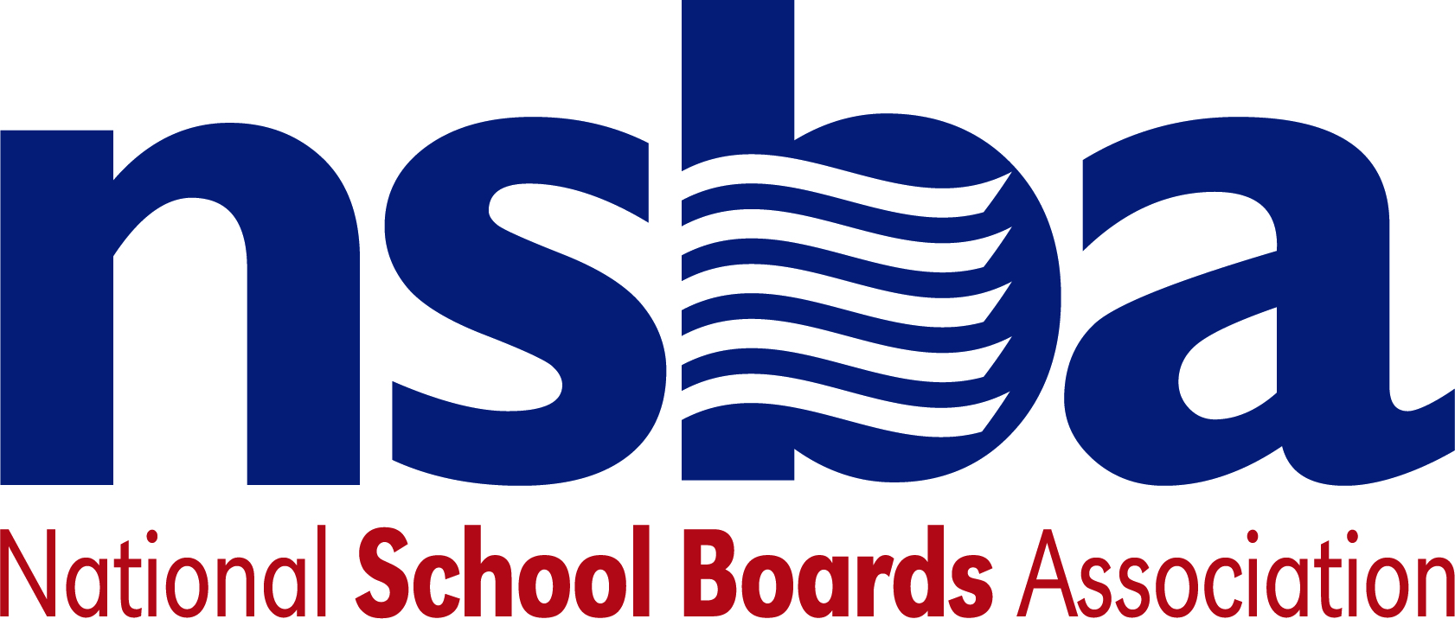

Federal Advocacy & Public Policy Team
January 29, 2021
NSBA Weekly Update

Congressional Update

Senate HELP Committee to Hold Cardona Confirmation Hearing Wednesday
The Senate Health, Education, Labor, and Pensions (HELP) Committee has scheduled a hearing to consider the nomination of Dr. Miguel Cardona to serve as U.S. Secretary of Education for Wednesday, February 3, 2021 at 10 a.m. eastern. The hearing can be viewed by going to the HELP Committee website. NSBA will have further details about how the hearing went in next week’s update.

House Education Chair Introduces Three Major Education Bills as New Committee Membership Takes Shape
On Thursday, January 28, a group of Democratic lawmakers led by Chairman Bobby Scott (D-VA) on the House Education and Labor committee introduced three education-related proposals. The bills, known respectively as the “Reopen and Rebuild America’s Schools Act,” the “Save Education Jobs Act” and the “Learning Recovery Act of 2021” would provide an additional $466 billion for the K-12 community. These funds would be targeted specifically to help support state and local efforts to improve school infrastructure, address learning loss, and avert additional layoffs in the education sector. More information, including factsheets and section-by-section summaries of these bills can be found here. In addition to this work, both parties announced several new members that will be joining the committee in the 117th Congress:

1. Rep. Jamaal Bowman (D-NY)
2. Rep. Teresa Leger Fernandez (D-NM)
3. Rep. Kathy Manning (D-NC)
4. Rep. Frank Mrvan (D-IN)
5. Rep. Mondaire Jones (D-NY)
6. Rep. Joaquin Castro (D-TX)
7. Rep. Mark Pocan (D-WI)
8. Rep. Mikie Sherrill (D-NJ)
9. Rep. Mariannette Miller-Meeks (R-IA)
10. Rep. Burgess Owens (R-UT)
11. Rep. Bob Good (R-VA)
12. Rep. Lisa McClain (R-MI)
13. Rep. Marjorie Taylor Greene (R-GA)
14. Rep. Diana Harshbarger (R-TN)
15. Rep. Mary Miller (R-IL)
16. Rep. Victoria Spartz (R-IN)
17. Rep. Scott Fitzgerald (R-WI)
18. Rep. Madison Cawthorn (R-NC)
19. Rep. Michelle Steel (R-CA)

In addition to these new developments, the committee also reconsidered and passed the National Apprenticeship Act of 2021—a legislative proposal largely the same as one passed by the entire House last Congress. The full chamber is expected to consider this measure the week of February 1.

Senators Chart Path Forward in 117th Congress
Earlier this month, both Democratic candidates in Georgia won their respective elections giving Democrats control of an evenly split 50-50 Senate chamber with Vice President Kamala Harris serving as a tie-breaking vote. Yet, for the better part of January, leadership in the Senate has failed to come to an agreement for how to formalize this power sharing structure. This disagreement appeared to have centered on Minority Leader Mitch McConnell’s (R-KY) insistence that Democrats commit to retaining the legislative component of the Senate’s filibuster. After several weeks of disagreement, McConnell backed away from this demand following public statements from two Democratic Senators who expressed their opposition to eliminating the filibuster. Since that time, both sides have reportedly coalesced around a 2001 version of a power sharing agreement.

The Senate is now working to formally pass an organizing resolution based on aspects of this power sharing agreement. This resolution will determine the rules that govern Senate operations in the 117th Congress, such as how many members each party will have on committees and it is expected to be passed by the chamber imminently.

Appropriations Committee Announces Leadership Assignments
The new House Appropriations Committee Chair, Rosa DeLauro (D-CT), announced new leaders for each of the 12 subcommittees under her jurisdiction. Of significant note to the K-12 education community, DeLauro plans to serve as Chair for the Labor-HHS-Education subcommittee, overseeing all education-related spending, as well as leader of the full appropriations committee. All of the currently serving Democratic members of the Labor-HHS-Education subcommittee are expected to return this Congress and there will be at several new Republican members, however these assignments have not yet been made public.

Administration Update

NSBA Calls on FCC to Use Existing E-Rate Funds to Help Close the Homework Gap
NSBA joined with the Schools, Health and Libraries Broadband Coalition and several other organizations to submit formal comments to the Federal Communications Commission (FCC) asking for a declaratory ruling allowing the use of E-rate funds for remote learning services off campus. The declaratory ruling would allow schools and libraries to extend E-rate-funded broadband networks and services outside of a school or library location during Funding Years 2020 and 2021, without losing E-rate funds they are otherwise eligible to receive. Importantly, this requested action would not require the collection of any additional Universal Service funds. You can read NSBA’s media statement and find the filing here.

USED Extends Deadline for State ESSA Plan Amendments
On Tuesday, January 26, the U.S. Department of Education sent a letter to all chief state school officers notifying them that the department is extending a February 1 deadline to submit requests for waivers from certain requirements of the Every Student Succeeds Act (ESSA) and related plan amendments. The letter references a recent FAQ distributed by USED on January 19 which outlines the process states must undertake to make a change to their ESSA plan or to request a waiver from certain provisions in the law. The letter indicates that this move is part of the Biden Administration’s overall review of all existing USED policies.

CDC Researchers Support School Buildings Reopening (With Some Caveats)
As the pandemic continues, school leaders and policymakers across the country are grappling with whether and how to reopen safely for in-person student learning. On Tuesday, January 26, three researchers from the Centers for Disease Control and Prevention (CDC) published an article stating, in part, that “accumulating data now suggest a path forward to maintain or return primarily or fully to in-person instructional delivery.” The article provides an extensive analysis and review of existing research on this topic. Among several findings, the article argues that, “. . . there has been little evidence that schools have contributed meaningfully to increased community transmission.” Instead, the authors argue that schools and policymakers should consider limiting close-contact activities, such as sports, mandate face masks, reduce classroom size, increase air ventilation, use hybrid attendance models, and base school reopening decisions on the context of a school’s wider community.

IES Study on Distance Learning
USED’s Institute of Education Science’s “What Works Clearinghouse” (WWC) initiative released a report this week reviewing 36 studies relating to distance learning programs. The authors found that 15 of these studies met the minimum design parameters for WWC. Of these 15 studies, the WWC found that only four met Tier I requirements outlined in the ESSA—a provision in the law that is intended to help states and local school districts identify the most effective programs, practices, and policies supported by research. All distance learning studies examined as part of this effort can be viewed here.

Bills

- H.R.465 To amend the Richard B. Russell National School Lunch Act to require a school food authority to make publicly available any waiver of the Buy American requirement, and for other purposes. Sponsor: Rep. Garamendi, John [D-CA-3]
- H.R.447 National Apprenticeship Act of 2021 Sponsor: Rep. Scott, Robert C. "Bobby" [D-VA-3]
- H.R.426 To provide that for purposes of determining compliance with title IX of the Education Amendments of 1972 in athletics, sex shall be recognized based solely on a person's reproductive biology and genetics at birth. Sponsor: Rep. Steube, W. Gregory [R-FL-17]
- H.R.400 To amend the Elementary and Secondary Education Act of 1965 to increase civics education programs, and for other purposes. Sponsor: Rep. Hastings, Alcee L. [D-FL-20]
- S.72 A bill to require full funding of part A of title I of the Elementary and Secondary Education Act of 1965 and the Individuals with Disabilities Education Act. Sponsor: Sen. Van Hollen, Chris [D-MD]
- S.52 A bill to establish a career pathway grant program. Sponsor: Sen. Hassan, Margaret Wood [D-NH]
- S.45 A bill to amend the Elementary and Secondary Education Act of 1965 to strengthen school security. Sponsor: Sen. Cruz, Ted [R-TX]

NSBA Update

NSBA Advocacy Institute 2021 Goes Online in June: NSBA has decided it is in the best interest of the organization and its members that the 2021 Advocacy Institute be a fully online experience that will take place virtually Tuesday, June 8 and Wednesday, June 9, using a digital platform. Due to continued uncertainty over what the District of Columbia guidelines will be this summer, as well as other unknown issues related to COVID-19 and travel, scheduling an in-person event would be risky for the organization and attendees. Further, in addition to restrictions on capacity at area hotels, setting up in-person visits with members of Congress seems unlikely under the present circumstances. Therefore, NSBA is planning a high-quality online event focused on unifying members around our advocacy priorities and highlighting key policy issues, providing advocacy training, and bringing in well-known national figures to address the online attendees. NSBA is excited about the potential for this event and is working on refining the agenda and logistics.
CSALS Meeting on Monday, February 1, 2021: The next CSALS meeting will be this Monday, February 1, 2020 at 4:00 pm eastern. The agenda will go out Monday morning and the meeting logistics are below:
Topic: CSALS Meeting
Time: Feb 1, 2021 04:00 PM Eastern Time (US and Canada)

Join Zoom Meeting
https://zoom.us/j/92964189492

Meeting ID: 929 6418 9492
One tap mobile
+13017158592,,92964189492# US (Washington DC)
+13126266799,,92964189492# US (Chicago)

Dial by your location
+1 301 715 8592 US (Washington DC)
+1 312 626 6799 US (Chicago)
+1 646 876 9923 US (New York)
+1 253 215 8782 US (Tacoma)
+1 346 248 7799 US (Houston)
+1 408 638 0968 US (San Jose)
+1 669 900 6833 US (San Jose)
Meeting ID: 929 6418 9492
Find your local number: https://zoom.us/u/aetfj8YEb2

