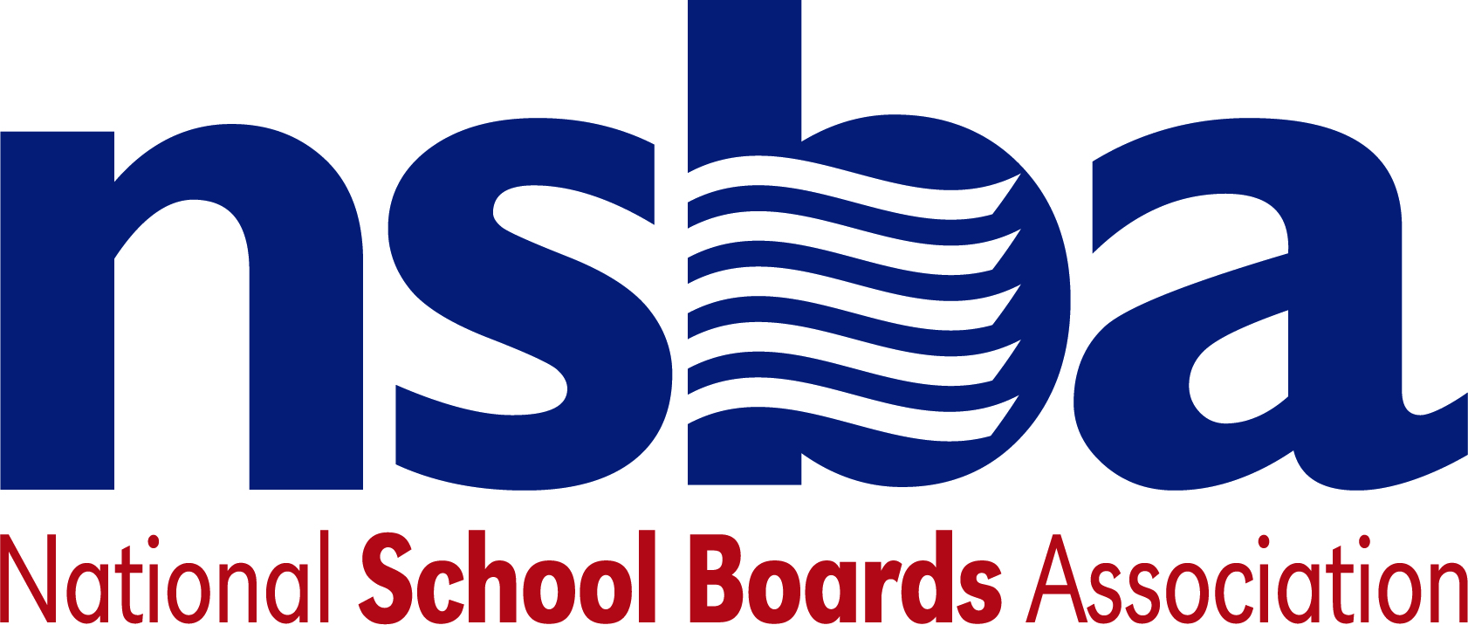

Federal Advocacy & Public Policy Team
February 19, 2021
NSBA Weekly Update

Congressional Update

House Moves Forward with Pandemic Relief/NSBA Sends Letter to Budget Committee
Late last week, several House committees finalized their respective pieces of a $1.9 trillion pandemic relief package modeled on President Biden’s American Rescue Plan. These efforts are part of a wider “budget reconciliation” process that allows lawmakers to advance legislation with simple majorities in both legislative chambers. As part of this effort and in addition to the $130 billion in proposed emergency aid for the K-12 community finalized last week, the House Energy and Commerce Committee approved a measure that would provide $7.6 billion in funding to the E-rate program. The bill also would direct the Federal Communications Commission (FCC) to develop rules allowing schools and libraries to use a portion of these funds to purchase connectivity equipment. Late Friday, February 12, the House Oversight Committee approved their component of the forthcoming reconciliation package which aims to provide nearly $350 billion in aid for State, Local, and Tribal governments—a proposal that, if passed, would likely positively impact state K-12 education budgets as well.

In total, House committees of jurisdiction have now cleared nine separate legislative components that constitute President Biden’s American Rescue Plan. Having now assembled them into a single package, the House Budget Committee will hold a virtual markup on Monday, February 22, to formally consider this legislation. The measure is expected to pass and advance for consideration on the House floor following this markup and related vote next week. The House Education and Labor Committee released a preliminary estimate of a state-by-state breakdown of the education funding in the proposed bill.

Today, in anticipation of the markup of the legislation on Monday, NSBA sent a letter to the U.S. House Budget Committee in support of several measures that will help students, schools, and their communities in the COVID-19 recovery package. Specifically, NSBA noted the legislation would provide targeted assistance for secure, healthy learning environments, including resources to help mitigate loss of learning, services for social and emotional needs, and broadband connectivity for students impacted by the digital divide as well as provide supports for school districts and other public sector employers for COVID-related emergency employee leave and additional supports for our most vulnerable students to address equity in education.

Senate Appropriations Roster Announced
On Friday, February 12, Senate Appropriations Committee Chair Leahy (D-VT) and Vice Chair Shelby (R-AL) announced the rosters, including the respective chairs and ranking members, for each of the subcommittees that oversee various components of the federal budget, including education. Of note, Senator Murray (D-WA) will serve as Chairwoman, once again, for the Senate Labor-HHS-Education Appropriations Subcommittee—the panel overseeing all education spending in the Senate. Senator Blunt (R-MO) will serve as Ranking Member. More information can be found here.

Administration Update

CDC and USED Issue Updated School Reopening Guidance
As referenced in last week’s update, on Friday, February 12, the Centers for Disease Control and Prevention (CDC) released new guidance to help states, districts, and schools reopen safely for in-person instruction. Dubbed an “operational strategy,” the CDC argues that “Evidence suggests that many K-12 schools that have strictly implemented mitigation strategies have been able to safely open for in-person instruction and remain open.” The new guidelines provide a series of recommendations organized around several “essential elements” including:

- Consistent implementation of layered mitigation strategies to reduce transmission of SARS-CoV-2 in schools
- Indicators of community transmission to reflect level of community risk
- Phased mitigation and learning modes based on levels of community transmission
- Testing to identify individuals with SARS-CoV-2 infection to limit transmission and outbreaks
- Vaccination for teachers and school staff, and in communities, as soon as supply allows

In addition, the U.S. Department of Education (USED) also released a handbook detailing strategies for safely reopening K-12 schools. The document emphasizes safe practices for in-person learning and considerations for extracurricular activities and transportation, among other elements, in determining how best to reopen a school. While both guidance documents underscore the need to prioritize vaccinations for K-12 school professionals and staff, the administration has stopped short of calling for widespread vaccinations prior to reopening schools—a position echoed by Dr. Anthony Fauci this week.

FCC Comment Deadline Approaching
Final input from the public is due February 23 in response to a recent public notice from the Federal Communications Commission (FCC) regarding the E-rate program. The notice is seeking input on potential changes to the E-rate program that would broaden the allowable uses of E-rate funding to better support remote learning during the pandemic. At present, E-rate funds cannot be used to support activities aimed at increasing broadband access unless they are directly on a school or library campus. Earlier this month, NSBA and several other organizations filed a petition calling on the agency to allow E-rate funds to be used “off campus” to more effectively support remote learning during the ongoing pandemic. This petition led to the current request by the FCC for public comments. If granted, this temporary rule change could help an estimated 16 million students who lack internet connectivity at home connect to the internet and close the homework gap.

Bills

- H.R.1054 To require the Secretary of Education to provide assistance to the immediate family of elementary or secondary school staff members killed in an act of violence while performing school duties. Sponsor: Rep. Hastings, Alcee L. [D-FL-20]

NSBA Update

Next Week is Public Schools Week and Digital Learning Day: This is a reminder that two major national advocacy events are occurring next week. Public Schools Week runs from Monday, February 22 through Friday, February 26, 2021. NSBA is a proud partner in supporting this five-day long campaign helping administrators, teachers, specialists, parents, and school board members to host events for their communities and reach out to lawmakers, businesses, and other community members to discuss the importance of public education. During that same week, on Thursday, February 25, 2021, Digital Learning Day (#DLDay) will take place. #DLDay is an opportunity for educators to share great ideas, amazing stories, and promising practices through social media and within their own schools and communities. The goal of #DLDay is to show that every day in schools should be a digital learning day using technology and digital content to help teachers and students learn in new environments and instruction models such as personalized learning. There will be special emphasis by NSBA on #DLDay on closing the homework gap. NSBA will be actively participating in both celebrations and encourages state associations and local school board members to use these opportunities to promote public schools and the students they serve.
2021 Advocacy Institute Online Update: We have added a day to the NSBA Advocacy Institute. The event will now be June 8-10 and the final day will be a virtual “Hill Day” with a virtual luncheon featuring key Congressional leaders. Registration will open in early March.
New CSALS Chair Elected: Congratulations to Leah Fliter, Director of Governmental Relations for the Kansas Association of School Boards, who has been elected as Steering Committee Chair for the Conference of State Association Legislative Staff (CSALS) for 2021. NSBA is excited to work with Leah and CSALS in the coming months to promote our common advocacy goals.

