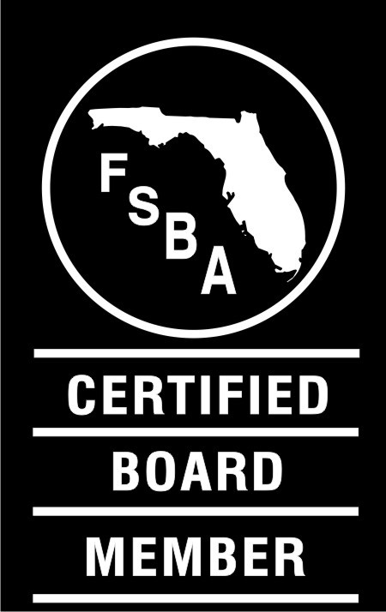
Florida School Boards Association
2021 SCHOOL FINANCE FORUM 2.0
April 8-9, 2021

Day 1—Thursday, April 8, 2021

7:00 – 8:30 Breakfast La Hacienda
8:30 a.m. Welcome, Introductions, and Startups
Budget
Revenues (Federal, State, Local)
Expenditures (All Objects)
Adopting, Presenting, and Monitoring the Budget
Truth in Millage
12:00 noon LUNCH (45 minutes)
Fund Balance
Break

Red Book Review
Audits (Operational, Financial, Student, Transportation, etc.)

4:30 p.m. Dinner on Your Own

Day 2—Friday, April 9, 2021

7:00 – 8:00 Breakfast in La Hacienda

8:00 a.m. Welcome and Question Review

Capital Plan – Five Year Work Plan

Break

Grants – Title 1, Title 2, Title 3, IDEA, ESSER(s), CARES, GEER, etc.

In depth review of the Florida Education Finance Program (FEFP)
- Full-Time Equivalent (FTE) Weights
- Enrollment Projections
- Funding by Programs
- Base Student Allocation (BSA)
- Additional Elements of the FEFP Formula
- Required Local Effort (RLE)
- Categorical Programs
- Scholarships, Vouchers, and Corporate Tax Credits
Preparing for the Future
Question and Answer Session 11:30 a.m. Adjourn

