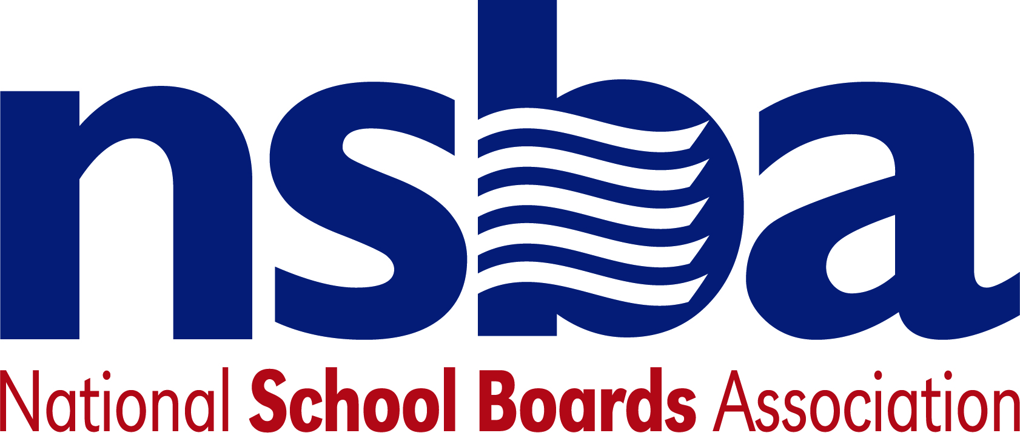

Federal Advocacy & Public Policy Team
March 26, 2021
NSBA Weekly Update

Congressional Update

House Releases Community Project Funding Guidance
On Tuesday, March 23, the House Appropriations Committee formally published guidance regarding the process for Members of Congress to request “Community Project Funding”—the committee’s new term for appropriations earmarks. As previously shared, House appropriations leaders have sought to ensure the new process for requesting earmarks ensures transparency and accountability as reflected in this new guidance. Of note for the K-12 community the “Innovation and Improvement” account for elementary and secondary education, composed of programs most recently funded at $1.1 billion, is eligible for requests from Members of Congress for the upcoming FY 2022 appropriations cycle—a process that must be completed by October 1, 2021 before current funding is set to expire.

Senate HELP Committee Considers Deputy Secretary of Education Nomination
On Wednesday, March 24, the Senate Health, Education, Labor, and Pensions (HELP) Committee held a hearing to consider President Biden’s nomination of Cindy Marten to be the next U.S. Deputy Secretary of Education. Since 2013, Marten has been the Superintendent of San Diego’s Unified School District in California. During the hearing, Marten promoted summer learning programs as an effective strategy for districts to consider when determining how best to combat student learning loss due to the ongoing pandemic. In addition, she highlighted her own experiences as superintendent when addressing the issue of school reopening’s. Marten also voiced support for the U.S. Department of Education’s recent decision to require states to move forward with federally mandated standardized assessments. The committee is expected to formally vote on Marten’s nomination in the coming weeks and she is widely expected to be confirmed by the full Senate shortly thereafter.

House Hearing Explores Educational Equity Post-Pandemic
On Thursday, March 25, the House Education and Labor Committee’s Early Childhood, Elementary,
and Secondary Education Subcommittee held a hearing titled, “Lessons Learned: Charting the Path to Educational Equity Post-COVID-19.” Witnesses included:

- Marc H. Morial, President and CEO, National Urban League
- Jennifer Dale, Parent, Lake Oswego, OR
- Selene A. Almazan, Legal Director, Council of Parent Attorneys and Advocates, Inc.
- Alberto M. Carvalho, Superintendent of Schools, Miami-Dade County Public Schools

The hearing focused on a slew of K-12 education topics and issues brought to the forefront due to the ongoing pandemic. Much of the discussion centered on schools returning to in-person instruction, along with an exploration of how states and school districts plan to make use of federal pandemic aid made available through the recently passed American Rescue Plan. The topic of standardized assessment was also brought up a number of times—by both witnesses and subcommittee members—with some arguing that testing should be suspended during the pandemic, while others defended testing as a key way to ensure an equitable educational recovery for all students. An archived video of the hearing, along with written statements, is available here.

Administration Update

USED Hosts School Reopening Summit
On Wednesday, March 24, the U.S. Department of Education (USED) hosted a “National Safe School Reopening Summit” which brought together education stakeholders from across the country to discuss and share best practices related to school reopening’s. The summit was comprised of three separate sessions focused on implementing the Center for Disease Control and Prevention’s (CDC) K-12 operational strategy regarding school reopening’s (recently updated by the CDC on March 19), lessons learned during these efforts, and how schools and districts can best address students’ academic, social, and emotional needs throughout the pandemic.

In addition to these discussions, Secretary of Education Miguel Cardona also announced that his department was making nearly two-thirds of the approximately $122 billion in K-12 funding from the American Rescue Plan (ARP) available to states and school districts ($81 billion total). In a related press release, the department noted that “The remainder of ARP [K-12] funds will become available after states submit the plans they are developing and implementing for using ARP. . .” funding to safely reopen schools.

Following the summit, the department also announced plans to launch a school reopening listening tour and “Summer Learning and Enrichment Collaborative” which will seek to share best practices for summer learning. This announcement came after 11 Senators, led by Sen. Murphy (D-CT) wrote to Cardona urging his department to provide further information and guidance regarding how states and school districts can best provide summer enrichment activities.

USED Releases New School Survey Data
Shortly after his inauguration, President Biden signed an executive order supporting the reopening of K-12 schools. As part of this order the President directed USED’s Institute of Education Sciences (IES) to survey K-12 schools and districts regarding the impact of the COVID-19 pandemic, including collecting data on the status of in-person instruction at schools. On Tuesday, IES released the first in what will be a series of findings from an ongoing survey of public schools throughout the country. This newly released survey showed that more than three-quarters of all fourth and eight grade public school students attended schools that provided hybrid or in-person instruction during the past few months. The survey and related data collection will continue monthly through June of this year with additional results published periodically. The full survey results from this most recent release can be accessed here.

Bills
- S.883 A bill to modify the Federal TRIO programs. Sponsor: Sen. Collins, Susan M. [R-ME]
- S.879 A bill authorize the Secretary of Education to make grants to support educational programs in civics and history, and for other purposes. Sponsor: Sen. Coons, Christopher A. [D-DE]
- H.R.2147 To prohibit States and local educational agencies that ban books from receiving funds under the Student Support and Academic Enrichment Grants program. Sponsor: Rep. Joyce, John [R-PA-13]
- H.R.2106 To provide for the elimination of the Department of Education, and for other purposes. Sponsor: Rep. Rouzer, David [R-NC-7]

NSBA Update

CSALS Meeting on Monday, March 29, 2021 at 4:00 pm eastern: There will be a CSALS meeting this Monday. The agenda will go out the day of the event. Call logistics are below:

Topic: CSALS Meeting
Time: Mar 29, 2021 04:00 PM Eastern Time (US and Canada)

Join Zoom Meeting
https://zoom.us/j/93378453318

Meeting ID: 933 7845 3318
One tap mobile
+13017158592,,93378453318# US (Washington DC)
+13126266799,,93378453318# US (Chicago)

Dial by your location
+1 301 715 8592 US (Washington DC)
+1 312 626 6799 US (Chicago)
+1 646 876 9923 US (New York)
+1 408 638 0968 US (San Jose)
+1 669 900 6833 US (San Jose)
+1 253 215 8782 US (Tacoma)
+1 346 248 7799 US (Houston)
Meeting ID: 933 7845 3318
Find your local number: https://zoom.us/u/acKX02LRBK

