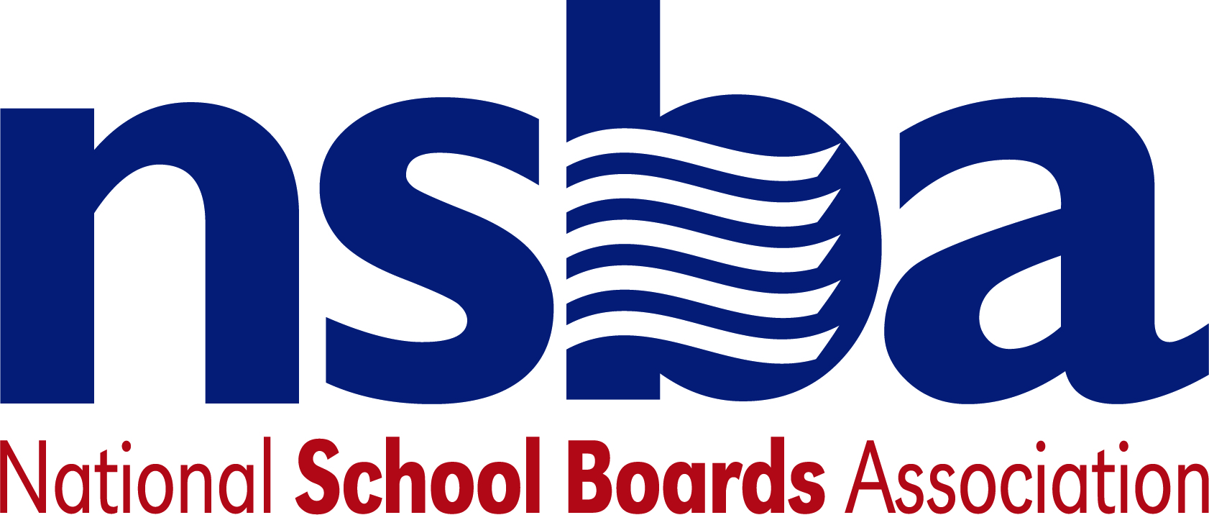

Federal Advocacy & Public Policy Team
March 5, 2021
NSBA Weekly Update

Congressional Update

Senate Considers American Rescue Plan
On Saturday, February 27, the House of Representatives passed the American Rescue Plan (ARP) Act of 2021 (H.R. 1319), mostly along party lines, by a margin of 219-212. If enacted, ARP would provide nearly $1.9 trillion in assorted relief funding to help respond to and recover from the COVID-19 pandemic. Since the bill’s passage in the House, ARP was sent to the Senate where the upper chamber has spent most of this week determining what components of the legislation are allowable under the budget reconciliation process—a legislative mechanism allowing Congress to pass legislation, like ARP, with simple majorities in both chambers. On Thursday, March 4, the Senate Budget Committee released a substitute amendment, making several changes to the House-passed version of the ARP, as the full chamber prepares for formal consideration of the legislation over the next few days.

Of particular note, the Senate’s version of the ARP proposes $125 billion in additional aid for the K-12 community via the existing Elementary and Secondary Education Relief (ESSER) Fund—roughly $3 billion less than proposed by the House. In addition, the Senate’s vision for ARP requires that 87.5% of funds be distributed to local school districts (as opposed to 90% in the House-passed ARP). With a higher state-level funding set-aside allowance, the Senate version of the ARP would require state education agencies to reserve at least one percent of this funding for evidence-based summer school and afterschool programs respectively. Another change made by the Senate is a new requirement that 2.5% of this funding be used for purchasing educational technology. Both bills maintain a requirement that at least five percent of this state-level funding be used to address learning loss.

The Senate’s proposed bill also makes several technical changes to the legislation’s “maintenance of equity” provision and slightly modifies the existing local allowable uses of ESSER funds to ensure funding can be used to implement school reopening guidance from the Centers for Disease Control and Prevention (CDC) among other changes.

Unlike the House version of the ARP, the Senate version of ARP proposes $2.75 billion in dedicated funding for nonpublic schools to support private schools. While the House-passed bill authorizes equitable services for private schools consistent with the existing Elementary and Secondary Education Act (ESEA) statute, the Senate version would establish a precedent to expand vouchers beyond ESEA equitable services and thus create another federal funding stream for private schools, rather than a limited form of assistance within existing law. NSBA believes public tax dollars should only support public schools and opposes any efforts to subsidize tuition or expenses at elementary or secondary private schools, religious schools, or private home/correspondence schools with public tax dollars. Specifically, NSBA opposes vouchers, tax credits, and tax subsidies for use at non-public K-12 schools. NSBA encourages outreach to Congress concerning this issue.

Finally, the Senate’s version of ARP proposes $7.172 billion in additional funding for the E-rate program to support student remote learning to help with the homework gap, the term used to describe the digital divide for students when they are out of school buildings. The number is approximately $500 million less than the amount proposed by the House. While the overall numbers in both versions of the legislation is below the $12 billion that NSBA believes is ultimately needed for short-term relief in narrowing the homework gap, it is a good step forward in helping the millions of students who lack adequate access during the pandemic.

After releasing the text of the bill in the Senate, members voted along party lines to proceed to debate on this updated version of ARP Thursday afternoon. The Senate’s formal consideration of this bill is expected to be protracted and will likely last through much of the weekend. However, this legislation is widely expected to pass narrowly along party lines—a sequence of events that would send the bill back to the House for final consideration and likely passage sometime next week. Lawmakers hope to pass this legislation prior to March 14 when currently expanded unemployment benefits are set to expire.

Earmarks Mount a Comeback in Congress
In 2011, Congress banned the use of “earmarks”—funding requested by individual members of Congress for specific projects or purposes. On Monday, March 1, House Appropriations Chair Rosa DeLauro (D-CT) announced plans to resurrect the practice, rebranding them as “Community Project Funding,” and proposing much stricter rules regarding their use. Earmarks have fervent proponents who argue that the practice facilitates more efficient legislating in Congress, while detractors argue it leads to waste and has the potential for abuse. Chairwoman DeLauro’s counterpart in the Senate, Appropriations Committee Chairman Leahy (D-VT), is reportedly working on a forthcoming agreement with the House to fully reinstitute the practice for the current 117th Congress and the related appropriations process.

Administration Update

Cardona Confirmed to Lead USED
On Monday, March 1, the Senate officially confirmed Miguel Cardona as the next U.S. Secretary of Education. The Senate voted 64-33 in favor of Cardona’s nomination and Vice President Kamala Harris formally swore him in the following day. In an op-ed published on Tuesday, Secretary Cardona announced that he plans to host a national summit on reopening school buildings and outlined several related areas that he plans to prioritize in the near-term. On Wednesday, Secretary Cardona, along with First Lady Jill Biden, visited K-12 schools in Connecticut and Pennsylvania highlighting efforts to safely reopen school buildings for in-person instruction. The visit comes amid President Biden’s call earlier in the week to prioritize teacher vaccinations as part of wider efforts to expedite reopening of school buildings in the coming weeks and months ahead.

Bills
- H.R.1581 To support library infrastructure. Sponsor: Rep. Levin, Andy [D-MI-9]
- H.R.1566 To amend the Child Abuse Prevention and Treatment Act to require that equitable distribution of assistance include equitable distribution to Indian tribes and tribal organizations and to increase amounts reserved for allotment to Indian tribes and tribal organizations under certain circumstances, and to provide for a Government Accountability Office report on child abuse and neglect in American Indian tribal communities. Sponsor: Rep. Grijalva, Raul M. [D-AZ-3]
- H.R.1547 To improve the financial literacy of secondary school students. Sponsor: Rep. Cartwright, Matt [D-PA-8]
- H.R.1498 To require that local educational agencies disclose negotiations with teacher unions as a condition for eligibility to receive funds under the Elementary and Secondary School Emergency Relief Fund of the Education Stabilization Fund of the Coronavirus Response and Relief Supplemental Appropriations Act, 2021. Sponsor: Rep. Good, Bob [R-VA-5]
- H.R.1433 To reauthorize the Helen Keller National Center for Youths and Adults Who Are Deaf-Blind. Sponsor: Rep. Pocan, Mark [D-WI-2]
- H.R.1418 To amend the Elementary and Secondary Education Act of 1965 to provide grants to local educational agencies to establish "Family Friendly School" policies at 500 elementary schools that align the school day with the work day to better support working families and to disseminate the learnings from these model schools so that other local educational agencies may adopt these practices, and to establish a supplemental 21st century community learning centers grant program to support programs and activities during summer recess when school is not in session. Sponsor: Rep. Morelle, Joseph D. [D-NY-25]

Discretionary Grants
USED published notice on a discretionary grant program for the Office of Elementary and Secondary Education:
- “Indian Education Discretionary Grants Programs – Professional Development Grants Program” – The Indian Education Professional Development Grant programs seeks to increase the number of qualified Indian individuals in professions that serve Indians, as well as to provide training to qualified Indian individuals to become teachers and administrators. The estimated available funds for this program total $7,809,000, with no award exceeding $400,000 for the first, second, or third 12-month budget period. Applications are due by May 3, 2021, and further information is available here.

NSBA Update
NSBA 2021 Advocacy Institute Online: The registration link for the 2021 Advocacy Institute Online, a virtual event, scheduled for June 8, 9, and 10 is now open for registration. NSBA is excited to provide this special online experience focused on the issues and priorities for the nation’s local school board members. Scores of nationally known speakers, members of Congress, and officials from the Biden administration will be announced in the coming weeks and a national poll on public schools will be released during the opening session that is being commissioned by the National School Boards Action Center. Issues highlighted in the poll will include the homework gap, the importance of teachers, public school funding, the pandemic, private school vouchers, and other issues impacting education. The results from the poll will help drive messaging and communications as NSBA moves its advocacy agenda for public schools forward.

