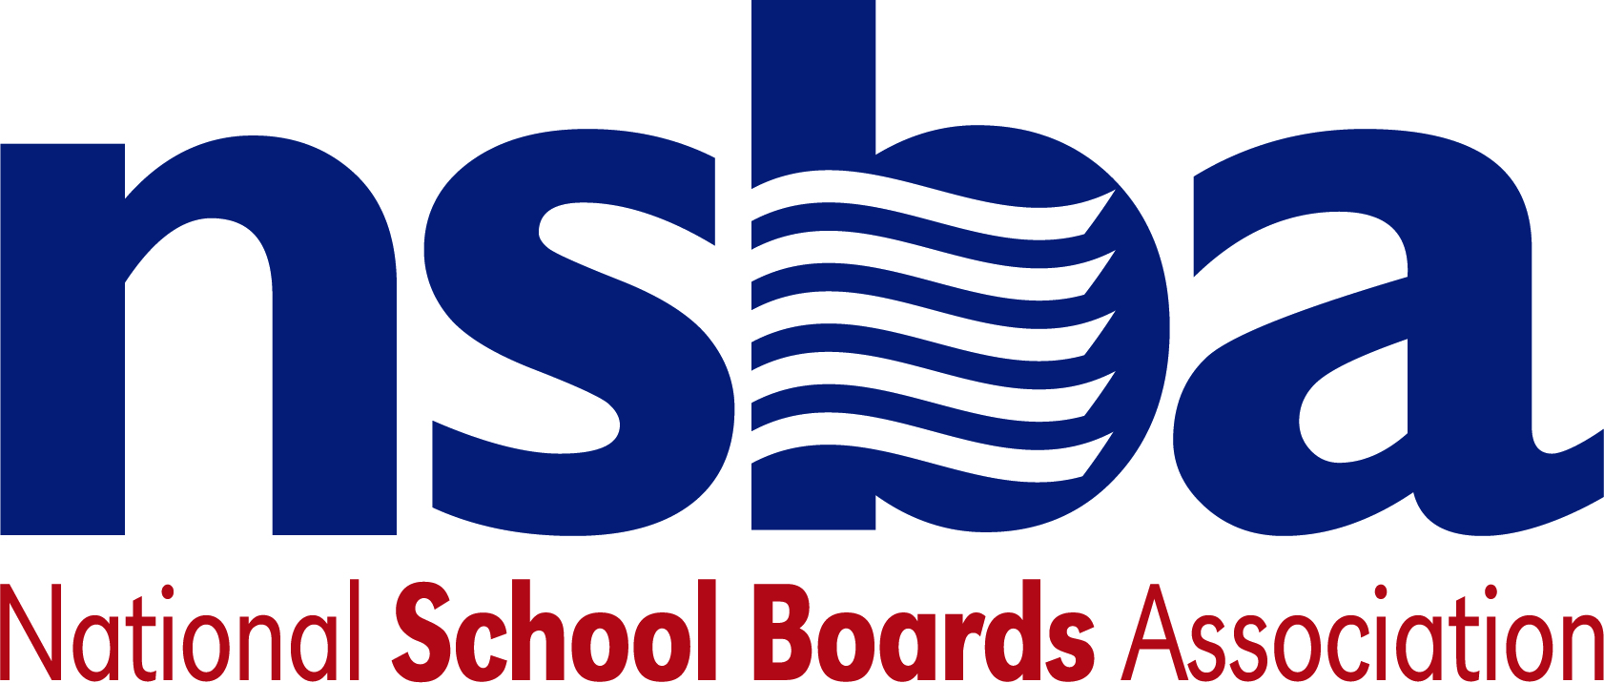

Federal Advocacy & Public Policy Team
April 2, 2021
NSBA Weekly Update

Congressional Update

President Biden Unveils Infrastructure Proposal
On Wednesday, March 31, the Biden administration released a long-awaited legislative proposal to invest roughly $2.3 trillion in infrastructure projects and related efforts over the next eight years. Dubbed the “American Jobs Plan,” the proposal outlines a multitude of areas that the administration would like Congress to prioritize for infrastructure investment as part of a larger push to spur further economic recovery. Of particular note, the proposal envisions a new $100 billion investment specifically dedicated to modernizing existing structures and building new K-12 school facilities. The plan also proposes $12 billion and $25 billion for these same purposes for community colleges and childcare facilities, respectively. The proposal also seeks to invest heavily in the nation’s digital infrastructure, recommending Congress dedicate $100 billion to expand broadband access and increase affordability. To fund these and many other new proposed investments, the American Jobs Plan recommends tax increases on corporations and high-income earners among other provisions intended to raise revenue.

Democratic education leaders, Chairman Scott (D-VA) and Chairwoman Murray (D-WA), expressed early support for the proposal upon its release. However, Congressional Republicans have been much less receptive to this initial legislative proposal from the Biden Administration. With both the House and the Senate on recess through most of next week, lawmakers will have ample opportunity to consider the proposal before returning to Washington, D.C. later this month. A White House factsheet on the plan can be accessed here.

Administration Update

USED Announces (Some) State Waiver Decisions
Late Friday evening, March 26, the U.S. Department of Education (USED) released several decisions regarding state waiver requests related to the Every Student Succeeds Act (ESSA). In response to the ongoing pandemic, several states have sought to waive federally mandated testing requirements as part of ESSA. Since President Biden’s inauguration earlier this year, USED has made clear that it will not issue “blanket waivers” for states absolving them of these testing requirements for a second year in a row. In Friday’s communications to states, USED formally denied assessment broad waiver requests from Georgia and South Carolina. Conversely, USED approved Colorado’s more narrow request for additional testing flexibilities. In response to several other states, the department has asked for additional information as it considers other requests for flexibilities regarding the implementation of ESSA this spring.

GAO Report on State and School Pandemic Education Funding
On Wednesday, March 31, the Government Accountability Office (GAO) released a new report examining the federal government’s overall response to the COVID-19 pandemic. As part of this effort, the GAO specifically examined the U.S. Department of Education’s (USED) ongoing efforts to track how states and school districts are making use of billions of dollars in pandemic relief funding. The report found that USED’s current approach to tracking this spending could inaccurately portray the amount of funding actually spent by states and school districts. The report goes on to make several recommendations, including that USED, “... regularly collect and publicly report information on school districts’ financial commitments (obligations), as well as outlays (expenditures) in order to more completely reflect the status of their use of federal COVID-19 relief funds.” USED has expressed agreement with this finding and related recommendations and plans to modify annual reporting requirements to capture this information more accurately going forward.

FCC Connectivity Fund Comment Deadline Next Week
Last month, the Federal Communications Commission (FCC) announced that it was seeking input from the public on how best to structure rules regarding the Emergency Connectivity Fund—$7.171 billion in funding authorized by the American Rescue Plan Act of 2021 (P.L. 117-2) intended to allow schools and libraries to use these funds to purchase eligible connectivity equipment and devices. These additional funds provided by the ARP aim to help more students afford internet-capable devices and reduce the so-called homework gap and larger digital divide exacerbated by the ongoing pandemic. Comments are due next week, April 5, with reply comments due April 23.

Bills

• S.1026 A bill to assist States in, and pay for the Federal share of the cost of, defraying the cost of pre-apprenticeships or related instruction associated with qualified apprenticeship programs, and for other purposes. Sponsor: Sen. Klobuchar, Amy [D-MN]

NSBA Update

New NSBA Blog on NAEP and Music Education: The NSBA Center for Public Education recently released a blog that explores music education, from the newly released 2016 NAEP assessments in music and visual arts results to its role in school transformation. As we navigate through the pandemic is it important to remember the vital role the arts can play to help students have a full educational experience. You can view the blog here

