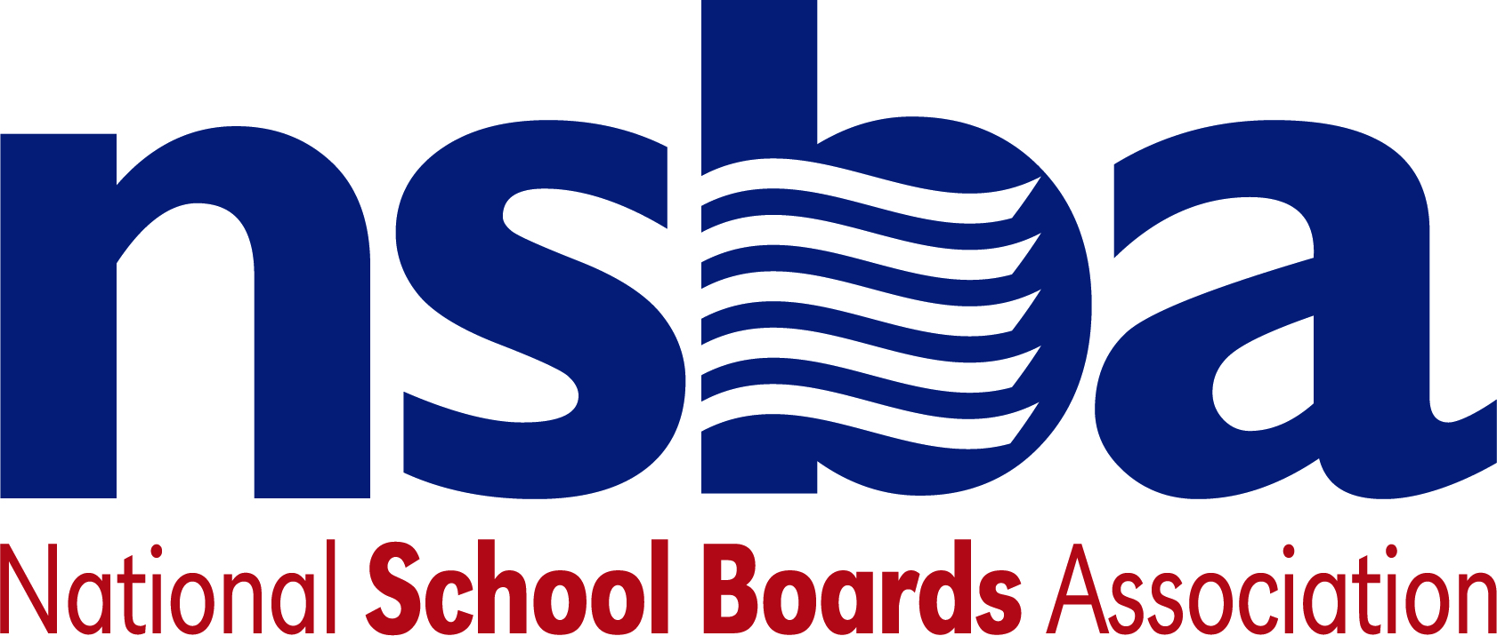

Federal Advocacy & Public Policy Team
May 14, 2021
NSBA Weekly Update

Congressional Update

Forthcoming Infrastructure Package Continues to Take Shape
Since the passage of the American Rescue Plan Act (P.L. 117-2), legislation that provided nearly $122 billion in additional funding for the K-12 community, President Biden has pivoted his administration to its next legislative priority— significant new investments in the nation’s infrastructure. President Biden’s infrastructure priorities, outlined in the American Families and Jobs plans and totaling nearly $4 trillion, must now be considered by Congress to advance further and be enacted into law. However, unlike the American Rescue Plan which was quickly considered and passed by Congress earlier this year, lawmakers in both chambers of Congress and from both parties have not approached the American Jobs and Families plans with a similar sense of urgency.

Working to nudge lawmakers closer towards consensus, President Biden hosted Democratic and Republican Congressional leaders for a series of discussions this week at the White House regarding a potential pathway forward. At issue are fundamental disagreements over what should be included in an infrastructure package—Republicans want to narrowly focus on “traditional” infrastructure investments such as roads and bridges, while Democrats favor an approach inclusive of a much wider array of potential investments in areas such as cybersecurity and human capital. Both Democrats and Republicans also disagree on the appropriate size of such investments and how to pay for them.

President Biden’s meetings this week, which also included discussions with key lawmakers like Sen. Manchin (D-WV) and the top leaders from both parties, are intended to make clear whether a bipartisan pathway forward is possible or if Democrats in Congress will need to pass these proposals on their own, likely making use again of the legislative process known as reconciliation. As these discussions take shape, NSBA’s advocacy team will continue to ensure lawmakers appreciate the need for investments in the nation’s K-12 schools and related infrastructure needs.

House Education Committee Explores Youth Employment Issues
On Thursday, May 13, the House Education and Labor Committee’s Higher Education and Workforce Investment Subcommittee held a hearing examining how the Workforce Innovation and Opportunity Act (WIOA) can be improved to create employment opportunities for more of the nation’s youth. As the committee considers making updates to WIOA this year, the hearing was framed as an important way for lawmakers to explore various issues impacting youth programs and activities authorized by WIOA. Witnesses included the heads of National Job Corps Association and the Philadelphia Youth Network, a Senior Advisor for the National Youth Employment Coalition, and a Human Resources Manager of a firm in North Carolina.

Witnesses, as well as some lawmakers, expressed a willingness to re-examine current out-of-school youth requirements as part of current law and emphasized the importance of streamlining the eligibility process for identifying eligible learners to better meet their needs. In addition, witnesses emphasized the need to expand WIOA’s conception of work-based learning to better align workforce development and education systems to provide additional employment opportunities for eligible youth. A link to the hearing, including witness and committee testimony, can be found here.

Senate Confirms Number Two at U.S. Education Department
On Tuesday, May 11, the Senate voted 54-44 to confirm Cindy Marten to be Deputy Secretary of Education—the second highest ranking position at the Department. Marten is only the second USED nominee to be fully confirmed by the Senate, with James Kvaal’s nomination to be Undersecretary of Education still awaiting a full vote by the Senate. In addition, President Biden announced on Thursday, May 13, that he intends to nominate Catherine Lhamon to be Assistant Secretary for the Office of Civil Rights—a position she formerly held under President Obama.

Administration Update

Emergency Connectivity Fund Goes Live
The recently passed American Rescue Plan included $7.171 billion for an “Emergency Connectivity Fund” (ECF) intended to allow eligible schools and libraries to use these funds to purchase connectivity equipment and devices on behalf of students and educators. Since that time, the Federal Communications Commission (FCC) has been crafting new rules and related guidance to implement the ECF. On Tuesday, May 11, the FCC released its final Report and Order for these funds which outlines new rules governing the ECF, such as how these funds may be accessed and used. As structured, the ECF was created to help close the digital divide and homework gap. A 45-day application period is expected to open this summer.

FCC and USED Launch Outreach Campaign
On Wednesday, May 12, the U.S. Department of Education (USED) and the FCC jointly announced an outreach campaign to raise awareness about another connectivity program—the Emergency Broadband Benefit (EBB) Program authorized by the Coronavirus Response and Relief Supplemental Appropriations Act of 2021 (CRRSAA) that passed last December—among eligible families and individuals. The EBB provides subsidies for eligible families and households to pay monthly bills for broadband. More information from the FCC about this effort can be found here. Additional information for how to apply for this funding can be accessed here. Eligible consumers can also locate participating service providers in their area using a new “Companies Near Me” tool.
USED Announces Presidential Scholars
On Thursday, May 13, the U.S. Department of Education (USED) announced the 57th class of U.S. Presidential Scholars. This year’s class included 161 students who were recognized for their achievements in academics, the arts, and career and technical education (CTE). The White House Commission on Presidential Scholars annually selects students within these categories based on a holistic review of students’ achievements both in and outside of the classroom. Created in 1964, the program has recognized and honored over 7,600 top-performing students from across the country. A full list of this year’s scholars can be found here.

CDC/USED Mask Guidance for Schools Remains in Effect for Now
Although the Centers for Disease Control and Prevention (CDC) issued new guidance Thursday, May 13 on the use of masks and face coverings for individuals who are fully vaccinated, the existing CDC and U.S. Department of Education (USED) guidance for schools remains in place. When, and if new guidance is issued, NSBA will inform the state associations. Until new guidance is announced, USED advises that students, teachers, and staff should follow the existing guidance.

Bills
- S.1602 A bill to make demonstration grants to eligible local educational agencies or consortia of eligible local educational agencies for the purpose of increasing the numbers of school nurses in public elementary schools and secondary schools. Sponsor: Sen. Tester, Jon [D-MT]
- S.1565 A bill to provide for hands-on learning opportunities in STEM education. Sponsor: Sen. Shaheen, Jeanne [D-NH]
- S.1562 A bill to amend the Workforce Innovation and Opportunity Act to provide funding, on a competitive basis, for summer and year-round employment opportunities for youth ages 14 through 24. Sponsor: Sen. Durbin, Richard J. [D-IL]
- S.1543 A bill to amend the Public Health Service Act to provide best practices on student suicide awareness and prevention training and condition State educational agencies, local educational agencies, and tribal educational agencies receiving funds under section 520A of such Act to establish and implement a school-based student suicide awareness and prevention training policy. Sponsor: Sen. Hassan, Margaret Wood [D-NH]
- H.R.3166 To make demonstration grants to eligible local educational agencies or consortia of eligible local educational agencies for the purpose of increasing the numbers of school nurses in public elementary schools and secondary schools. Sponsor: Rep. Titus, Dina [D-NV-1]
- H.R.3163 To prohibit the award of Federal funds to schools that promote certain race-based theories to students, and for other purposes. Sponsor: Rep. Roy, Chip [R-TX-21]
- H.R.3157 To amend section 8526A of the Elementary and Secondary Education Act of 1965 to prohibit Federal mandates, direction, or control with respect to American history and civics education, and for other purposes. Sponsor: Rep. Murphy, Gregory [R-NC-3]
- H.R.3137 To amend title III of division H of the Consolidated Appropriations Act, 2021 to prohibit the expenditure of funds on the priorities noticed in the proposed rule submitted by the Department of Education relating to Proposed Priorities-American History and Civics Education, and for other purposes. Sponsor: Rep. Cawthorn, Madison [R-NC-11]
- H.R.3115 To amend the Child Nutrition Act of 1966 and the Richard B. Russell National School Lunch Act to make breakfasts and lunches free for all children, and for other purposes. Sponsor: Rep. Omar, Ilhan [D-MN-5]
- H.R.3106 To amend the Workforce Innovation and Opportunity Act to provide funding, on a competitive basis, for summer and year-round employment opportunities for youth ages 14 through 24. Sponsor: Rep. Kelly, Robin L. [D-IL-2]
- H.R.3100 To amend the Food and Nutrition Act of 2008 to expand the eligibility of students to participate in the supplemental nutrition assistance program, establish college student food insecurity demonstration programs, and for other purposes. Sponsor: Rep. Hayes, Jahana [D-CT-5]

NSBA Update

It Is Time to Get Registered! Advocacy Institute is Fast Approaching, June 8-10, 2021: Today, NSBA was proud to announce Congressman Robert C. “Bobby” Scott, Chairman of the House Committee on Education and Labor, will speak with NSBA Executive Director and CEO Anna Maria Chávez during the 2021 Advocacy Institute Online during a Keynote Congressional session. Several national leaders from the Biden Administration will be announced next week as well as additional leaders in Congress representing both political parties. Do not miss out on this important bipartisan education event. We urge you and your members to participate in this major online event championing public schools. nsba.org/AI2021

