Virtual Annual African, African American and Caribbean Studies Summer Institute 2020
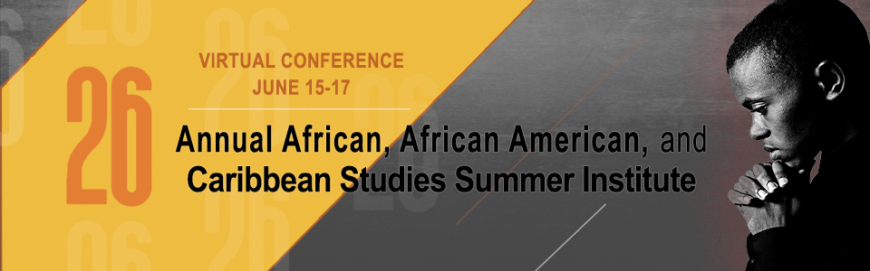

Theme: Educational Transformation: Integrating African and African American Studies from Contributions to Social Action
The office of African, African American, Latino, Holocaust, and Gender studies welcomes you to its annual summer institute. We anticipate that the topics and strategies discussed in this year’s institute will be conducive in the development of an equitable learning experience for Black students, therefore, increasing academic achievement for this subgroup. This is an integral part in the District’s initiative to eliminate systemic barriers that create predicable outcomes for students of color.
Our goal is to help participants develop an understanding of transformative educational experiences for Black students. This theme is predicated on Dr. James Banks’s approaches to multicultural education reform, which are:
• The Contributions Approach
• The Additive Approach
• The Transformation Approach
• The Social Action Approach
The aim is to provide our participants with a deeper understanding of how to create curriculum and pedagogical strategies that are transformative and reflect Afro-diasporic perspectives.
#AfAmInstitute

Organizers and Hosts
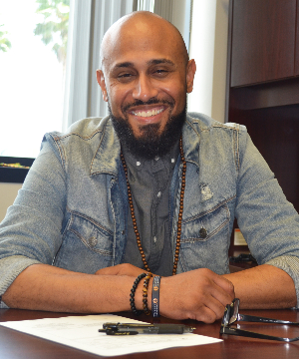Brian Knowles
Manager, African, African American, Holocaust, Latino, and Gender Studies
Brian Knowles, M.Ed. has been an educator for over 13 years. He earned his B.A. degree in History from Florida Atlantic University and completed his graduate studies at the University of West Florida. Brian currently serves as the Manager of the Office of African, African American, Latino, Holocaust, and Gender Studies within the School District of Palm Beach County, the tenth–largest public school district in the United States.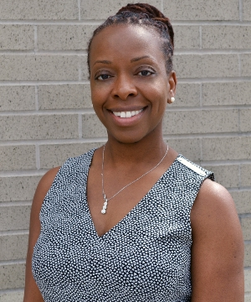Karen Jefferson
Specialist, African, African American, Holocaust, Latino, and Gender Studies
Karen Jefferson is a veteran educator with over 15 years of experience. She earned a B.A. degree in Political Science with a certificate in Ethnic Studies from Florida Atlantic University and completed her graduate studies at Lynn University. Karen serves as the Instructional Specialist for the Office of African, African American, Latino, Holocaust, and Gender Studies within the School District of Palm Beach County. Her work entails designing culturally responsive curriculum and professional development with a focus on pedagogical strategies for Black student engagement.
Monday, June 15, 2020 - Virtual Schedule
Libation by Akbar Watson
Lift Every Voice & Sing by Michelle Martin
Welcome Message from Superintendent, Dr. Donald E. Fennoy II
Opening Remarks from Brian Knowles and Karen Jefferson 4:19
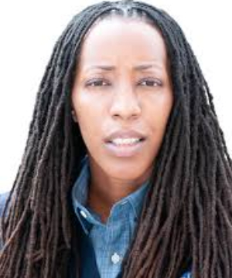60:01
Featured Presenter
Dr. Bettina L. Love
Get Free: Hip Hop, Creativity, Social Justice, and Civics
Dr. Love will discuss the critical role of normalizing African diasporic culture in schools through Hip Hop. Participants will develop an understanding of how to utilize Hip Hop culture to inspire student activism.
27:52
Brian Knowles
Changing the Narrative: Teaching Black History Beyond Slavery and Oppression
Traditional narratives have either omitted or minimized the historical contributions of Black people. During this session, we will explore the extensive history of African people on the continent and throughout the diaspora. Expanding the story beyond the confinement of slavery and civil rights.
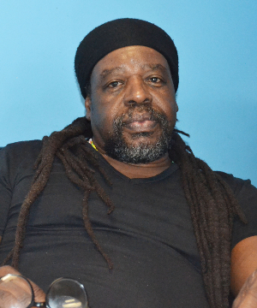1:02:16
Akbar Watson
Learn More
Literature of the African Diaspora
Pyramid Books is committed to giving all students access to learning about their cultural heritage and their place in the global community. Pyramid’s vision is to encourage all students to read and enjoy the reading process. The books that Pyramid Books have chosen to examine are all books that explore the magnificence of the African Diaspora and how the diaspora relates to each student’s life experience.
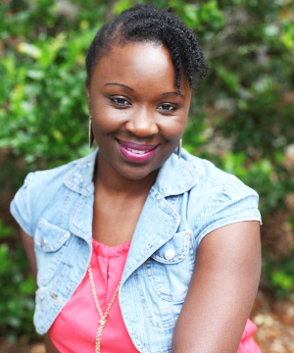1:03:44
Dr. Melanie Acosta
Learn More
“I Ain’t A Killa’ But Don’t Push Me”: Dismantling Black Student Alienation Through Curriculum & Instruction
Positive classroom communities take intentional nurturing by teachers to transform classroom spaces into places where Black students want to be considering the often anti-Black hostility, or Black student alienation, (Acosta, 2013; King, 1991; Love, 2019) that shapes Black students’ schooling experiences. Participants will engage in analysis and collective dialogue toward an overarching framework for dismantling Black student alienation.
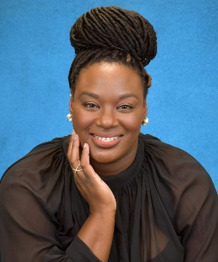50:48
Mariota Theodoris
Learn More
I Don't Like My Students!: An Educator's Guide to Establishing & Maintaining Effective Relationships with Students
A critical aspect, that will change the culture of our schools, are tools for adolescents to establish, value, enrich, and cultivate thriving intrapersonal/interpersonal relationships between self, family, friends, peers, and adults in their schools and community.
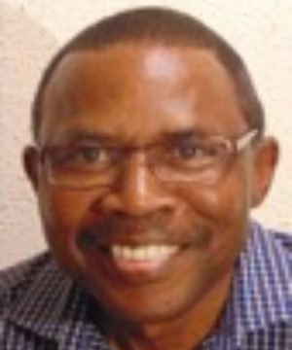1:11:36
Steve White
Learn More
Helping Black Children Reach Their Full Potential: The 7 Keys to Developing the Genius
A life changing workshop presentation designed especially for educators, parents and all who are genuinely concerned about the positive development of Black children. In this presentation, the attendees will receive practical information they can immediately put to use in their classroom or home to develop the genius potential lying dormant in black children.
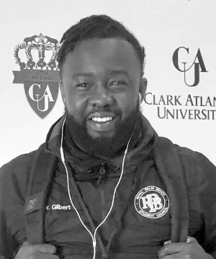34:58
Brandon Derrick Gilbert
Learn More
Bold Leadership Excelsum (BLX): The Branding of Social Media
In this workshop, we will explore cultural misconceptions, popular practices and relationship building techniques with regards to teaching black and brown boys at the high school level. Under the framework of equity and access along with protocols from the Courageous Conversations about race discourse, we will engage in dialogue that will act as a catalyst in strengthening your ability to assist in the individual and educational growth of black and brown boys in education.
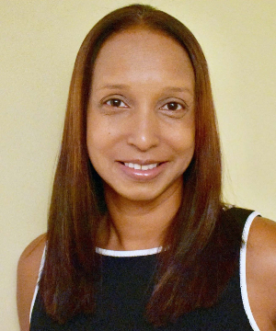44:40
Teresa Thomas
Learn More
Engaging Gifted Black Minds: Strategies and Resources for Instruction
This presentation will explore perceptions of giftedness and varying definitions. An overview into the structural differences in the gifted brain, the experience of African American gifted students in the classroom and implications for their instruction will be provided and frameworks of learning, teaching strategies, resources and lesson planning geared toward the needs of gifted African American learners will be shared.
Tuesday, June 16, 2020 - Virtual Schedule
Welcome: Debra Robinson, M.D. - School Board, District 7
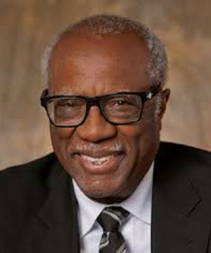46:25
Featured Presenter
Dr. James Banks
Teaching African American Students to Know, to Care, and to Act
Dr. Banks will walk participants through each of the approaches of Multicultural Curriculum Reform. These approaches are Contributions, Additive, Transformative, and Social Action. This session will help participants develop an understanding around the need to reform curriculum to engage and empower Black students.
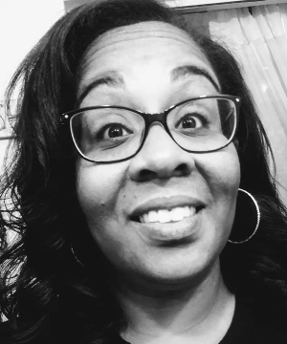50:11
Fernelize Henry
Learn More
African Americans, Latinos, and Social Activism
This workshop is an overview of how Blacks and Latinos fought against institutionalized racism, Imperialism and for workers’ rights in the late 19th and early 20th centuries.
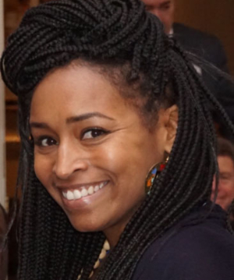55:24
Dr. Bianca Nightengale-Lee
Learn More
The Hip-Hop Learning Lab: An Exploration of Curriculum Development for the Lives and Literacies of Black Boys
For many Black male students, the divergence between who they are, and the curriculum used to teach them poses an ominous threat, as they attempt to reconcile their cultural and racial identities within traditionalized literacy instruction (Taylor, Brock, Case, & Taylor, 2013). The work focuses on an authentically created curriculum.
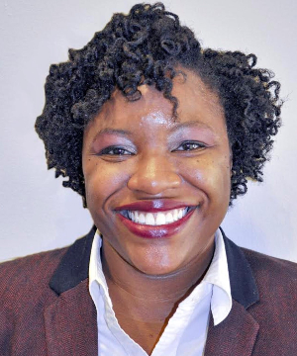60:19
Elizabeth Bullard
Learn More
"Just Vibe"
Are you having problems creating or integrating culturally relevant resources? Participants will learn how to vibe in the classroom by creating and integrating culturally relevant resources that will foster a student centered environment and increase student engagement in Mathematics.
1:04:53
Dr. Aylssa Jean
Learn More
Cultural Preservation
Cultural Preservation is a deliberate attempt to maintain cultural heritage from the past for the benefit of the present and future generations. In this session, Dr. Jean will discuss the importance of cultural preservation in the African, African American, Caribbean American communities. Through interactive activities, participants will explore misconceptions and discover simple ways of keeping the culture alive at home and in the classroom.
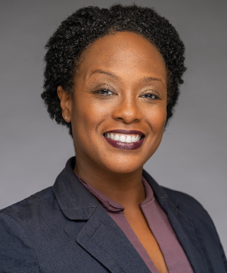1:00:21
Dr. Alisha Winn
Learn More
Memorializing and Identifying Sacred Grounds with Student Experiences
Throughout history, across this country, the state, and this city, historic African American cemeteries and burial sites have been neglected, built over, unrecognized and devalued. This session will explore these sites and cemeteries, how communities memorialize them, and student instruction. The session will focus on ways to engage students in remembering those they have lost, connect to sacred spaces, and create ways to highlight these topics.
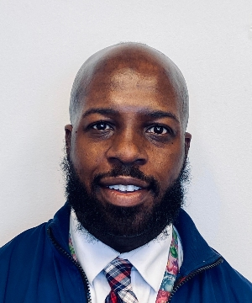1:28:30
Mackeral Etienne
Learn More
Teaching Haitian Culture and History to Empower All Students
The Haitian Revolution seems to be a forgotten piece in History and should be taught adequately in classrooms as it played a pivotal role in the development of the free world. Haitian History is Black History as Black History is American History, of course. Haiti is considered to be the poorest country in the western hemisphere; however, its rich history and culture can empower all young learners and strengthen their sense of global community.
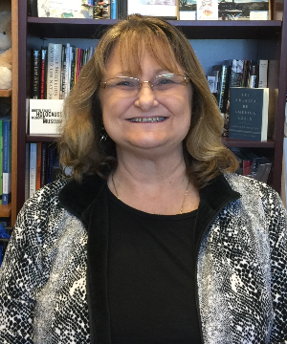37:37
Laureen Neubarth
Learn More
Infusing African American History into Elementary Social Studies
Participants will learn about grade appropriate infusion of African American history and shown how to locate these resources/lesson plans in Blender.
Wednesday, June 17, 2020 - Virtual Schedule
Welcome: Debye Raing - Retired, Manager of the Office of African and African American Studies 23:41
Closing Statement
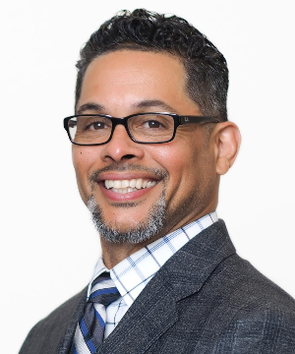59:57
Featured Presenter
Chris Chatmon
Kingmakers of Oakland: Elevating the lives of Black Boys
Chris Chatmon will discuss the work that he is leading in Oakland, California around reforming systems to create equity and access for Black boys. He will expound on how this work is being conducted through a nonprofit that he co- founded called Kingmakers of Oakland. Through this targeted strategy, the goal is to transform the educational experience of all students.
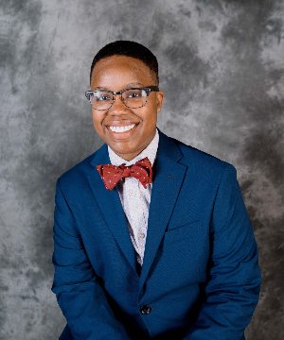1:12:00
Kezia Gilyard
Learn More
Black History is Queer History: Providing Mirrors for Our Youth
We will begin with a brief review of LGBTQ+ identities. I will provide a non-exhaustive list of Black and Afro-Caribbean historical figures and their contributions throughout history. We will discuss the interconnectedness of the struggles to end racial oppression, gender oppression, and the oppression of those who are not heterosexual.
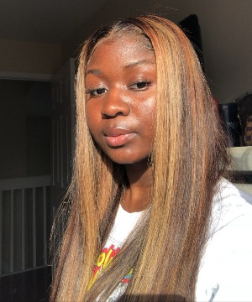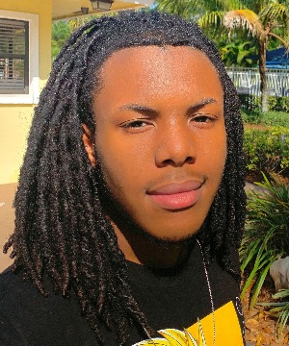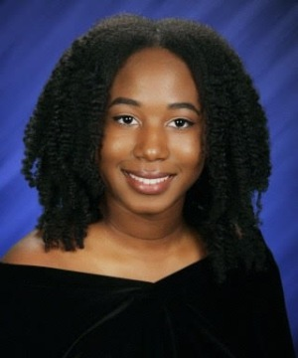
Sandra Elma, Dakari Holder, Abagail Joseph
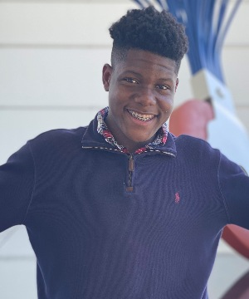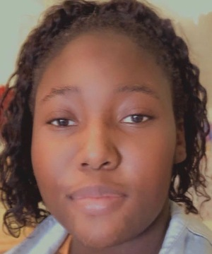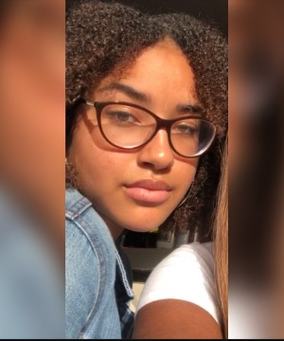
Joseph Rhinvil, Trinity Steele, Zorie Williams
1:07:07
The State of Education from a Black Student's Perspectives
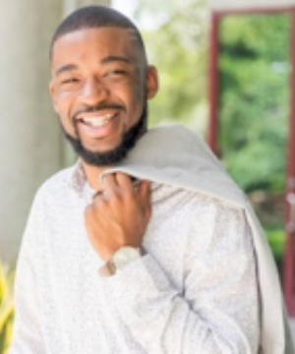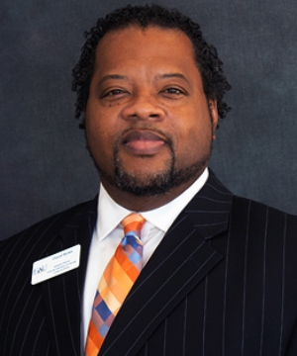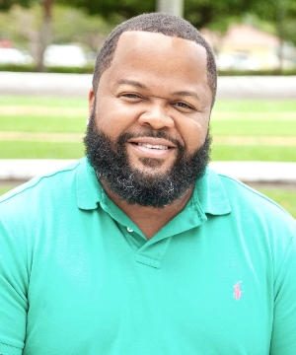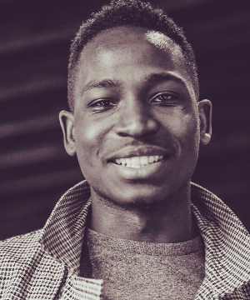 1:49:33
Kevan Allen, David Bynes, DeAlex Martin, Jamal Weatherspoon
Unapologetically Dope: Navigating the Politics of Education from the Black Male Perspective
26:52
Karen Jefferson
Beyond Black History Month: The importance of normalizing the celebration of holidays within Black Culture.
During the month of June, we celebrate Juneteenth as well as Caribbean-American Heritage Month. This presentation will explore the history of celebrations and the importance of commemorating these events as a way of preserving Black history and culture.
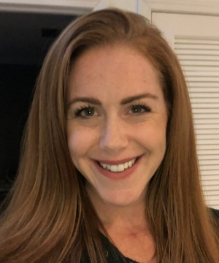 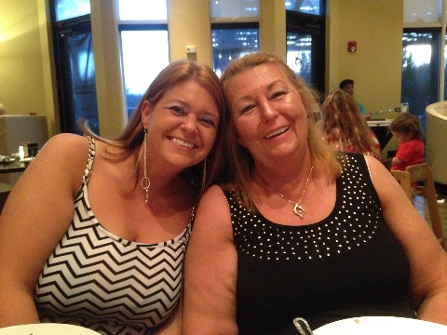
Jaclyn Gennaro, Marie-Amalie Farris, Tawny Anderson
A-37:40 B-32:06
White Fragility and the Responsibility of White People in Dismantling White Supremacy
White Fragility is one of the inherent characteristics of white people that keeps us from doing the work of anti-racism. Naming our own white fragility helps us to start our life-long journey from being non-racist to anti-racist.
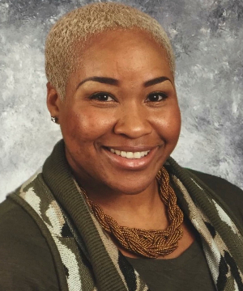11:29
Michelle Martin
Learn More
The Search for Equity: The Role of Universal Screening in Identifying Gifted Students of Color
Since Brown v Board, practitioners and educational institutions have made attempts to seek equitable identification measures for identifying black gifted students. Only one measure, although not flawless has proven efficient. This session will highlight the important role that universal screening plays in identifying students of color gifted programs, including specific tools and assessments.
Tools and Resources

• The Office of African, African American, Latino, Holocaust, and Gender Studies
• Equity Policy - 1.041
• African-American History Honors (#2100336)
• African History Honors (#2100365)
• Commissioner of Education's African American History Taskforce
• Examining the African American Experience in the 20th Century through Music and Visual Arts (#2104310)
• Exploring Hip Hop as Literature (#2104315)
• Great Men and Women of Color Who Shaped World History (#2100345)
• History and Contributions of Haiti in a Global Context (#2100355)

